

High-Resolution cryo-EM and
single-particle-analysis

SPHIRE 1.2a
Short Tutorial

A more comprehensive full-length SPHIRE tutorial describing many more
features can be downloaded at: http://www.sphire.mpg.de
SPHIRE 1.2a Short Tutorial 1
STEP 0. Getting started 3
STEP 1. Register Settings 4
STEP 2. CTF Estimation 5
STEP 3. CTF Assessment 6
STEP 4. Particle Picking 7
STEP 5. Particle Extraction 8
STEP 6. ISAC – 2D Classification 10
STEP 6b. Beautifier – High resolution classes for publication 12
STEP 7. Creation of particle sub stack for high-resolution refinement 13
STEP 8. R-VIPER – Initial model generation 14
STEP 9. Comparison of 2D classes with the initial model 15
STEP 10. Rescaling of the initial reference 16
STEP 11. Preparing a mask for 3D refinement 17
STEP 12. Meridien- High Resolution 3D refinement 18
STEP 13. PostRefiner - Sharpening and FSC curve 21
STEP 14. CTF refinement – Per particle defocus 23
STEP 15. Preparing a mask from the sharpened volume 24
STEP 16. High Resolution 3D refinement of CTF refined particles 25
STEP 16. Final PostRefiner 26
STEP 17. Local Resolution and Local Filter (optional) 27

STEP 0. Getting started

1. Open a terminal.

2. Go to the folder SphireDemoResults cd SphireDemoResults

3. Create a working directory mkdir working_directory

4. Change to this directory cd working_directory

5. Activate the SPHIRE environment

6. Launch the SPHIRE GUI sphire
7. Confirm that you want to create a new project directory

8. Suspend the GUI Ctrl + z
9. Then move the GUI to the background bg

Welcome to SPHIRE!

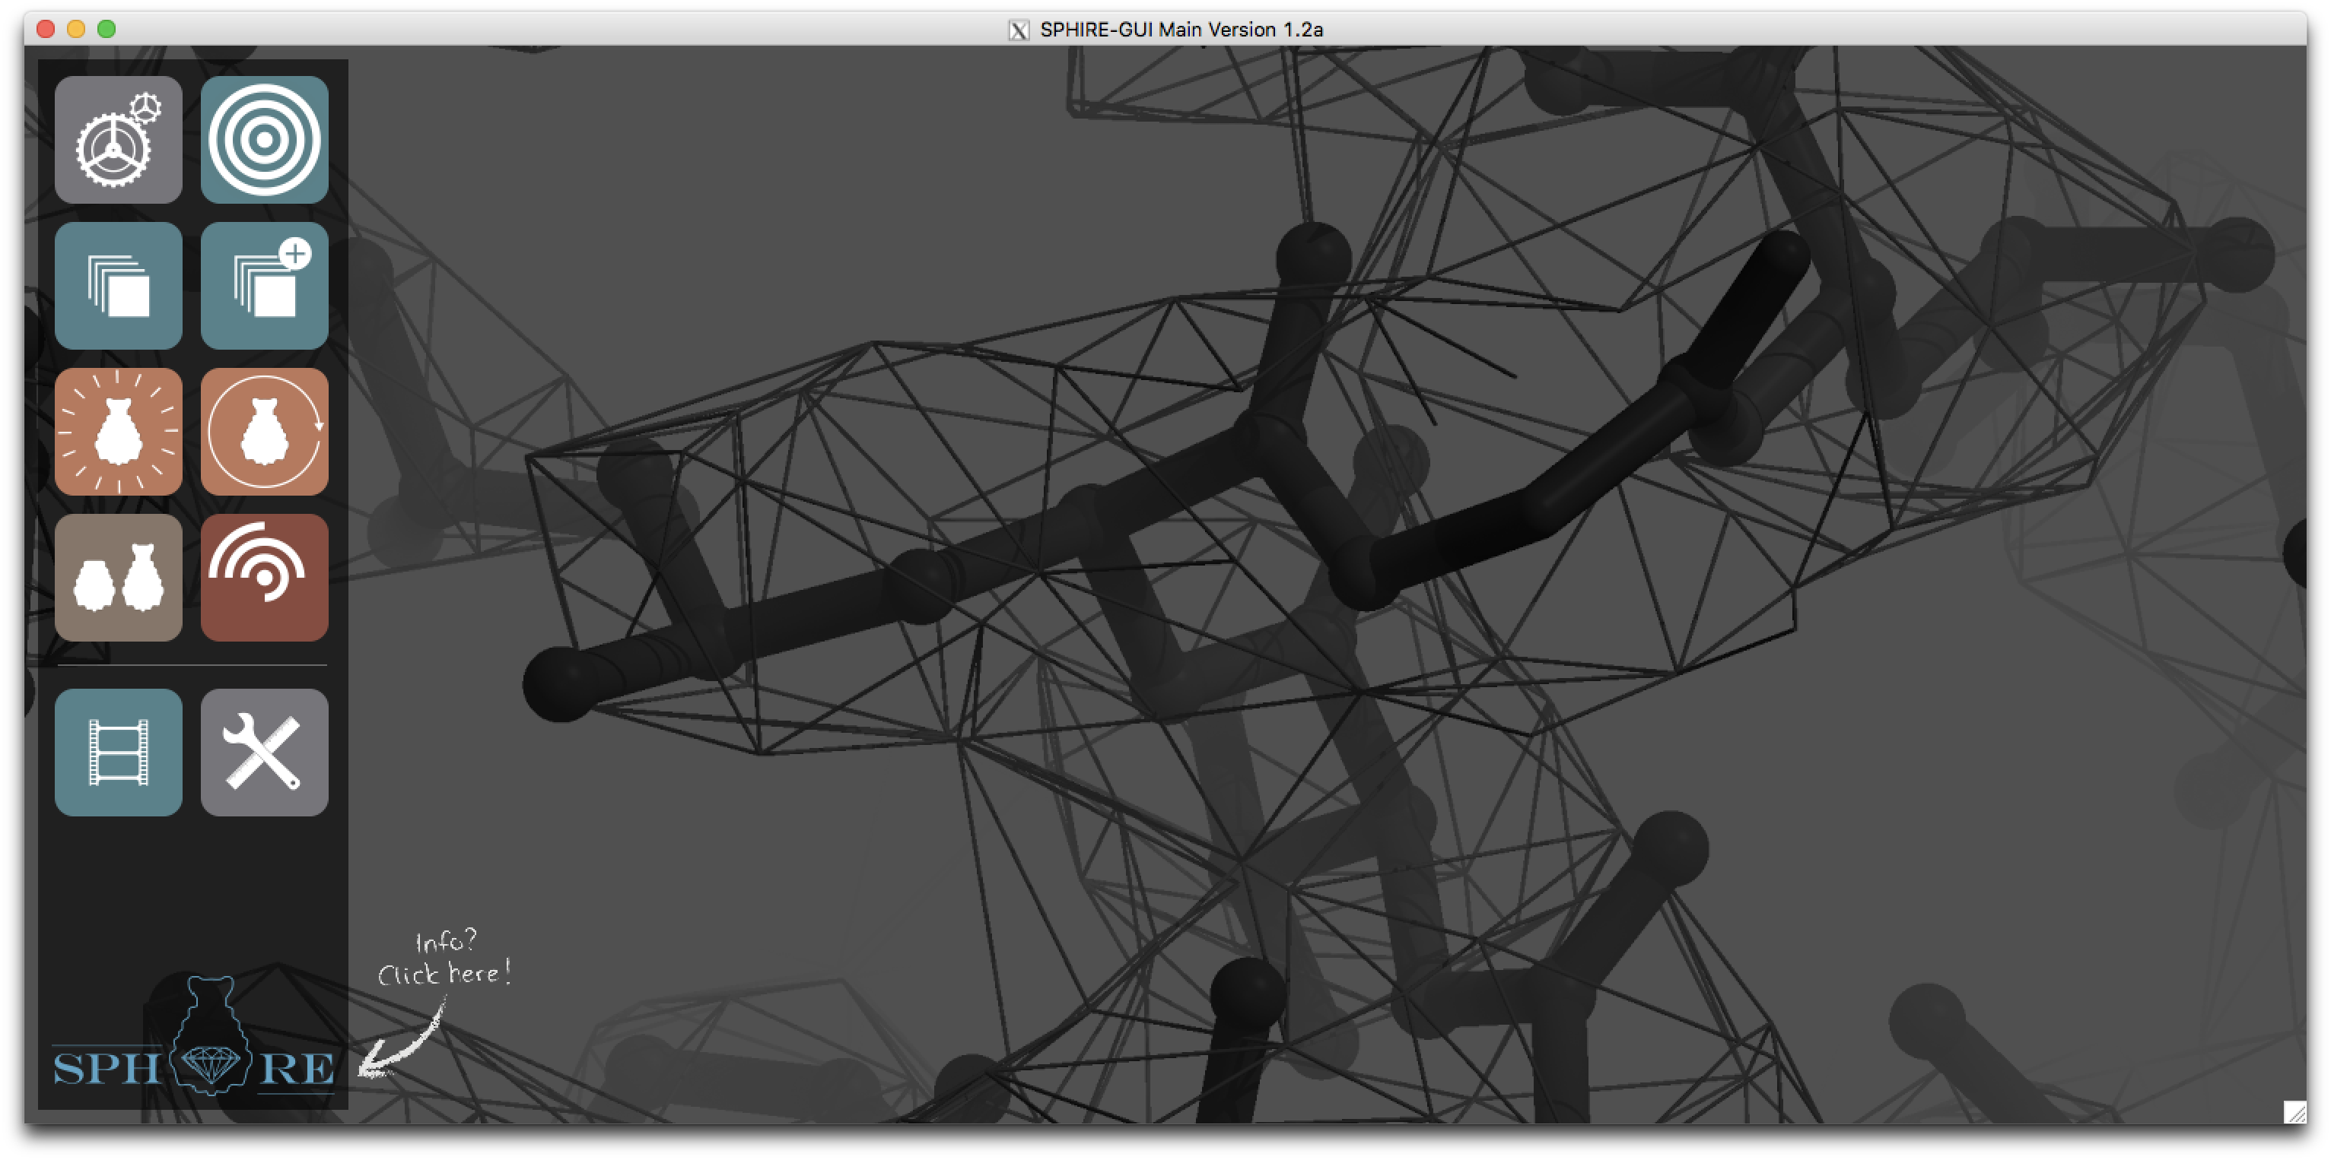

STEP 1. Register Settings

The first step is to provide the project-wide constant-value parameters.


1. Press the Project pictogram.

2. Provide following parameters:

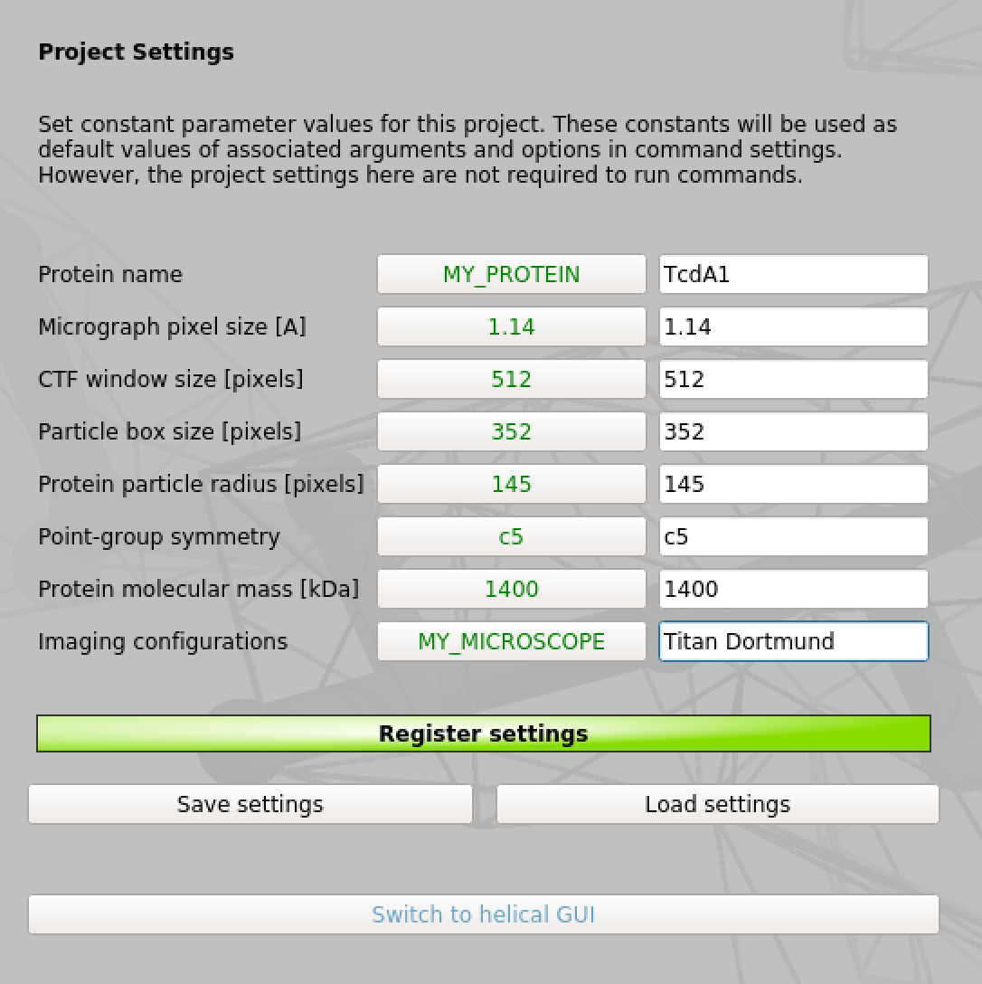
Project name: TcdA1

Micrograph pixel size [Å]: 1.14

CTF window size [pixels]: 512

Particle box size [pixels]: 352

Protein particle radius [pixels]: 145

Point-group symmetry: c5

Protein molecular mass [kDa]: 1400

Imaging configurations: Titan Dortmund

3. Press the Register settings button.

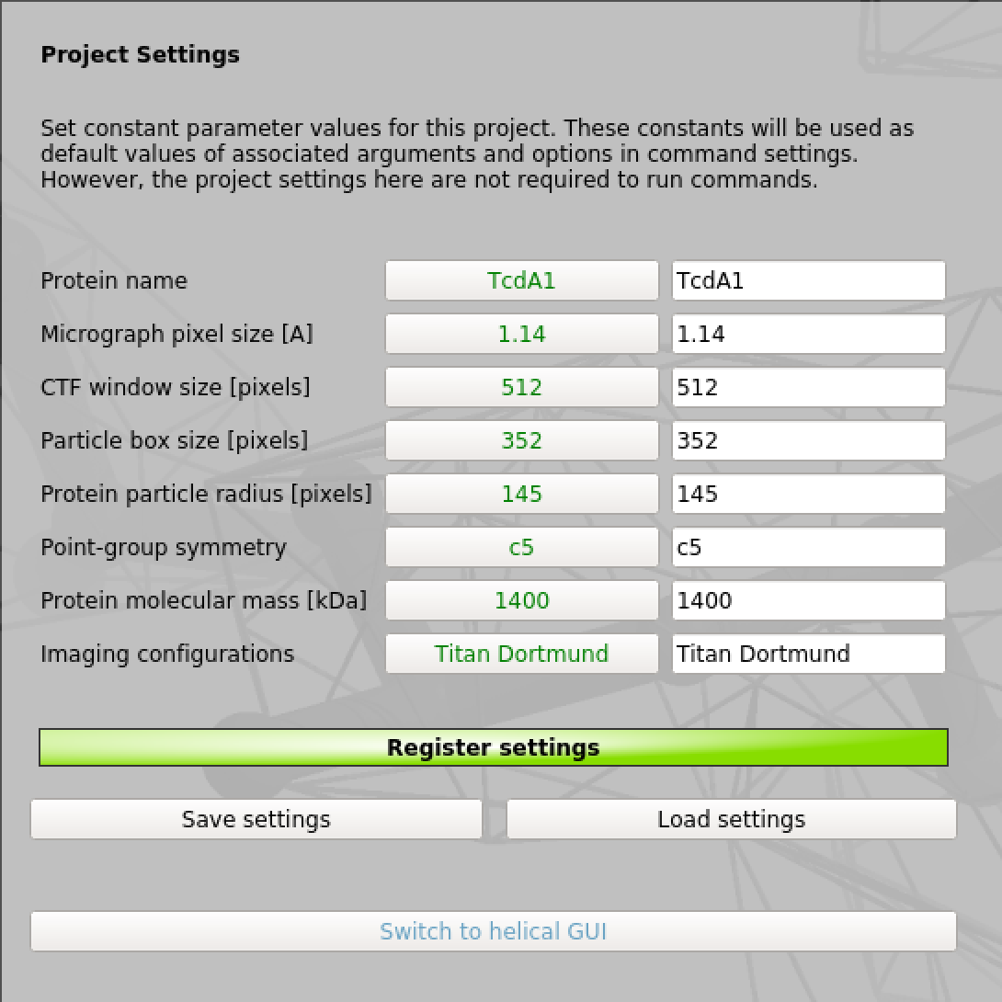

Registered settings will be filled in automatically in all windows and appear in green in the “restore default” button next to the related text field.

STEP 2. CTF Estimation

Now we will estimate the CTF of the motion corrected micrographs. Note that the CTF estimation will be performed exclusively on the not dose-weighted micrographs.


1. Go to the main window of the SPHIRE GUI and press the button CTER
on the left and then the button CTF Estimation in the middle.

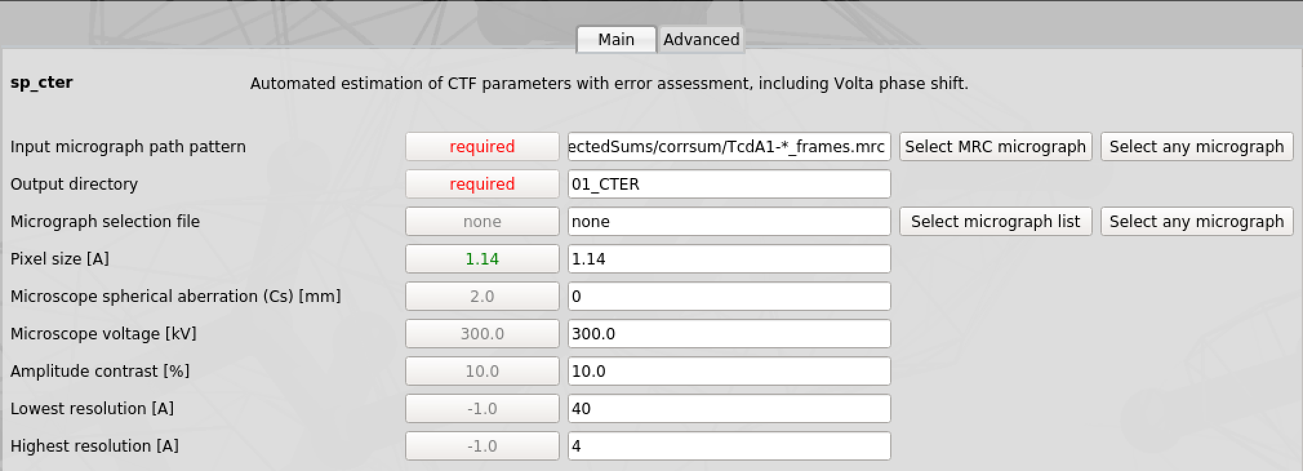
Provide following parameters:

Input micrograph path pattern: CorrectedSums/corrsum/TcdA1-*_frames_sum.mrc

Output directory: 01_CTER

Micrograph selection file: none

Pixel size: 1.14 (registered setting)

Microscope spherical aberration (Cs) [mm]: 0 (Cs corrected)

Microscope voltage (kV): 300.0

Amplitude contrast [%]: 10.0

Lowest resoution [Å]: 40

Highest resolution [Å]: 4

Advanced Parameters:

Use PW spectrum: ✓
Calculate 2D power spectra: ✓

2. Press the button.

3. Monitor the progress of the sp_cter job.

4. Once the job has finished, check the content of the output folder 01_CTER.

5. The CTF results are stored in the file 01_CTER /partres.txt.
Execute cat 01_CTER/partres.txt in the terminal or open the file with a text editor to check its content.

STEP 3. CTF Assessment

The CTF results can be analyzed using SPHIRE’s CTF Assessment tool. Using this tool, multiple criteria can be used simultaneously, in order to remove outlier images that might have a negative impact on the final result.

Our data set is pre-cleaned, thus, we will only perform a simplified screening as proof of principle and discard the image with the highest defocus value.
1. On the main window of SPHIRE, press the CTER button on the left
and then the CTF Assessment button in the middle.

2. Select the CTF parameter file 01_CTER /partres.txt and press the button to launch the GUI tool.

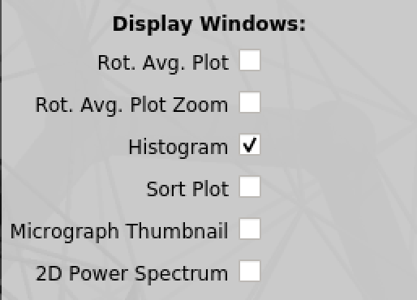
3. Uncheck Rot. Avg. Plot Zoom and Sort Plot to close
plots we do not need at the moment

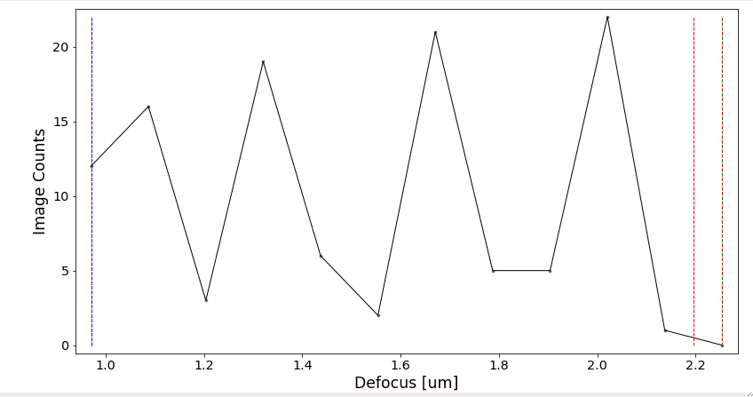
4. Shift + left click on the histogram window to set the upper defocus limit (red line) to ~ 2.2 µm in order to discard micrographs above this limit.

5. Press the  button and confirm selection.

6. Have a look at the number of unchecked micrographs.

7. Enter Tutorial in File Suffix and press the Save Selection Button.

8. Check the output of CTF Assessment in the 01_CTER folder.

STEP 4. Particle Picking

The next step is to pick and extract particles from the dose-weighted micrographs. For this purpose, we will select particles automatically using our neuronal network based particle picker crYOLO and the generalized model.

1. Go to the main window of the SPHIRE GUI and press the
button Window on the left and then the button crYOLO - predict
in the middle.

Provide following parameters:
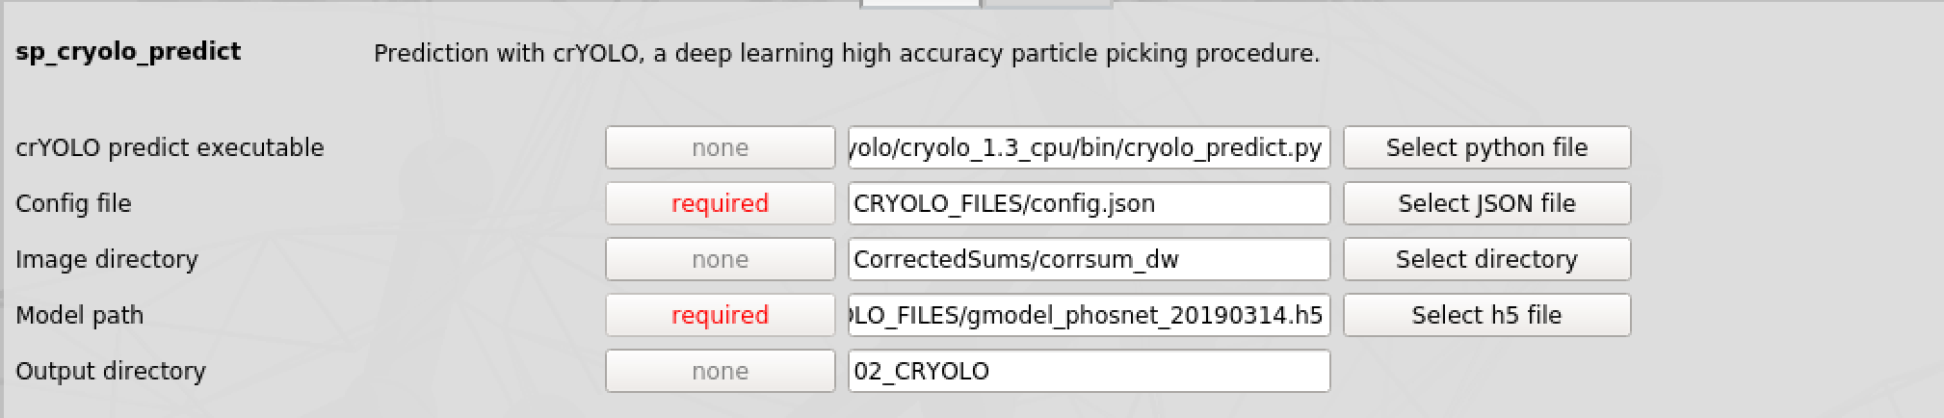
crYOLO predict executable: “Path to crYOLO executable/cryolo_predict.py”

Config file: CRYOLO_FILES/config.json

Image directory: CorrectedSums/corrsum_dw

Model path: CRYOLO_FILES/gmodel_phosnet_20190314.h5

Output directory: 02_CRYOLO

2. Press the button.

3. Monitor the progress of the crYOLO job.

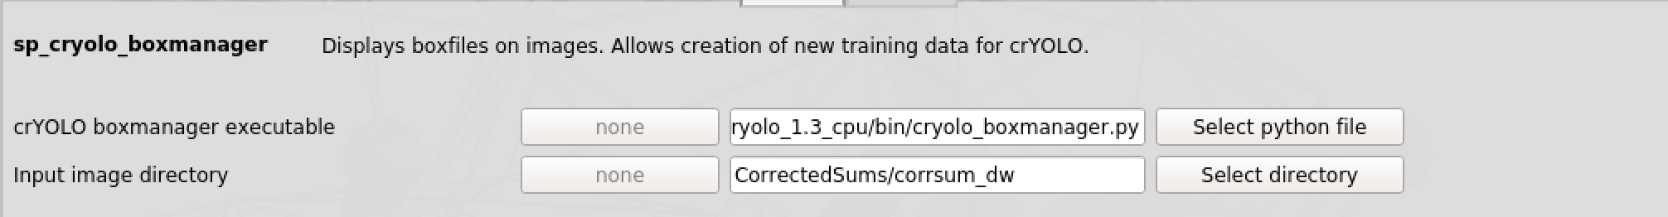
4. Once the job finished, use the cryolo_box_manager to display the picking results. In the main window of the SPHIRE GUI click the button Window on the left and then the button crYOLO - boxmanager in the middle (Utilities). Fill out the following fields:

crYOLO boxmanager executable: “Path to crYOLO executable/cryolo_boxmanager.py”

Input image directory: CorrectedSums/corrsum_dw

And press the button to open the box manager.

5. Click on the File and then select the Import box files option. Use the file browser to select the CBOX folder within the folder 02_CRYOLO to load the coordinates for each micrograph. Within the box manager you can adjust the confidence threshold to optimize picking results.

STEP 5. Particle Extraction

Due to limited computational resources, we will not use all boxes crYOLO picked but a smaller subset.
1. Go back to the main window of the SPHIRE GUI and press the button
Window on the left and then the Particle Extraction button in the middle.

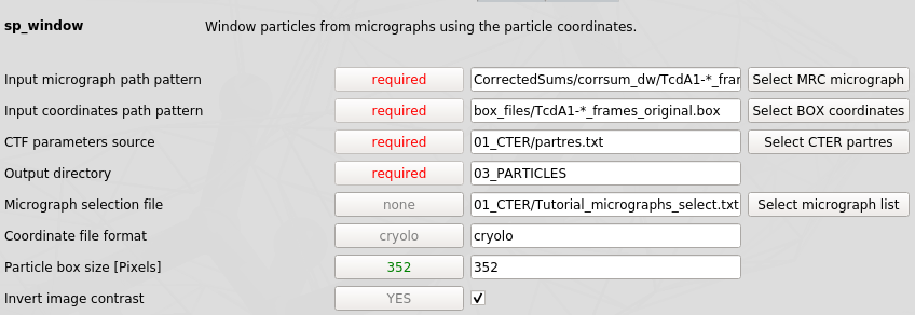
Provide following parameters:
Input micrograph path pattern: CorrectedSums/corrsum_dw/TcdA1-*_frames.mrc
Input coordinates path pattern: box_files/TcdA1-*_frames_original.box (subset)

CTF parameter source: 01_CTER/partres.txt

Output directory: 03_PARTICLES

Micrograph selection file: 01_CTER/Tutorial_micrographs_select.txt

Coordinate file format: cryolo

Particle box size [Pixels]: 352

Invert contrast: ✓

And press the button.

2. Monitor the progress of the sp_window job.
3. When the job is finished, create a bdb stack containing all extracted particles by pressing the Window button on the left and Particle Stack in the middle.

Provide following parameters:
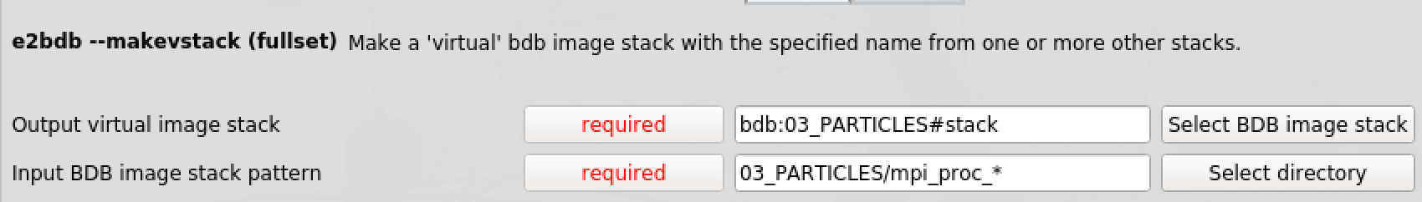
Output virtual image stack: bdb:03_Particles#stack
Input BDB image stack pattern: 03_Particles/mpi_proc_*

4. Afterwards, check the total number of particles in the resulting stack. Therefore, execute the following command in the terminal

e2iminfo.py bdb:03_PARTICLES#stack

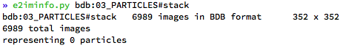

5. You can display the virtual stack using the utility Display Data.

STEP 6. ISAC – 2D Classification

We will use the ISAC approach to obtain validated 2D class-averages.

1. Press the ISAC button on the left and then the ISAC - 2D Clustering
button in the middle.

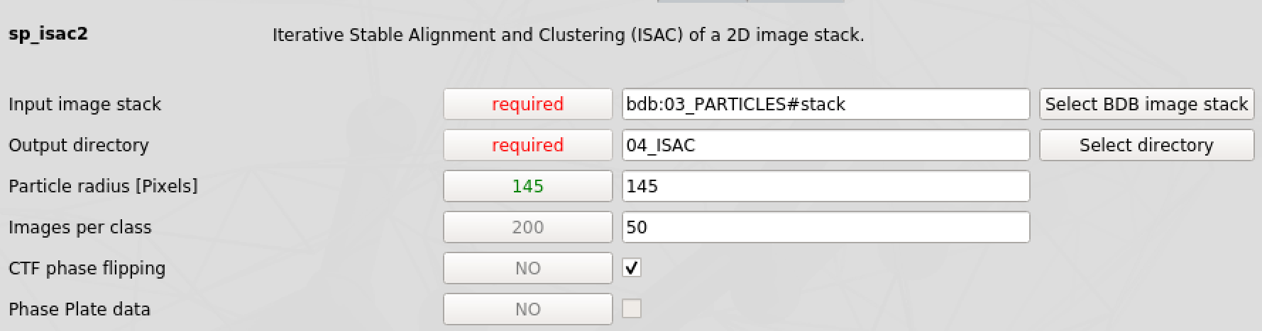
Provide following parameters:
Input image stack: bdb:03_PARTICLES#stack
Output directory: 04_ISAC

Particle radius [Pixels]: 145

Images per class: 50

CTF phase flipping: ✓

Advanced Parameters:

Minimum size of reproducible classes: 30

And press the button.

2. Monitor the progress of the sp_isac2 job.
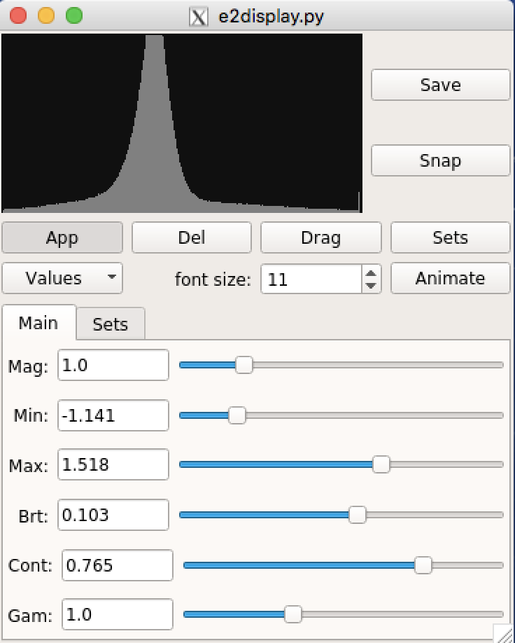
3. Display the resulting 2D class averages 04_ISAC/ordered_class_averages.hdf using the utility Display Data.
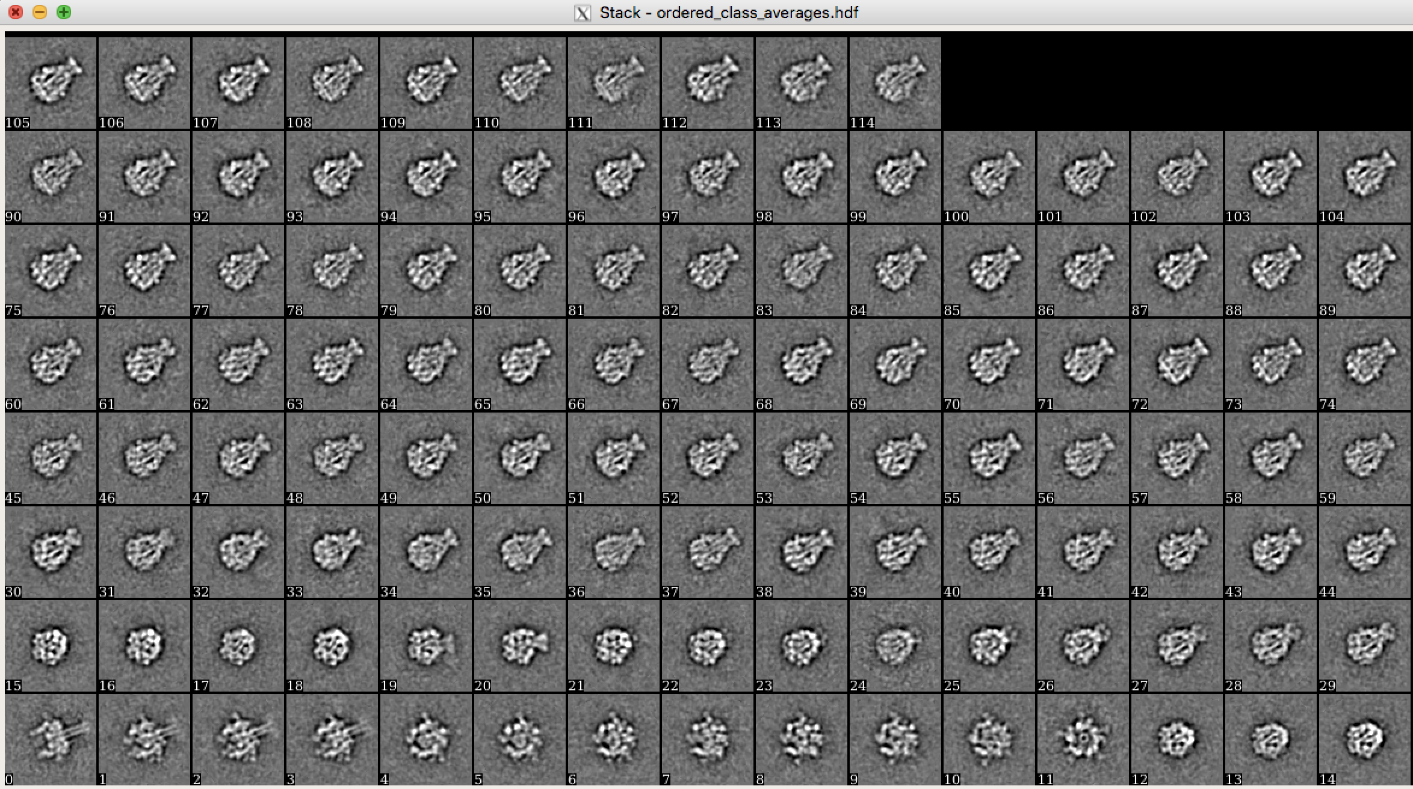
Does the data set contain contamination or different populations of particles?

Delete “bad” class averages (middle mouse button, press Del and then click on classes you want to delete) and store the remaining class averages into a new file named 04_ISAC/best.hdf (save button).

4. Check the number of remaining “good” classes by executing
e2iminfo.py 04_ISAC/best.hdf in the terminal.

STEP 6b. Beautifier – High resolution classes for publication

Particles are automatically downsized to 76 pixels within ISAC to speed up calculations. One can already see fine details in those classes, however, for publications one might want to compute full size class averages using the Beautifier to recover high resolution features.
1. Press the ISAC button on the left and then the Beautifier button
in the middle.

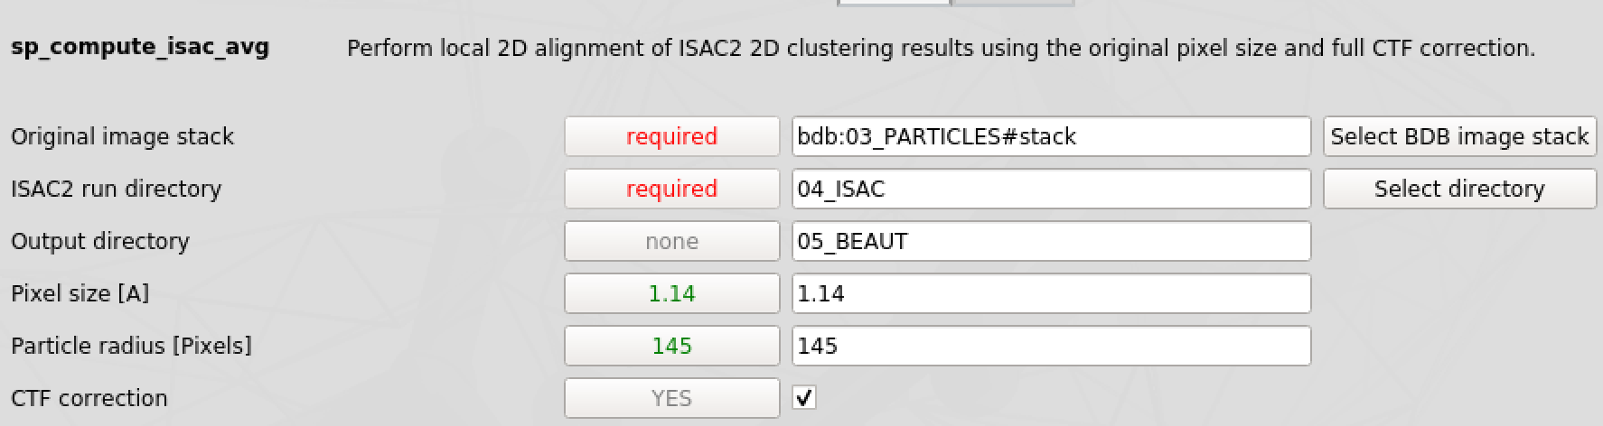
Provide following parameters:

Original image stack: bdb:03_PARTICLES#stack
ISAC2 run directory: 04_ISAC

Output directory: 05_BEAUT

Pixel size [A]: 1.14

Particle radius [Pixels]: 145

CTF correction: ✓

And press the button.
2. Display the resulting 2D class averages 05_BEAUT/ordered_class_averages.hdf using the utility Display Data.
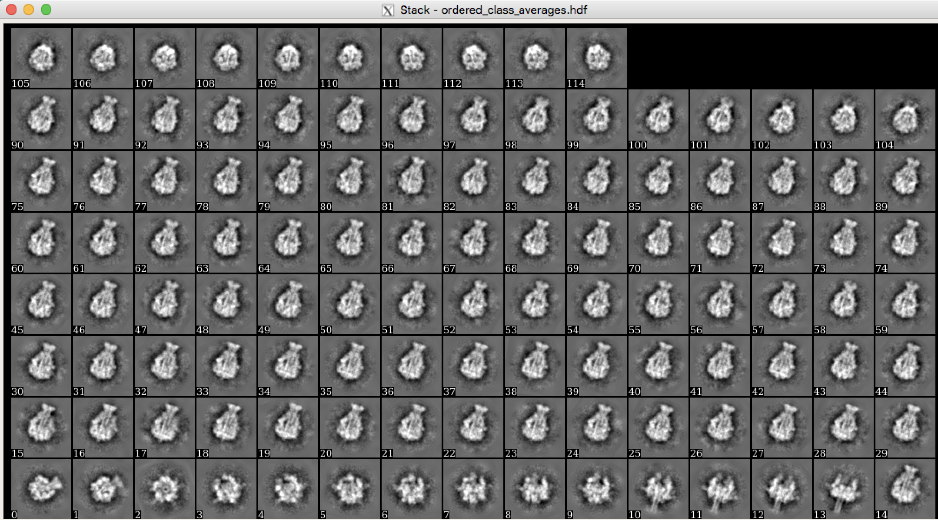

STEP 7. Creation of particle sub stack for high-resolution refinement

We found that our data set contains some particles of a second conformation and removed corresponding classes. Now, we create a sub stack of all particles belonging to “good” ISAC class averages using ISAC2 Stack Subset and will subsequently use it for the high-resolution 3D refinement

1. Press the ISAC button on the left and then the ISAC2 Stack Subset
button in the middle.

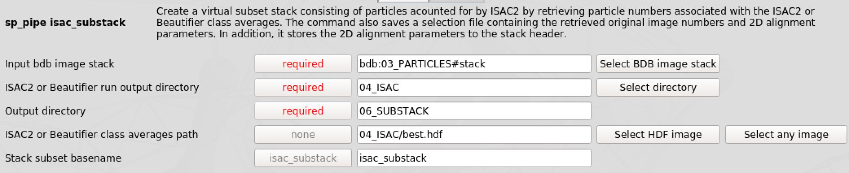
Provide following parameters:

Input bdb image stack: bdb:03_PARTICLES#stack
ISAC2 or Beautifier run output directory: 04_ISAC

Output directory: 06_SUBSTACK

ISAC2 or Beautifier class averages path: 04_ISAC/best.hdf

Stack subset basename: isac_substack

And press the button.

2. Afterwards, check the total number of particles in the resulting stack. Therefore, execute the following command in the terminal

e2iminfo.py bdb:06_SUBSTACK#isac_substack

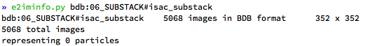

STEP 8. R-VIPER – Initial model generation

A good initial model is crucial for a successful 3D refinement. We will use
R-VIPER to determine a reproducible and validated initial model at intermediate resolution. Therefore, we will use the “good” class averages as input taking advantage of their high signal to noise ratio.

1. Press the VIPER button on the left and then the
Initial 3D Model – RVIPER button in the middle.

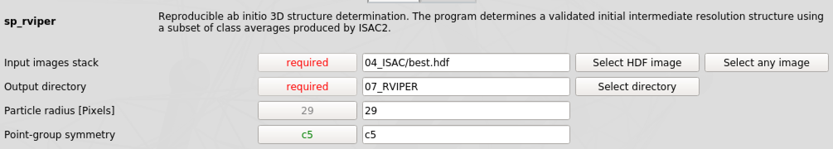
Provide following parameters:

Input image stack: 04_ISAC/best.hdf
Output directory: 07_RVIPER

Particle radius [Pixels]: 29 (downsized radius used by ISAC, default is 29 pixels)

Point-group symmetry: c5

And press the button.

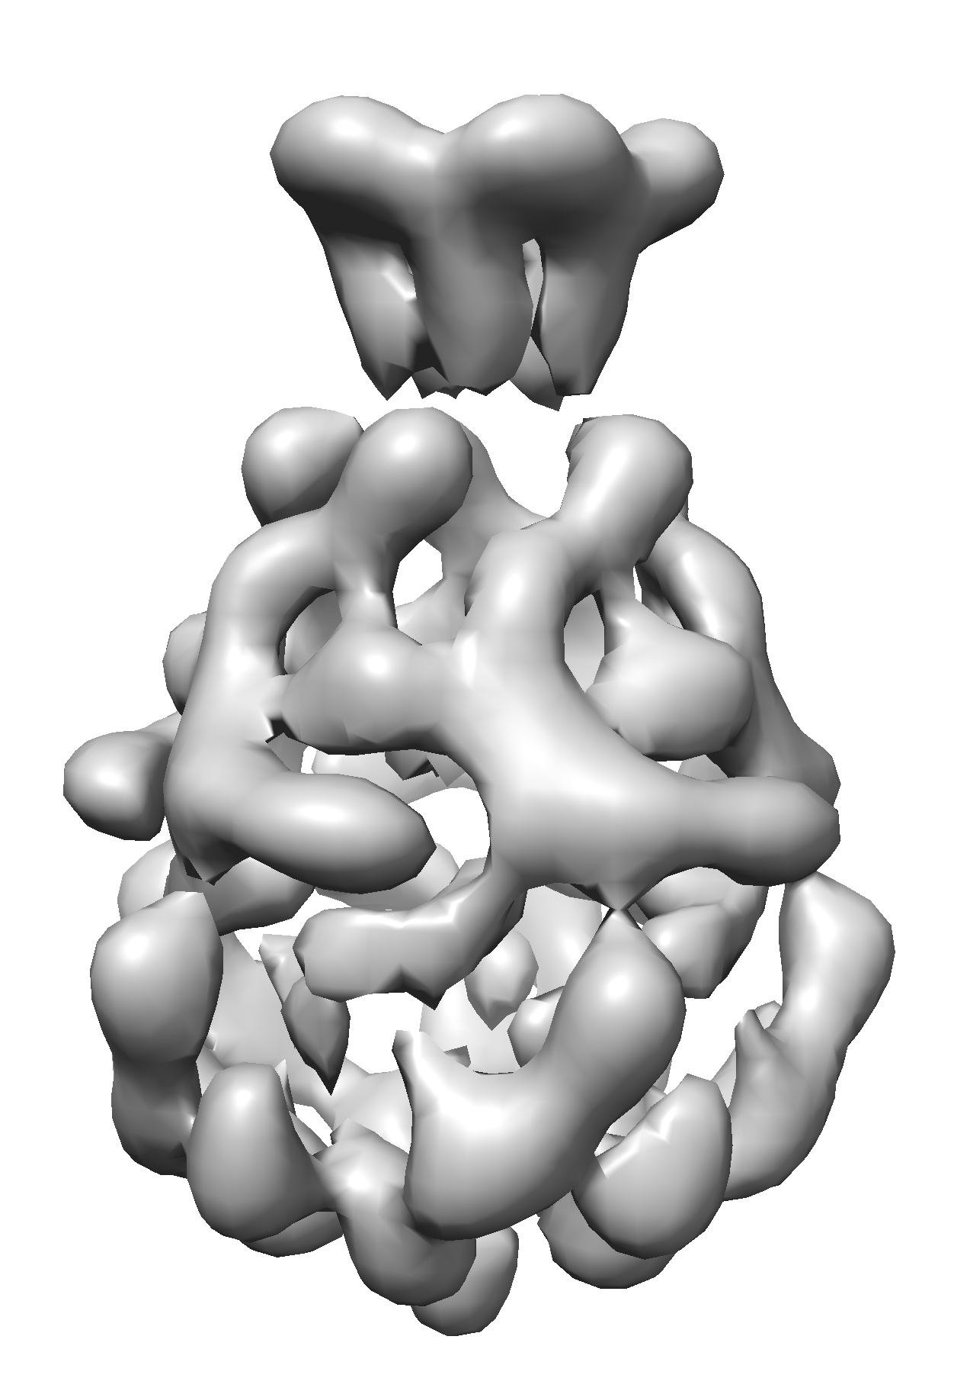
2. Monitor the progress of the sp_rviper job.

3. Display the final VIPER volume 07_RVIPER/average_volume_00*.hdf
using UCSF Chimera.

4. Compare the volume with the available x-ray structure

- Press File ➜ Fetch by ID ➜ Fetch PDB: 1VW1
- Press Favorites ➜ Volume Viewer ➜ Features ➜ Activate Coordinates ➜
Change the voxel size to 5.7 (= 1.14 / 0.2 – shrink ratio within ISAC)
- Favorites ➜ Model Panel ➜ activate 1VW1 only ➜ dock roughly into density using left and middle mouse button
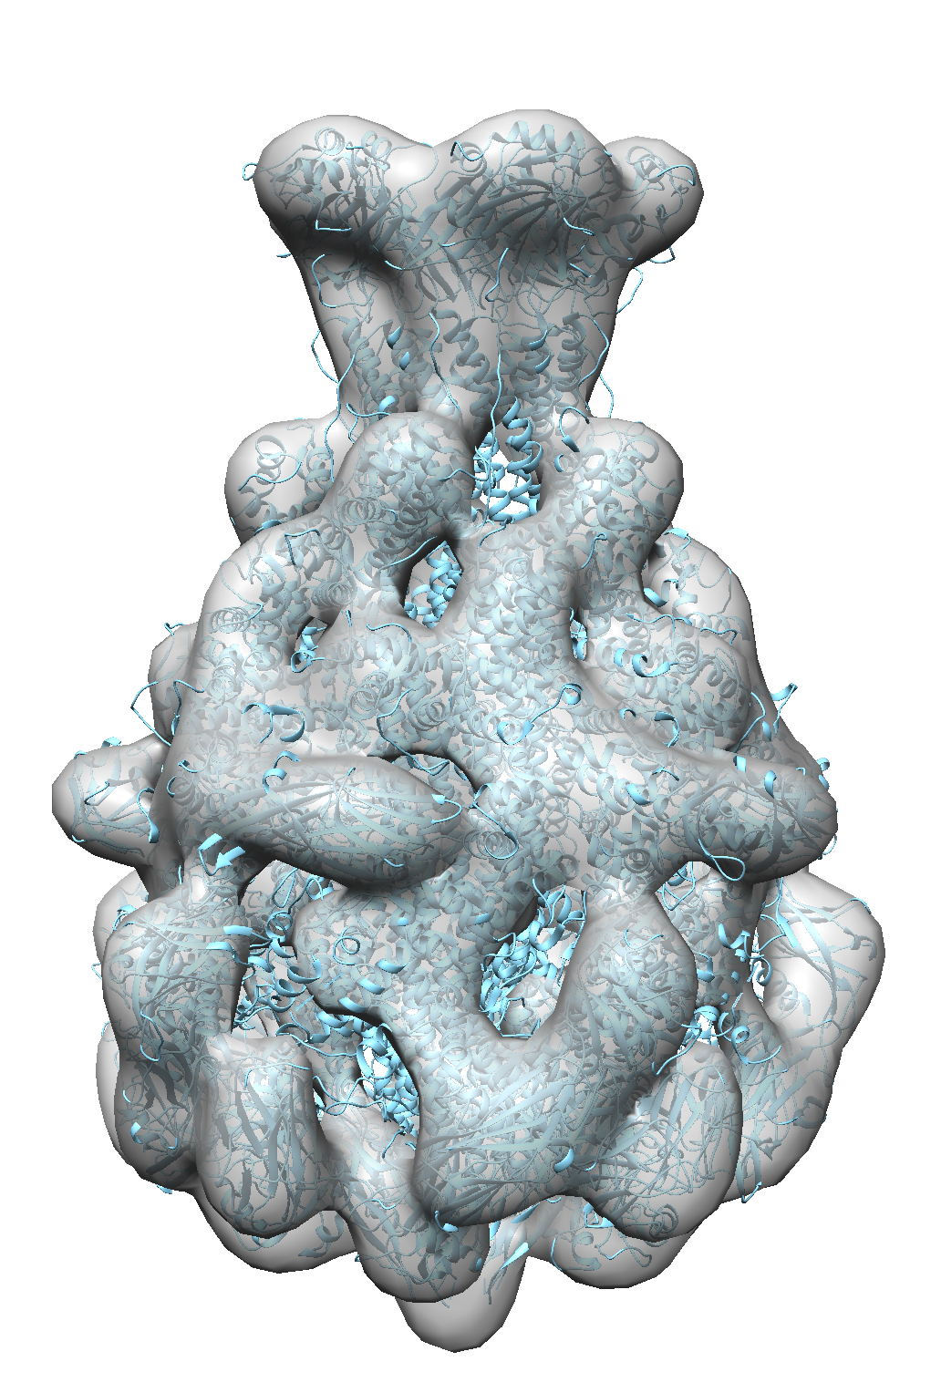
- Press Tools ➜ Volume data ➜ Fit in map ➜ Fit PDB into density
- Change the opacity of your volume by clicking the color panel in
Volume Viewer ➜ Opacity ✓ and the lower A value

Does the volume show the right-handedness?
You can change the handedness by

- Executing vop zflip #0 in the command line of UCFS Chimera
- Memorize if your handedness is correct or not for future processing steps

STEP 9. Comparison of 2D classes with the initial model

As the success of a 3D refinement strongly depends on the initial model provided, one should in general carefully check the generated volume. Although, RVIPER creates a reproducible and validated initial model, one might still want to compare projections of this volume with the original classes using Compare Re-projections.
1. Press the VIPER button on the left and then the
Compare Re-projections button in the middle.

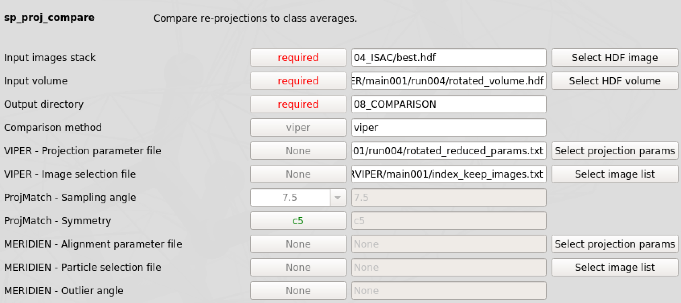
Provide following parameters:

Input image stack: 04_ISAC/best.hdf
Input volume: 07_RVIPER/main001/run00*/rotated_volume.hdf (use last run folder)

Output directory: 08_COMPARISON

Comparison method: viper

VIPER – Projection parameter file: 07_RVIPER/main001/run00*/rotated_reduced_params.txt

VIPER – Image selection file: 07_RVIPER/main001/index_keep_images.txt

And press the button.

2. Display the resulting comparison of 2D projections and 2D class averages 08_COMPARISON/comp-proj-reproj.hdf using the utility Display Data.
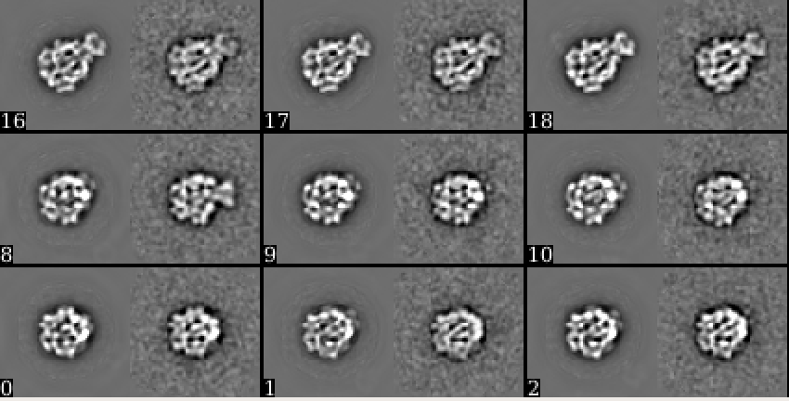

STEP 10. Rescaling of the initial reference

As mentioned before, particles have been resized during ISAC. Thus, the initial RVIPER model we generated from “good” class averages needs to be rescaled to match the original pixel size using the Volume Adjustment tool.

1. Press the VIPER button on the left and then the
Volume Adjustment button in the middle.

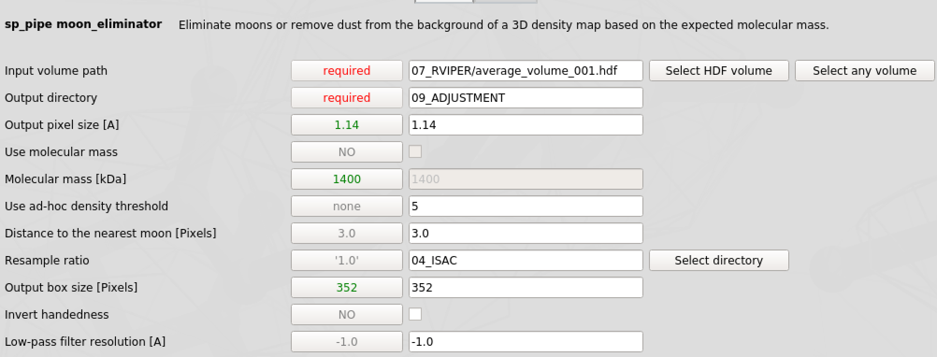
Provide following parameters:

Input volume path: 07_RVIPER/average_volume_00*.hdf
Output directory: 09_ADJUSTMENT

Output pixel size [A]: 1.14

Use ad-hoc density threshold: 5 (check in Chimera)

Distance to nearest moon [Pixels]: 3

Resample ratio: 04_ISAC
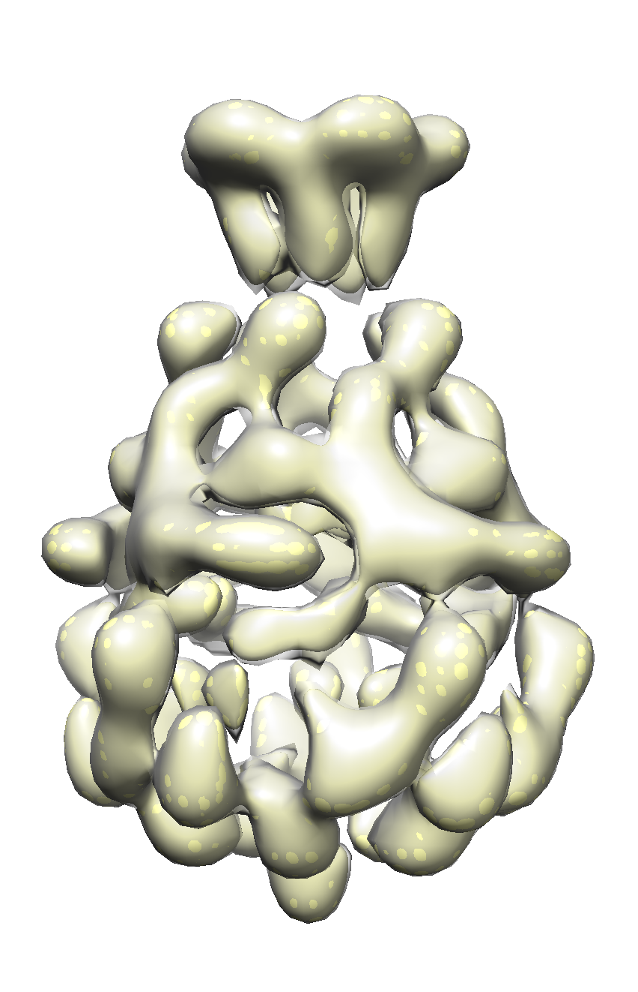
Output box size [Pixels]: 352

Invert handedness: If your handedness was wrong, tick this option ✓

Low-pass filter resolution [A]: -1

And press the button.

2. When the job is finished, open the resulting volume 09_ADJUSTMENT/vol3d_ref_moon_eliminated.hdf in UCFS Chimera.

3. Also open the original RVIPER model and enter the correct voxel sizes (1.14 Å for the adjusted volume and 5.7 Å for the original RVIPER model). Finally, fit one of the maps into the other. If your handedness was correct, the volumes should be almost identical.

STEP 11. Preparing a mask for 3D refinement

Now we will use the resampled VIPER 3D volume to create a mask for the subsequent high resolution 3D refinement using the Masking tool.
1. Press the VIPER button on the left and then the
Masking button in the middle.

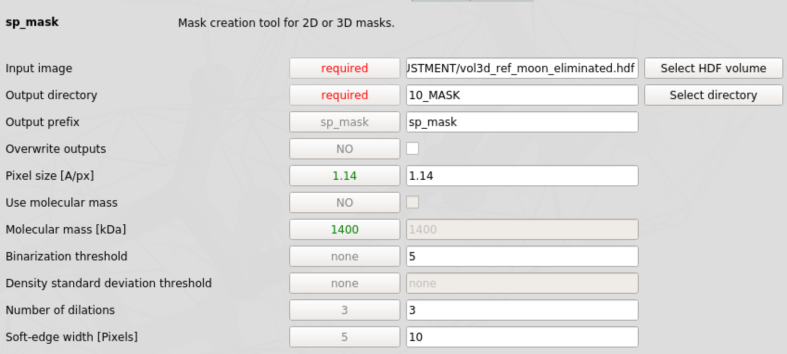
Provide following parameters:

Input image: 09_ADJUSTMENT/vol3d_ref_moon_eliminated.hdf
Output directory: 10_MASK

Output prefix: sp_mask

Pixel size [A]: 1.14

Binarization threshold: 5 (check in Chimera)

Number of dilations: 3 (each dilation corresponds to a binary extension by ~ 2 pixels)

Soft-edge width [Pixels]: 10

And press the button

2. Display the resulting 3D mask 10_MASK/sp_mask_mask.hdf and the rescaled reference 09_ADJUSTMENT/vol3d_ref_moon_eliminated.hdf with Chimera.
The mask should enclose the complete volume even at low thresholds.
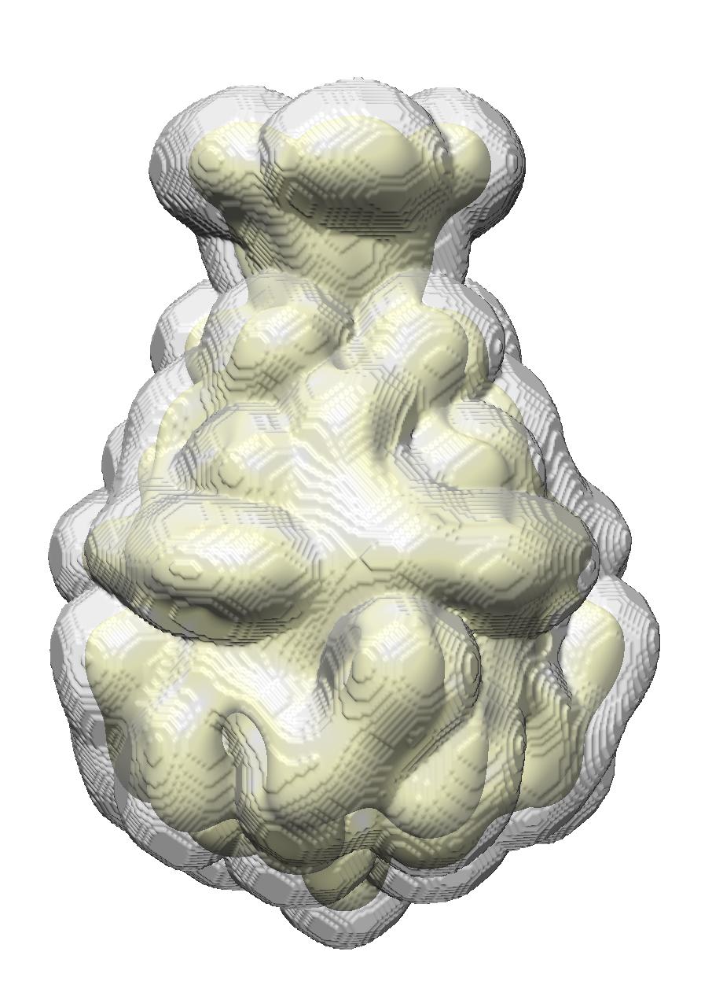

STEP 12. Meridien- High Resolution 3D refinement

Within this step we will create a high resolution density map from the sub stack of “good” particles we created in step 7 using Meridien – 3D Refinement. As a reference we will use the adjusted volume from RVIPER and the corresponding mask.
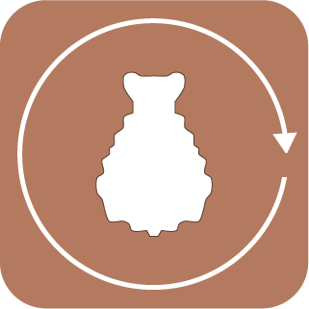
1. Press the MERIDIEN button on the left and then the 3D Refinement
button in the middle.

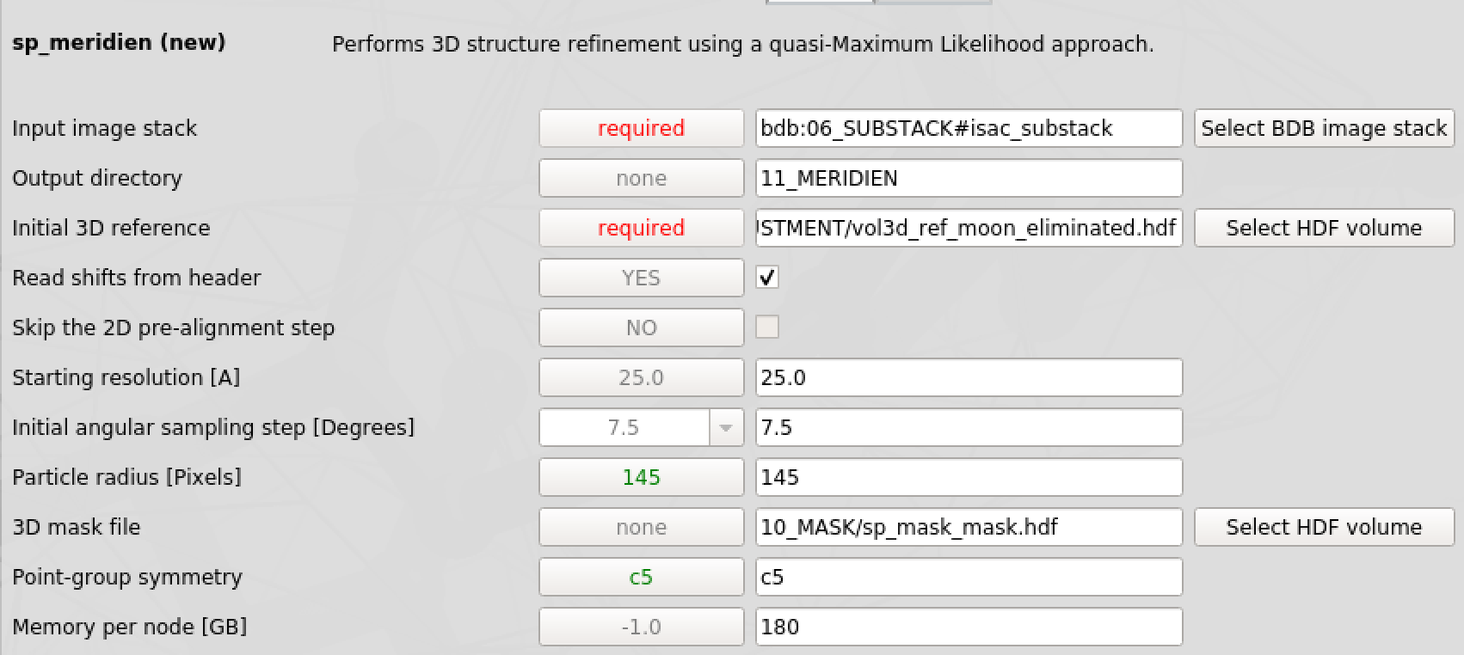
Provide following parameters:

Input image stack: bdb:06_SUBSTACK#isac_substack
Output directory: 11_MERIDIEN

Initial 3D reference: 09_ADJUSTMENT/vol3d_ref_moon_eliminated.hdf

Read shifts from header: ✓

Starting resolution [A]: 25.0

Initial angular sampling [˚]: 7.5

Particles radius [Pixels]: 145

3D mask file: 10_MASK/sp_mask_mask.hdf

Point-group symmetry: c5

Memory per node [GB]: Needs to be adjusted to available hardware

And press the button

2. Monitor the progress of the sp_meridien_new job.
You can quickly check the resolution and current status per iteration executing the following command in the terminal

grep ITER “meridien_logfile”

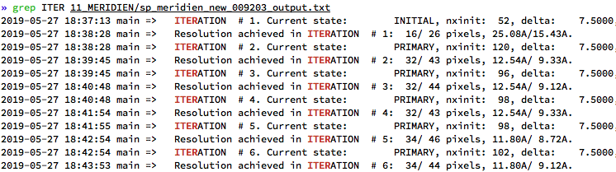

3. To monitor the progress of resolution during the refinement press the MERIDIEN button on the left and then the 3D Refinement Assessment button in the middle and press the button.

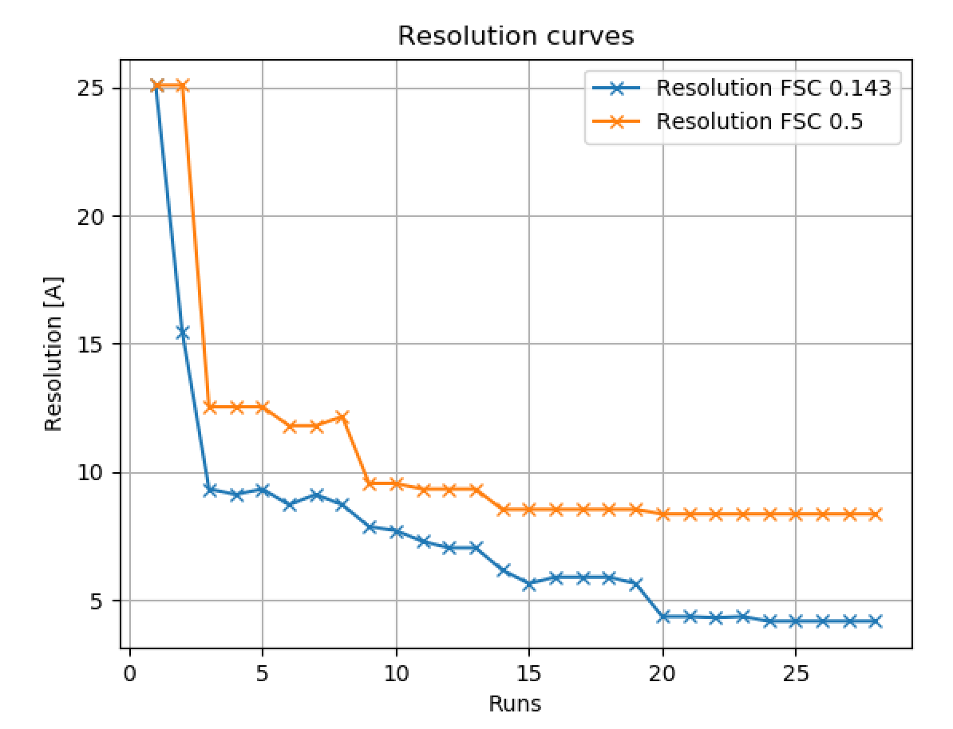
Select the Refinement directory 11_MERIDIEN to display a plot showing the progression of resolution (FSC 0.143 & 0.5) from iteration to iteration (runs).
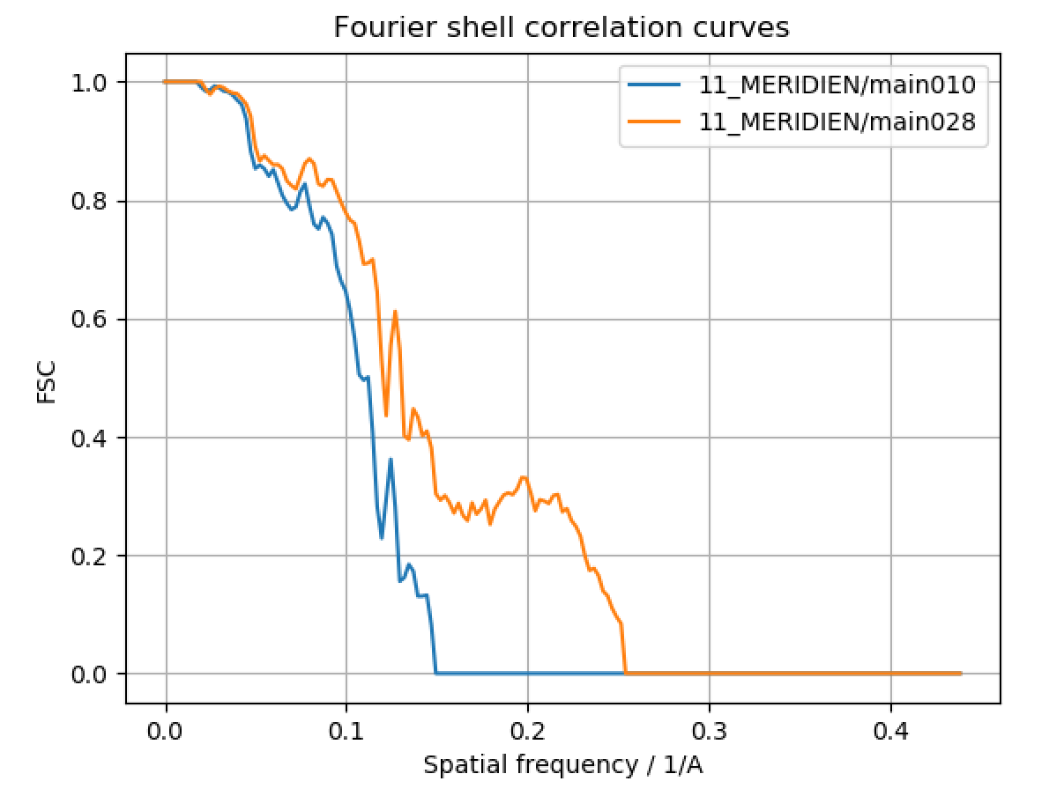
You can also select specific iteration(s) in the main window of the 3D Refinement Assessment tool (click the arrow and activate the check box) to display the FSC between the two half maps for this particular iteration of the refinement (Plot New ➜ FSC Plot). Note that the reported resolution during the refinement is underestimated.

6. Once the job has finished, press the MERIDIEN button on the left and then the Angular Distribution button in the middle to calculate a visualization of the final angular distribution.

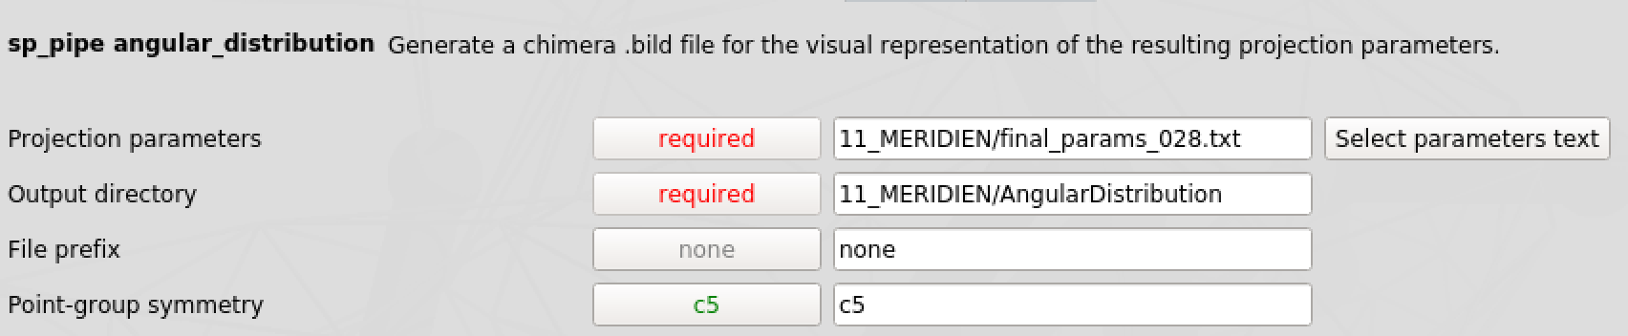
Provide following parameters:

Projection parameters: 11_MERIDIEN/final_params_0*.txt
Output directory: 11_MERIDIEN/AngularDistribution

And press the button.

7. Once the job has finished, open one of the final unfiltered half volumes 11_MERIDIEN/vol_0_unfil_0*.hdf and the angular distribution file 11_MERIDIEN/AngularDistribution/final_params_0*.bild in Chimera.

The color code for the 3D angular distribution can be read from the corresponding histogram 11_MERIDIEN/AngularDistribution/final_params_0*.png.

Due to the C5 symmetry of our protein, the angular distribution is limited to the unique fraction of the 3D sphere. The ideal case would be an even coverage of all possible projection angles. In our case we have more side views, which is in perfect agreement with the 2D classes we got earlier. Strongly preferred orientations can impede a successful high-resolution 3D refinement.
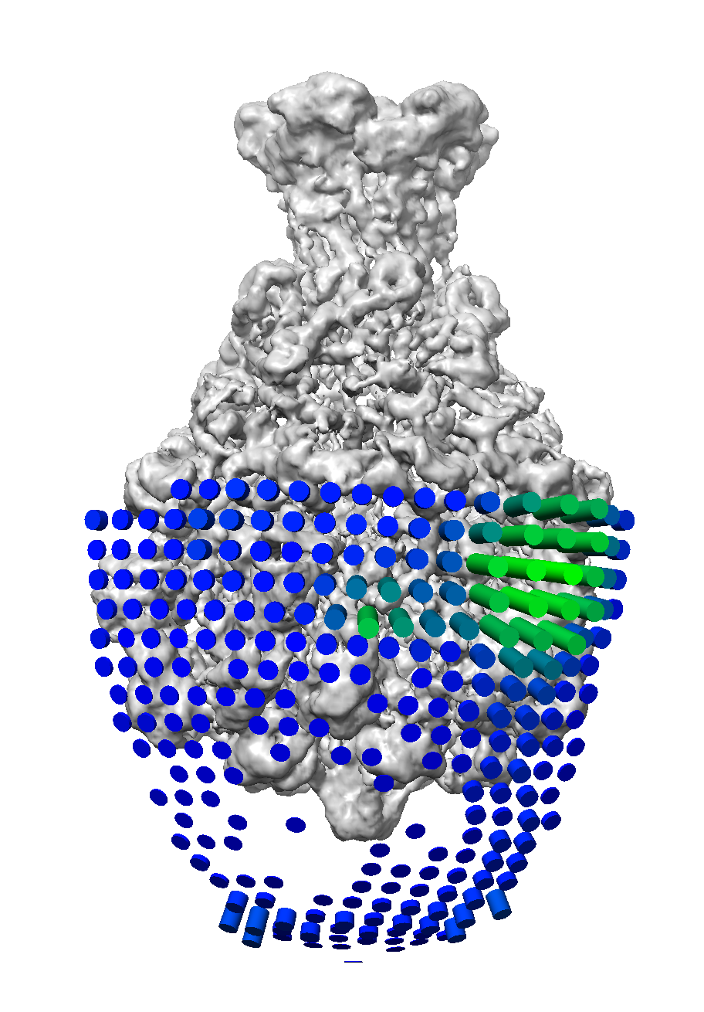

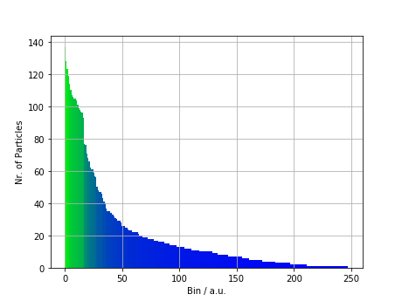

STEP 13. PostRefiner - Sharpening and FSC curve

We will now compute the sharpened reconstruction from the two half-volumes and report the final resolution using PostRefiner. The final map will be masked and filtered to its nominal resolution according to FSC@0.143.
1. Press the MERIDIEN button on the left and then the PostRefiner
button in the middle.

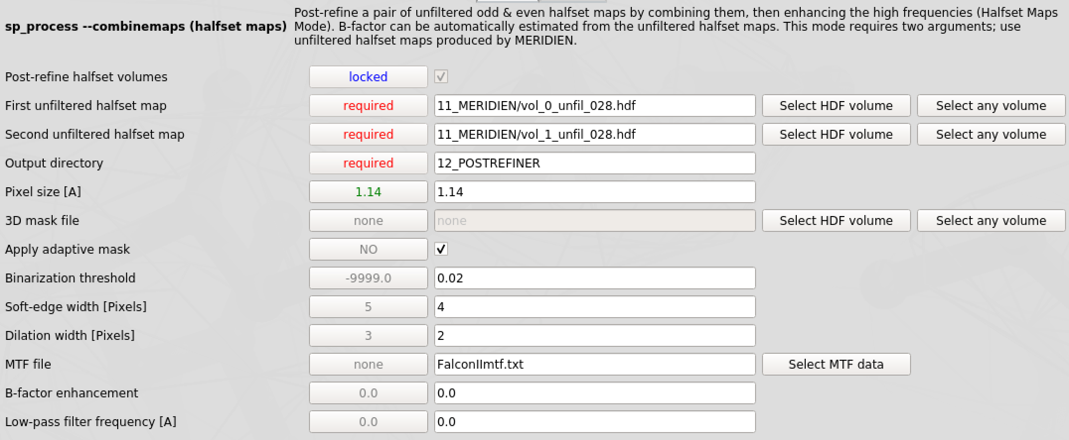
Provide following parameters:
First unfiltered halfset map: 11_MERIDIEN/vol_0_unfil_0*.hdf

Second unfiltered halfset map: 11_MERIDIEN/vol_1_unfil_0*.hdf
Output directory: 12_POSTREFINER

Pixel size [A]: 1.14

Apply adaptive mask: ✓

Binarization threshold: 0.02 (check in Chimera)

Soft-edge width [Pixels]: 4

Dilation width [Pixels]: 2 (each dilation corresponds to a binary extension by ~ 2 pixels)

MTF file: FalconIImtf.txt

B-factor enhancement: 0.0 (automatic)

Low-pass filter frequency [A]: 0.0 (to nominal resolution FSC@0.143)

And press the button.

2. You can monitor the progress by executing the following command in the terminal tail -f 12_POSTREFINER/log.txt.

3. Check the FSC curves 12_POSTREFINER/fsc.png for your final resolution (FSC masked halves) and to see if they look healthy (fall smoothly to 0 and fluctuate around this value) and

4. Open the final volume 12_POSTREFINER/vol_combined.hdf in Chimera and compare it to the x-ray structure PDB: 1VW1 (and the initial model).

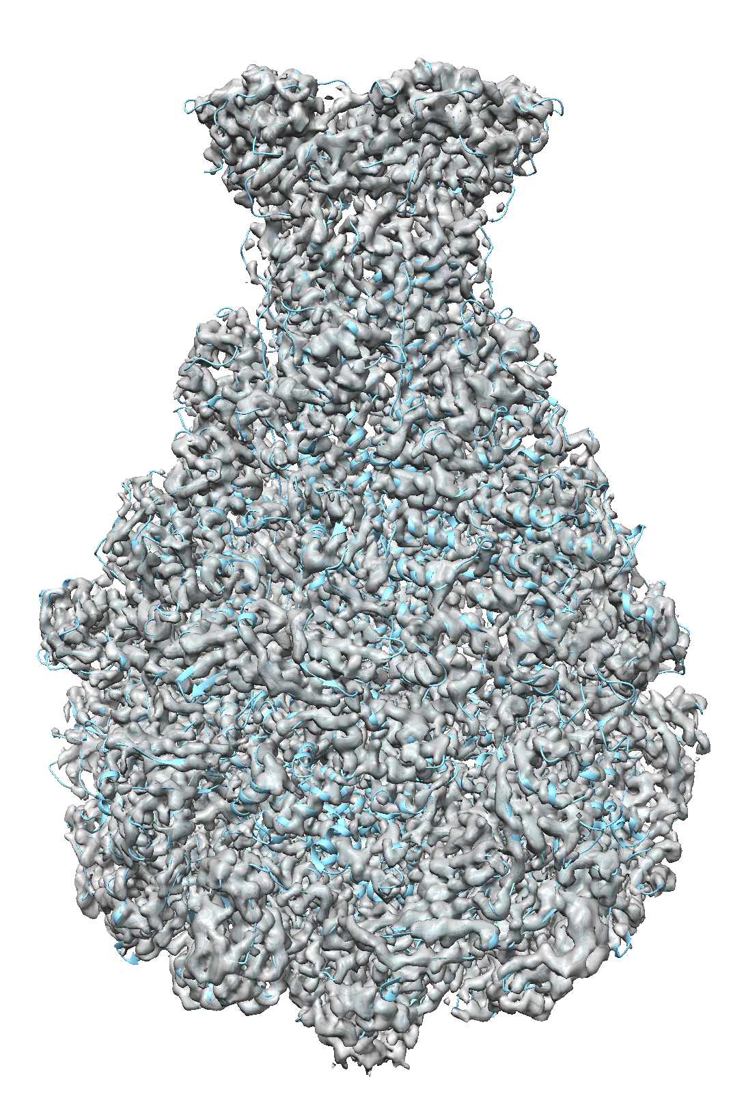
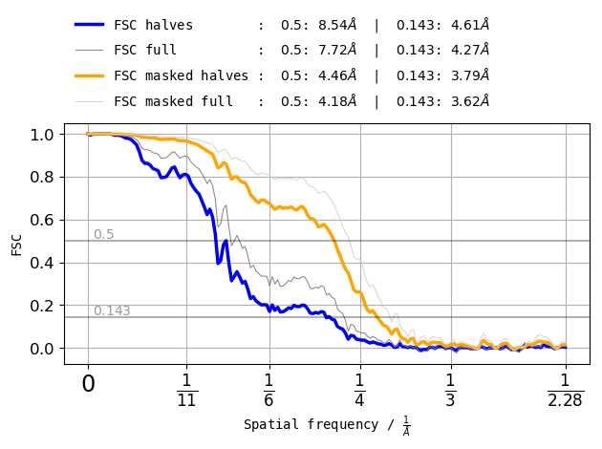
Congratulations! You produced your first near-atomic resolution reconstruction with SPHIRE!

STEP 14. CTF refinement – Per particle defocus

In step 2 we estimated the CTF per micrograph to enable the correction for its effect. Assuming one defocus value for all particles on one micrograph is, however, only an approximation. In reality, particles have different defocus values due to different z-heights in the thin vitrified ice layer. Therefore, we now calculate per particle CTF parameters using CTF refine.
1. Press the MERIDIEN button on the left and then the
CTF refine (Meridien) button in the middle (Utilities).

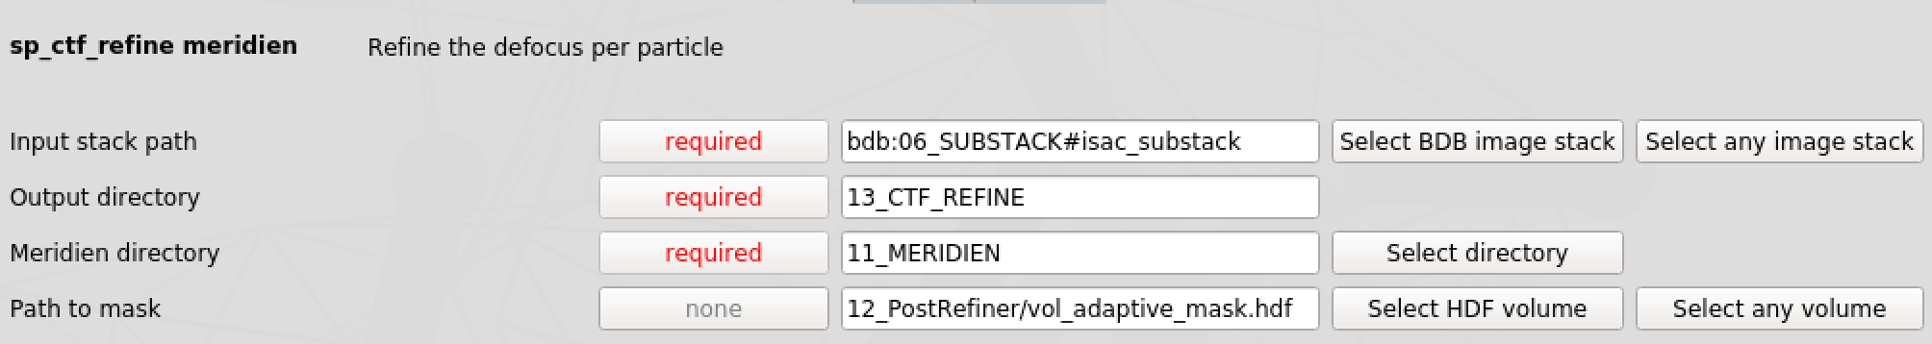
Provide following parameters:
Input stack path: bdb:06_SUBSTACK#isac_substack
Output directory: 13_CTF_REFINE

Meridien directory: 11_MERIDIEN

Path to mask: 12_PostRefiner/vol_adaptive_mask.hdf

And press the button.

2. Monitor the progress of the sp_ctf_refine_meridien job.

3. The output is a folder 13_CTF_REFINE/statistics containing text and image files to assess the performance of the CTF refinement and a virtual stack with per particle defocus values bdb:13_CTF_REFINE/ctf_refined.
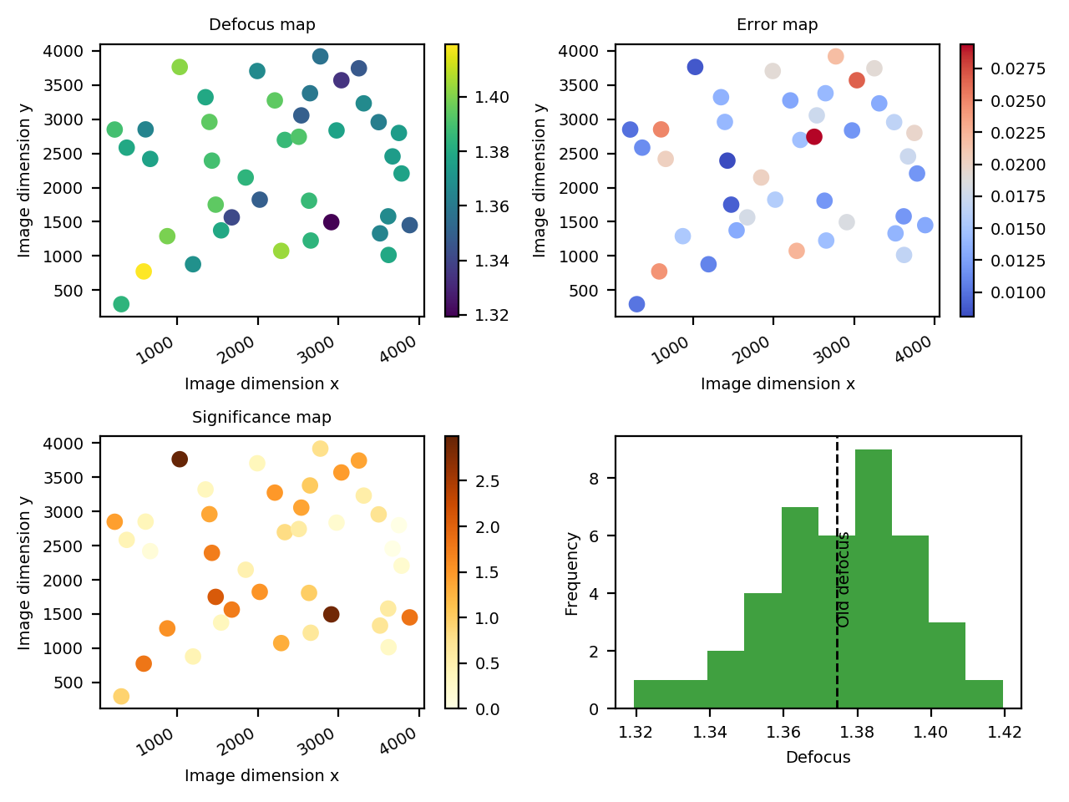

STEP 15. Preparing a mask from the sharpened volume

In the next step we will rerun the 3D refinement using the CTF refined stack (step 14) as input and our sharpened map (step 13) as initial reference. In step 11 we already created a 3D mask from our initial RVIPER model. As it is always a good idea to use a mask that matches the initial reference, we will create a new mask using the Masking tool which is based on the sharpened map.

1. Press the MERIDIEN button on the left and then the
Masking button in the middle (Utilities).

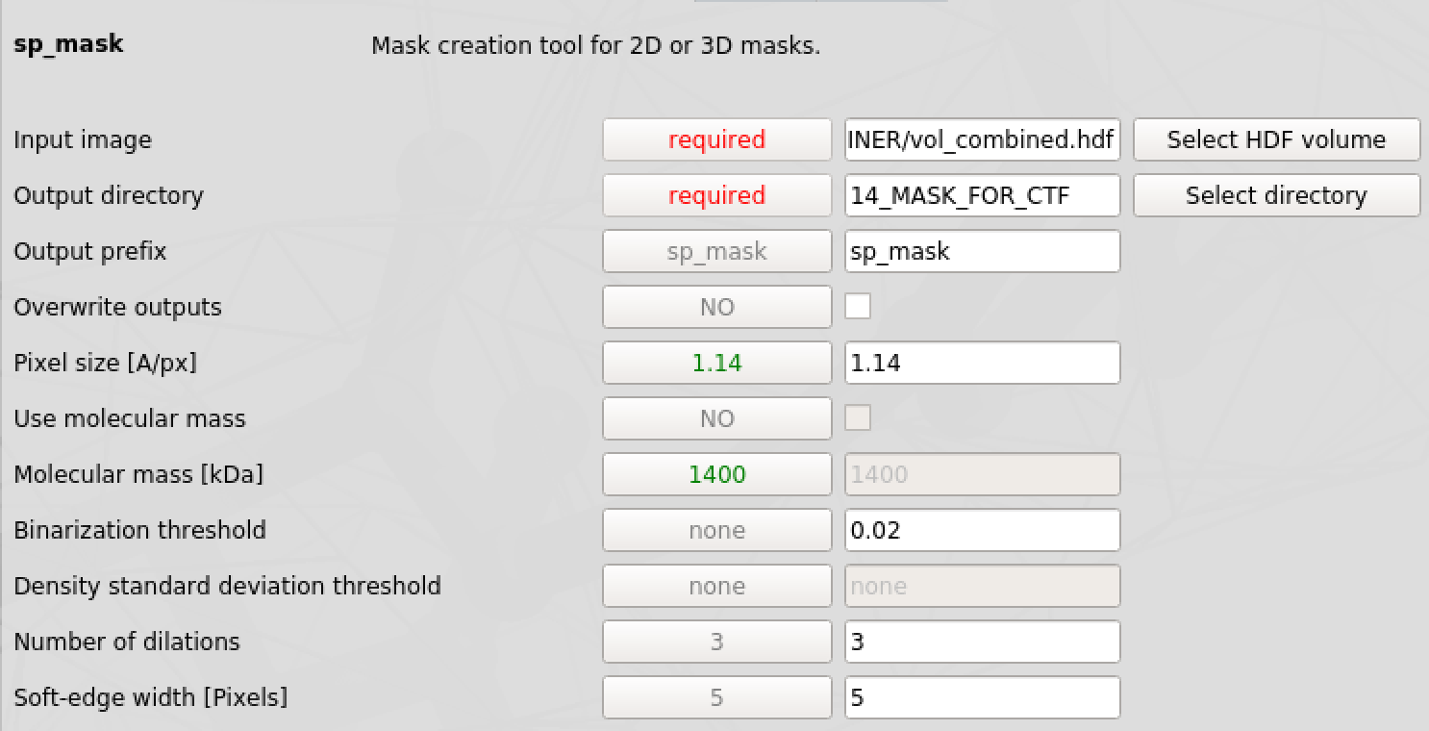
Provide following parameters:

Input image: 12_POSTREFINER/vol_combined.hdf
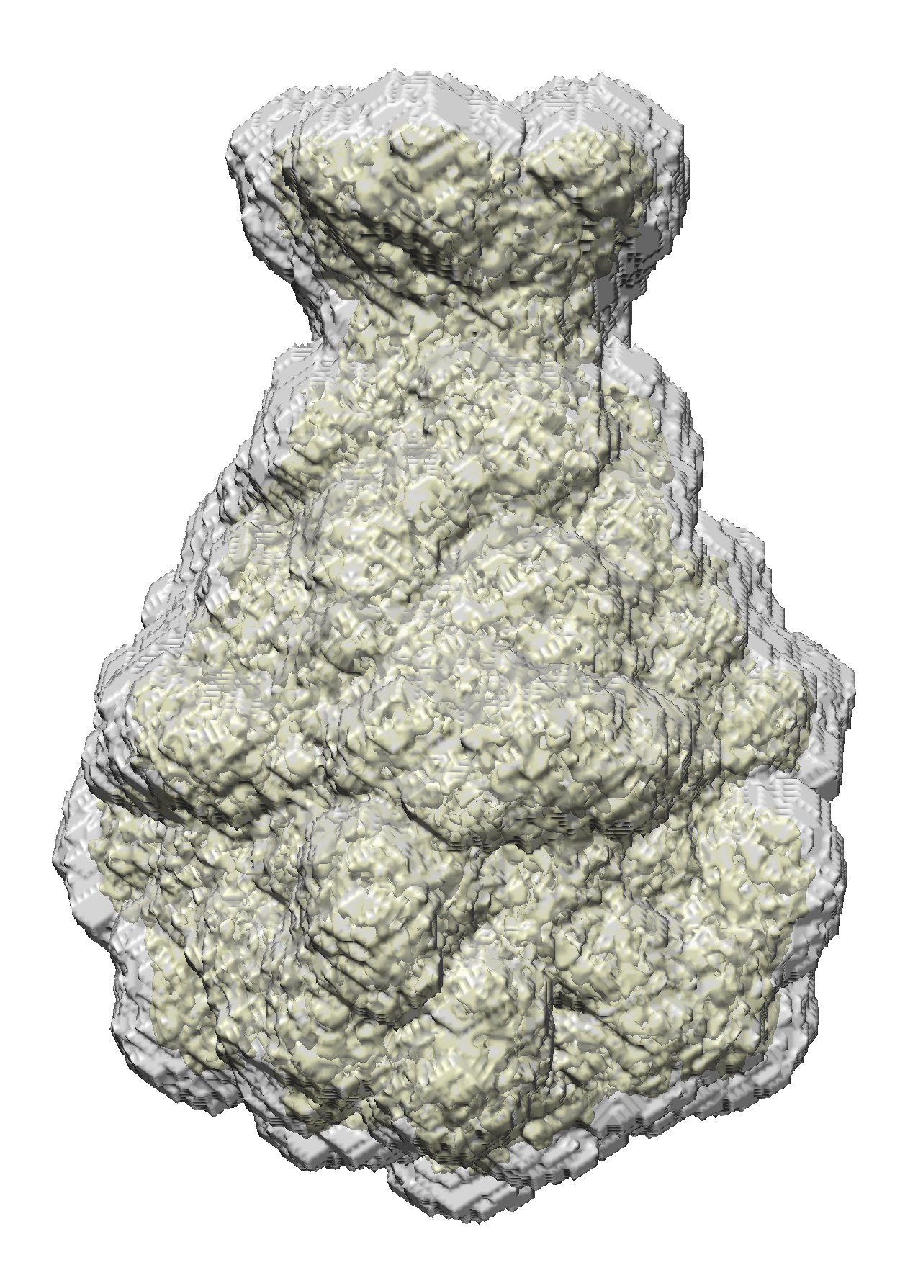
Output directory: 14_MASK_FOR_CTF

Output prefix: sp_mask

Pixel size [A]: 1.14

Binarization threshold: 0.02 (check in Chimera)

Number of dilations: 3

Soft-edge width [Pixels]: 5

And press the button

2. Display the resulting 3D mask 14_MASK_FOR_CTF/sp_mask_mask.hdf and the sharpened map 12_POSTREFINER/vol_combined.hdf with Chimera.
The mask should enclose the complete volume even at low thresholds.

STEP 16. High Resolution 3D refinement of CTF refined particles

In this step we rerun Meridien – 3D Refinement on the CTF refined particle stack using the sharpened map as a reference and the corresponding mask.
1. Press the MERIDIEN button on the left and then the 3D Refinement
button in the middle.

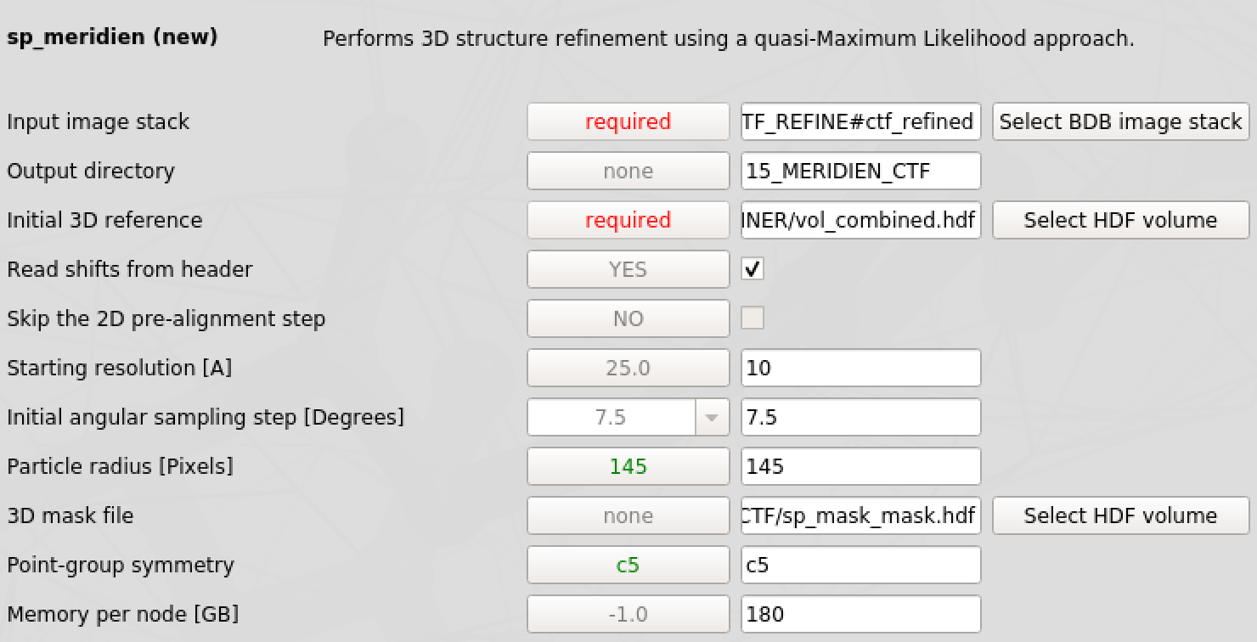
Provide following parameters:

Input image stack: bdb:13_CTF_REFINE#ctf_refined
Output directory: 15_MERIDIEN_CTF

Initial 3D reference: 12_POSTREFINER/vol_combined.hdf

Read shifts from header: ✓

Starting resolution [A]: 10.0

Initial angular sampling [˚]: 7.5

Particles radius [Pixels]: 145

3D mask file: 14_MASK_FOR_CTF/sp_mask_mask.hdf

Point-group symmetry: c5

Memory per node [GB]: Needs to be adjusted to available hardware

And press the button

2. Monitor the progress of the sp_meridien_new job and analyze and display results as described in step 12.

STEP 16. Final PostRefiner

We will now compute the final sharpened reconstruction using PostRefiner (see step 13 for details)
1. Press the MERIDIEN button on the left and then the PostRefiner
button in the middle.

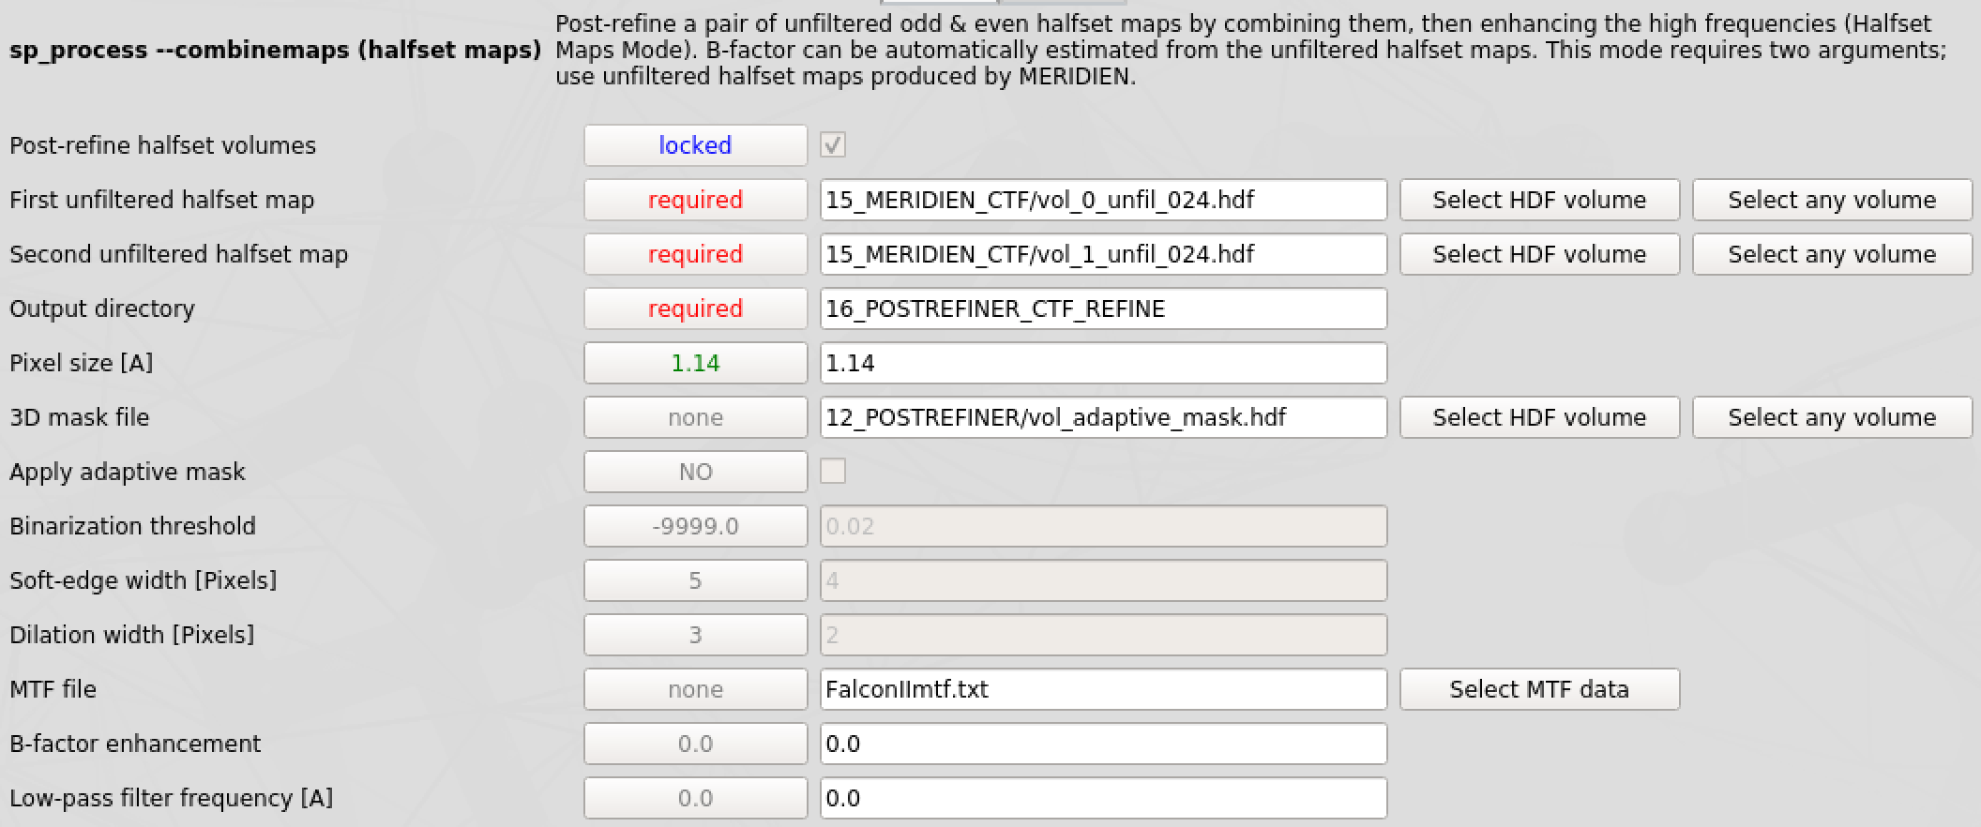
Provide following parameters:
First unfiltered halfset map: 15_MERIDIEN_CTF/vol_0_unfil_0*.hdf

Second unfiltered halfset map: 15_MERIDIEN_CTF/vol_1_unfil_0*.hdf
Output directory: 16_POSTREFINER_CTF_REFINE

Pixel size [A]: 1.14

3D mask file: 12_POSTREFINER/vol_adaptive_mask.hdf

MTF file: FalconIImtf.txt

B-factor enhancement: 0.0 (automatic)

Low-pass filter frequency [A]: 0.0 (to nominal resolution FSC@0.143)

And press the button.
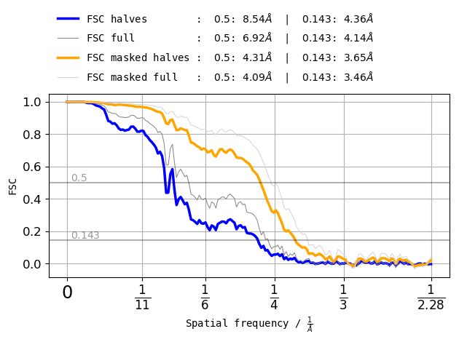
Resolution improved by 0.14 Å

STEP 17. Local Resolution and Local Filter (optional)

Within PostRefiner we filter our sharpened map to the nominal resolution based on the FSC@0.143 criterion. The resolution is however not uniform across the protein but varies. Thus, we will now calculate the Local Resolution and filter our map accordingly using 3D Local Filter.

1. Press the LOCALRES button on the left and then the
Local Resolution button in the middle.

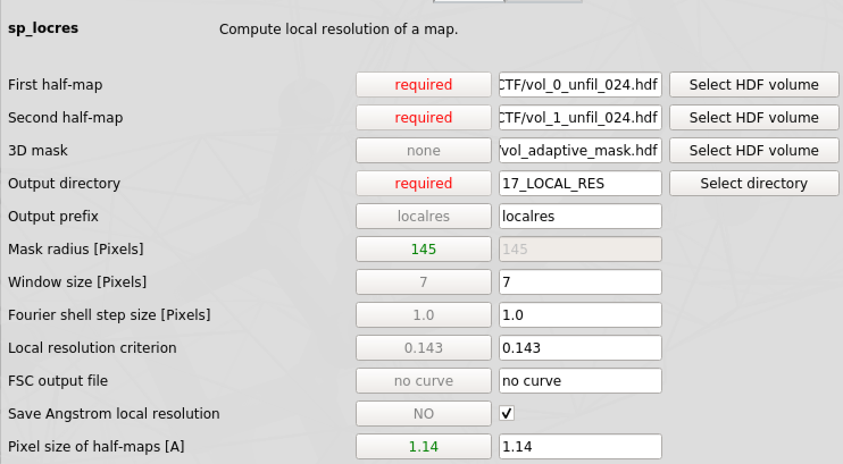
Provide following parameters:
First half-map: 15_MERIDIEN_CTF/vol_0_unfil_0*.hdf

Second half-map: 15_MERIDIEN_CTF/vol_1_unfil_0*.hdf

3D mask: 12_POSTREFINER/vol_adaptive_mask.hdf
Output directory: 17_LOCAL_RES

Output prefix: localres

Window size [Pixels]: 7

Fourier shell step size [Pixels]: 1.0

Local resolution criterion: 0.143

FSC output file: no curve

Save Angstrom local resolution: ✓

Pixel size of half-maps [A]: 1.14

And press the button.

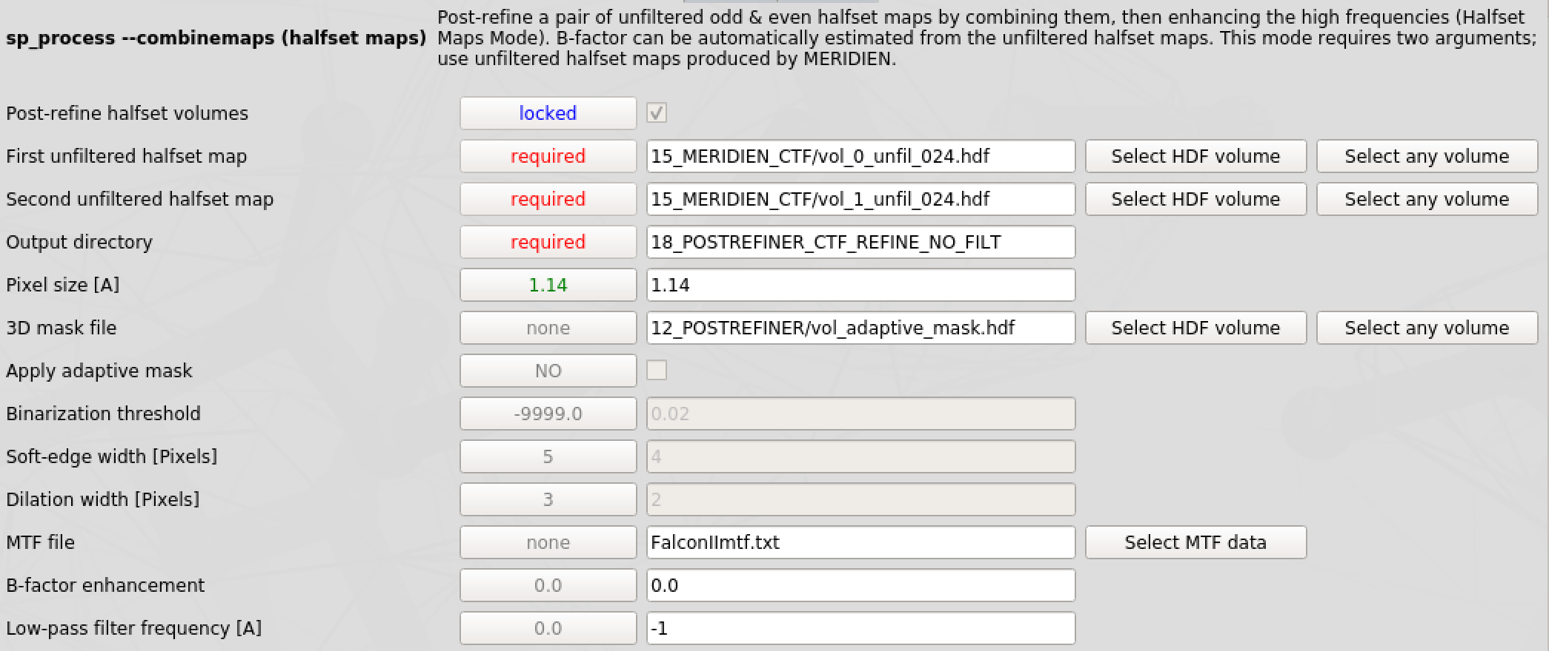
2. To filter the final map to local resolution using 3D Local Filter, we need to combine and sharpen half maps without filtering them. Therefore, rerun PostRefiner as described in step 16 but change parameters as indicated below.

Output directory: 18_POSTREFINER_CTF_REFINE_NO_FILT

Low-pass filter frequency [A]: -1 (no low pass filter applied)
3. Press the LOCALRES button on the left and then the
3D Local Filter button in the middle.

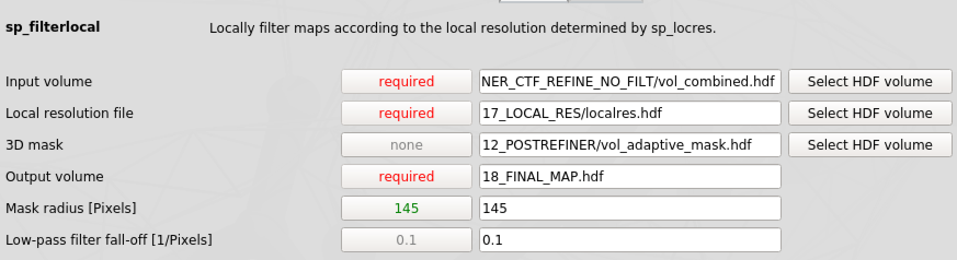
Provide following parameters:
Input volume: 18_POSTREFINER_CTF_REFINE_NO_FILT /vol_combined hdf

Local resolution file: 17_LOCAL_RES /localres.hdf

3D mask: 12_POSTREFINER/vol_adaptive_mask.hdf
Output volume: 17_LOCAL_RES /19_localfilt.hdf

Mask radius [Pixels]: 145

Low-pass filter fall-off [1/Pixels]: 0.1

And press the button.

4. Open the locally filtered map 17_LOCAL_RES/19_localfilt.hdf and the local resolution file 17_LOCAL_RES/localres_ang.hdf in Chimera. Finally, color the final map by its local resolution by clicking Tools ➜ Volume Data ➜ Surface Color
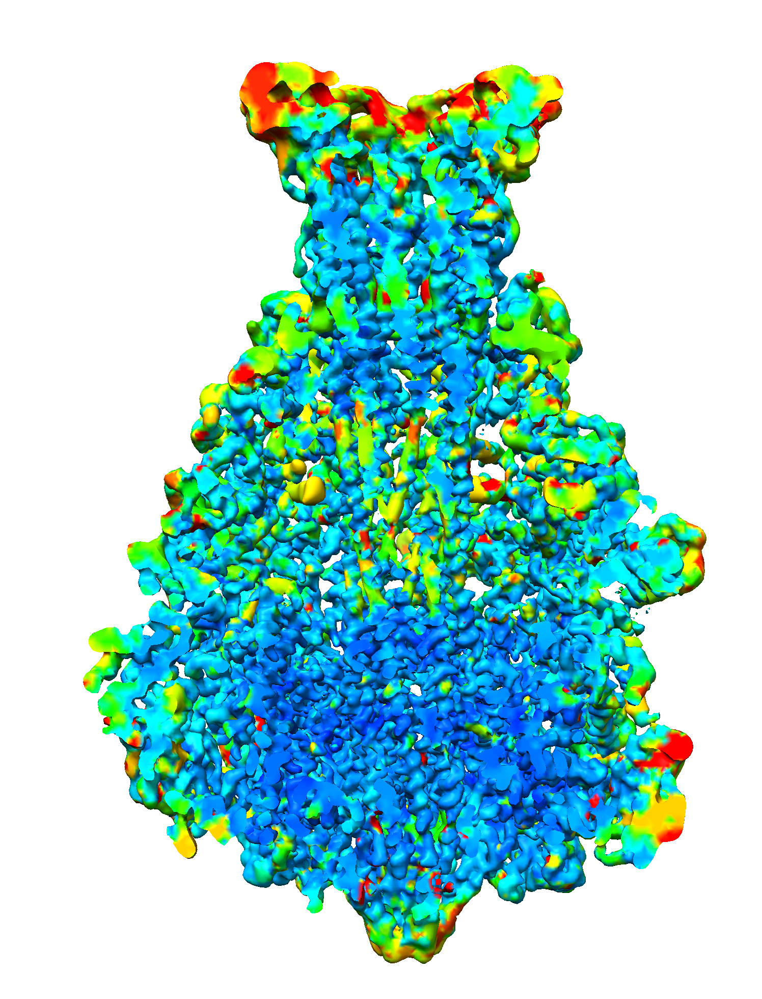
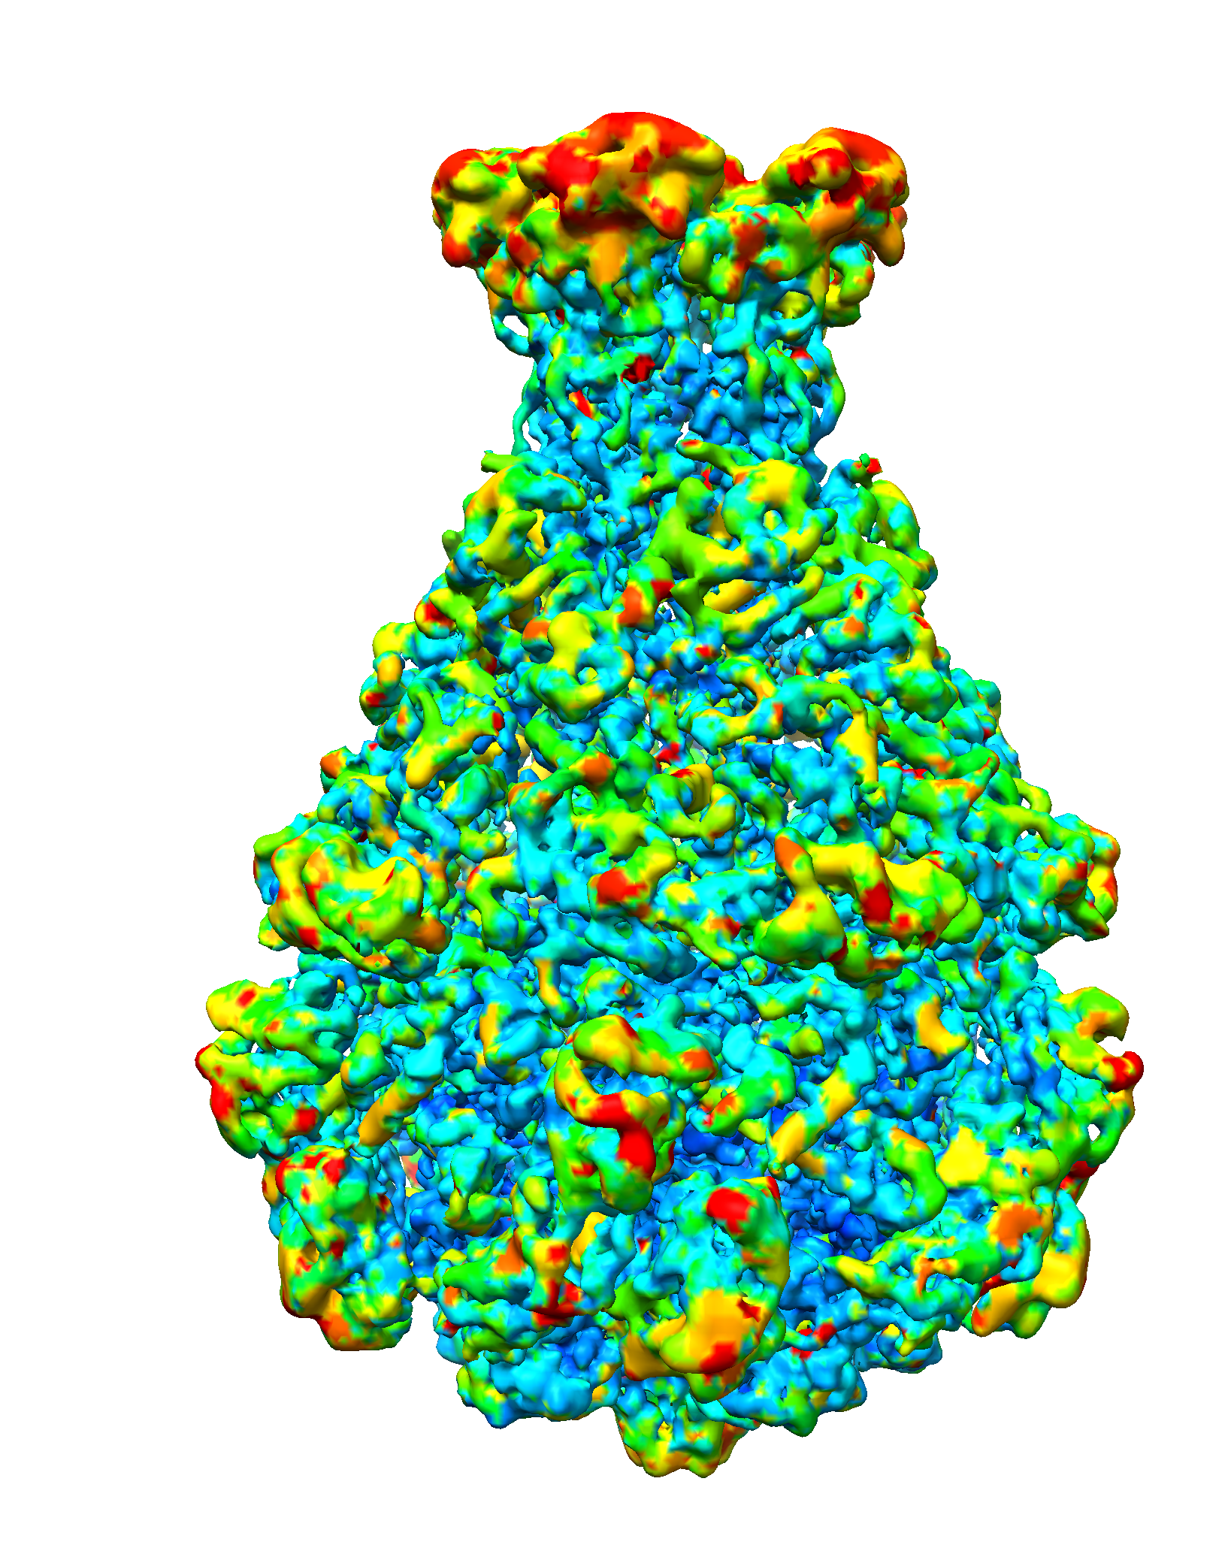
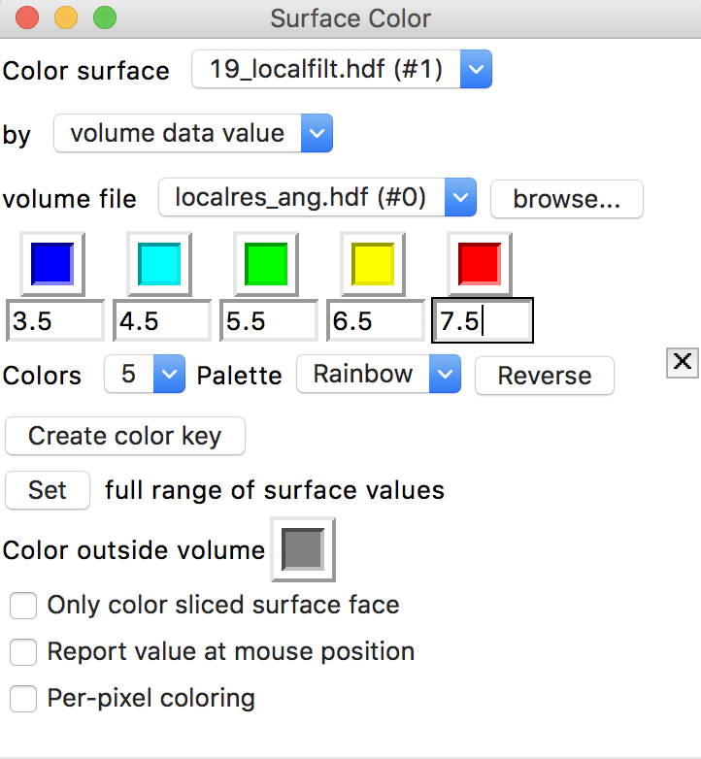
Congratulations!
You successfully finished the SPHIRE short tutorial.

If you are interested in our other features and more advanced tips please download our full-length tutorial at: http://www.sphire.mpg.de

