Voluntary & Velocity Themes
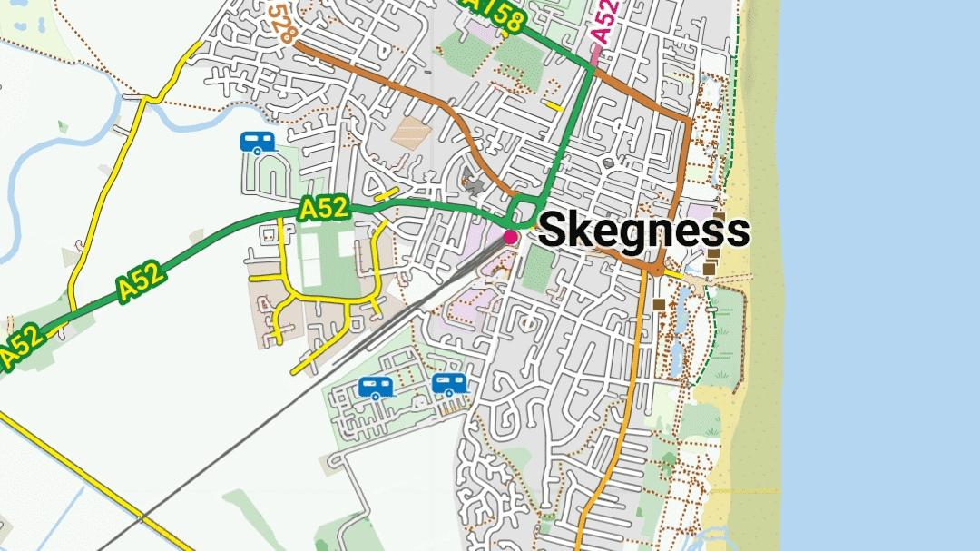
Voluntary: for LoMaps and OpenAndroMaps Mapsforge maps
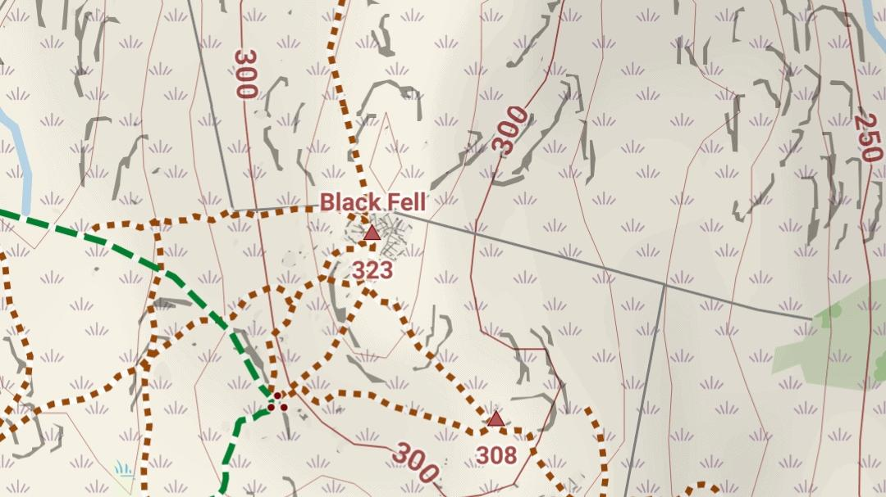
Voluntary: showing crag features from UK Ordnance Survey on OAM maps
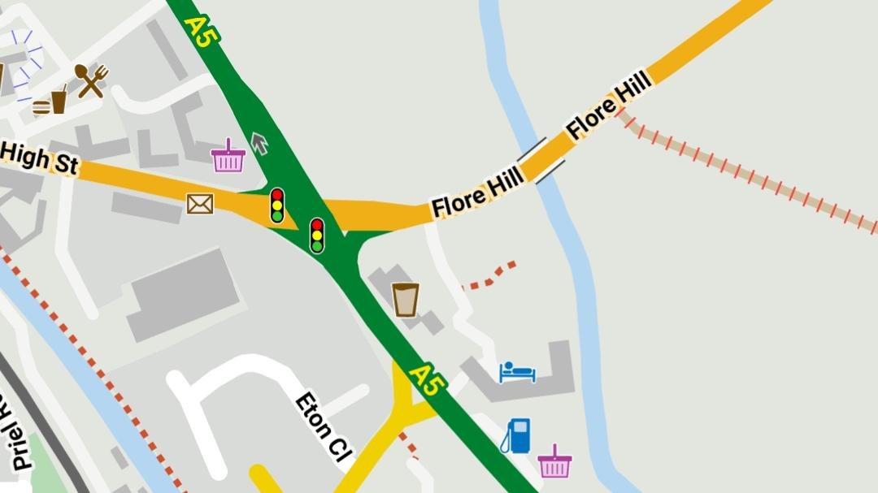
Velocity: simplified rapid draw theme
The Voluntary themes work well with both LoMaps from Locus Store and maps from OpenAndroMaps. They are designed for clarity of display. Colours are based on UK Ordnance Survey conventions and will be fairly familiar to British users. Even if you are not British, the colours and styles will probably work well for you. The themes automatically scale for devices with displays of different resolutions and symbols enlarge smoothly for higher zoom levels. The zoom levels at which various features appear has been adjusted to provide optimal information and reduce unwanted clutter.
You can choose Hiking & Wintersport, Cycling, City, Road, Multi, Transparent or Yellow styles within the Voluntary Locus Edition (LE) or Voluntary Mapsforge V5 themes.
The styles take advantage of switchable options. Display of hiking, cycle and mountain bike routes can now be switched on or off, as can highlighting for each of them. The number of options shown is relatively limited to aid ease of use. Hiking, Cycling, City and Road styles function almost as presets with a limited range of tailored options. Within these particular styles the display is subtly tailored to its purpose: for example, Road displays junction and road numbers better; Cycling has a better display of cycle routes. Multi, Transparent and Yellow have a fuller (but manageable) range of options. The settings of the options for each style are stored.
The City style is aimed at use in large cities such as London and has a less cluttered (and slightly faster) display at zoom levels 14 and below. Colours in the Yellow theme are more muted and are aimed at use with overlays in your app.
A "Transparent" style turns off the map background and enables use of a vector map as an overlay on top of a satellite image in your app. Similarly the "background" checkbox in the Yellow style can be used to achieve the same effect.
Generally, blue dashes are cycle ways, green dashes represent dual use both on bike and on foot (bridle paths in the UK), and brown shorter dashes use on foot only. Blue blobs are cycle routes, green blobs are hiking routes. Mountain bike trails are shown by violet blobs. Cycle routes are also indicated by blue dashes on the roads. Hiking, cycle and mountain bike routes can be emphasised by selectable overlays. The emphasis can be colour-coded in the Hike and Cycle themes.
Footpaths, bridleways and cycleways are indicated on the map by dashed lines where they follow the path of a mapped track or pedestrian way if the map supports it (currently OpenAndroMaps). Also on maps from OpenAndroMaps, blue dashes on roads are either cycle routes or roads with cycle tracks alongside, while shorter blue dashes on roads show cycle lanes in the road.
The Voluntary LE theme is offered in Locus if an older LoMap has been selected (or an older Mapsforge v3 map). The Voluntary V5 LE is optimised for both the latest LoMaps and OAM maps on the Locus app. Voluntary V5 is optimised OAM maps only, for use with other apps. All Voluntary themes are as similar as possible.
Also included is the visually-similar Velocity theme for a simpler display with much faster drawing.

a) Motorway  b) Primary Road  c) A-class Road  NB: Road numbers are displayed differently in older LoMaps | 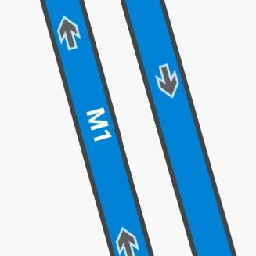 | 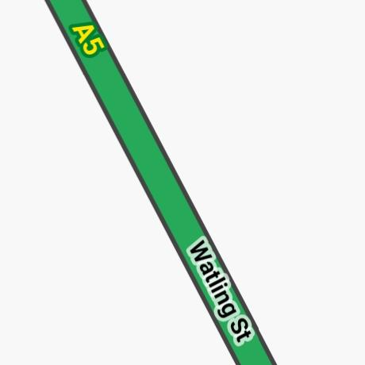 | 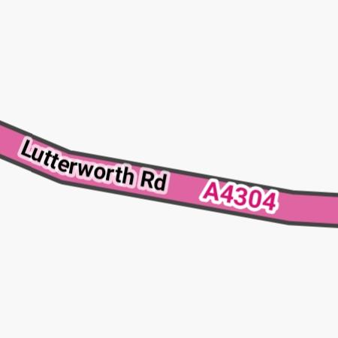
a) B-class Road  b) Tertiary  c) Unclassified | 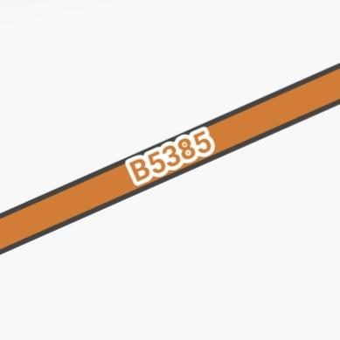 |  | 
a) Residential  b) Track (surfaced) with path  c) Bridleway on unsurfaced track |  | 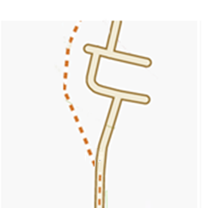 | 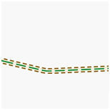
a) Track (grade 1, solid)  b) Track (grade 2, mostly solid), with bridleway  c) Track (grade 3, hard/soft mix) |  | 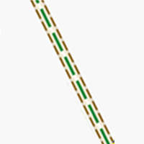 | 
a) Track (grade 4, mostly soft)  b) Track (grade 5, soft)  c) Track, grade unknown |  |  | 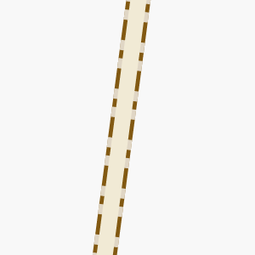
a) Unclassified road, compacted surface  b) Service road, loose gravel  c) Road under construction  Road surfaces (paved, rough paved, compacted, loose gravel, raw) broadly match track grades | 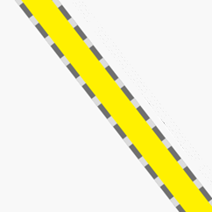 | 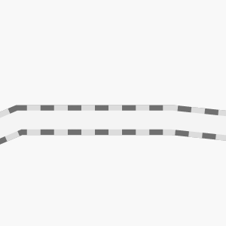 | 

a) Mini roundabout  b) Passing place  c) Turning circle | 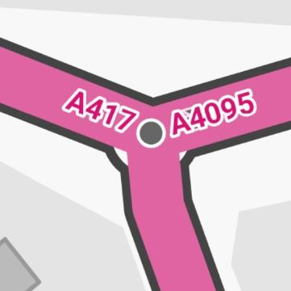 | 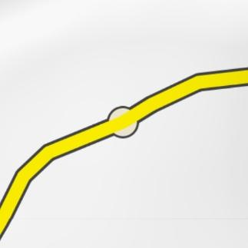 | 

a) Cycleway and residential roads  b) Bridleway (bike and foot)  c) Path (foot)  - (top) normal  - (bottom) greater difficulty or lower visibility, SAC scale “demanding mountain hiking” (T3) and above. | 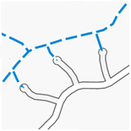 | 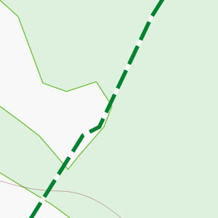 | 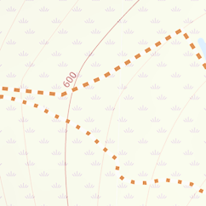
Cyclable surfaces:  a) Paved – long dashes  b) Compacted – medium dashes  c) Gravel – short dashes |  |  | 
a) Cycle track alongside road (long dashes) †  b) Cycle lane within normal road†  c) Cycle access allowed on pedestrian area (short blue dashes)  †Cycle tracks and lanes on roads etc shown only on maps from OAM. |  | 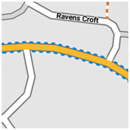 | 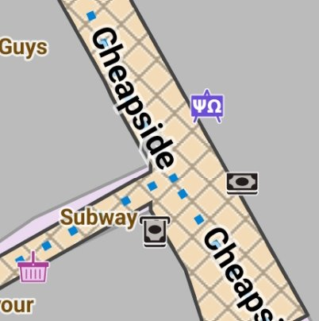
a) Ferry route  b) Cycle (super)highway (OAM)  c) Emphasised cycleway, usually dedicated | 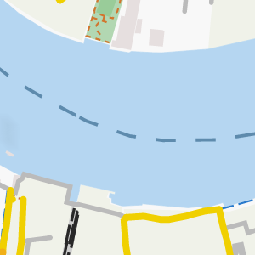 | 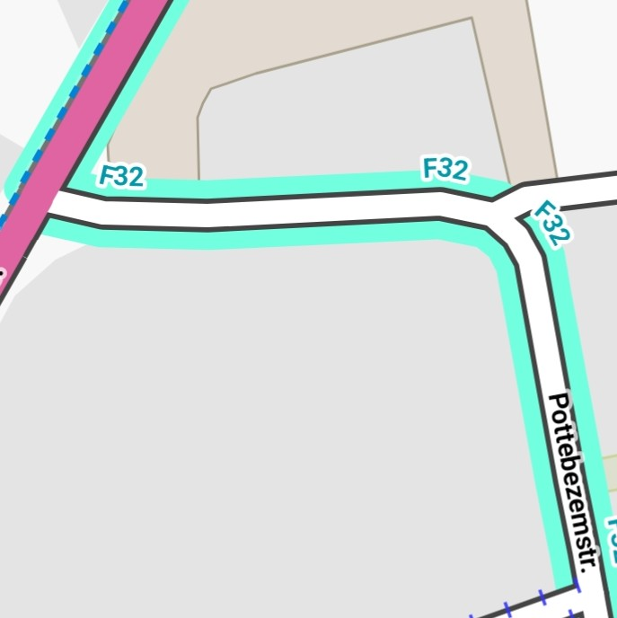 | 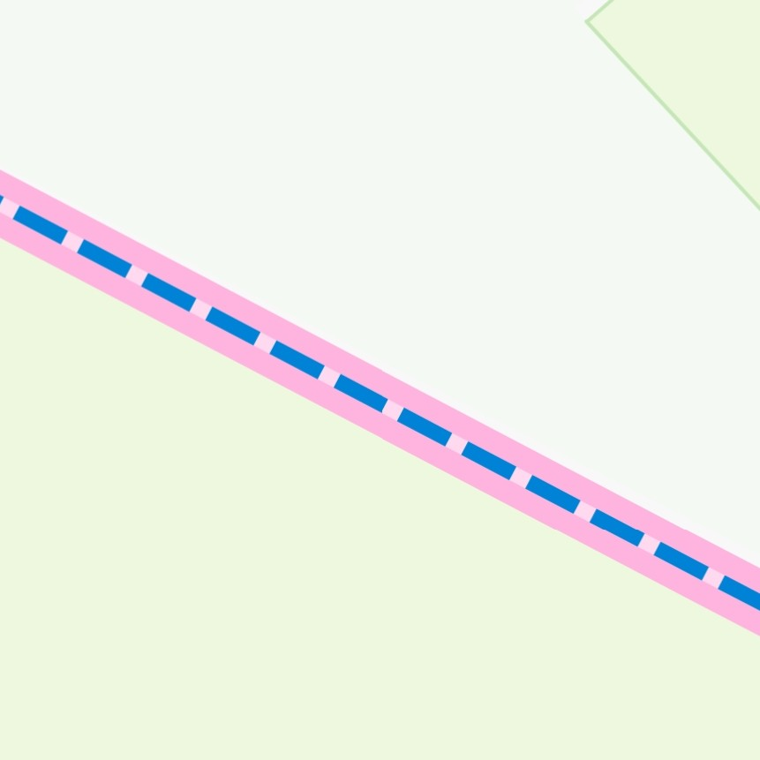
a) Hiking trail on road (intermittent dashes & blobs)  b) Cycle route on road  (red IDs for national & international routes, blue for regional, local & node)  Inset: cycle route node  c) Mountain bike trail on track with access on foot and by bike | 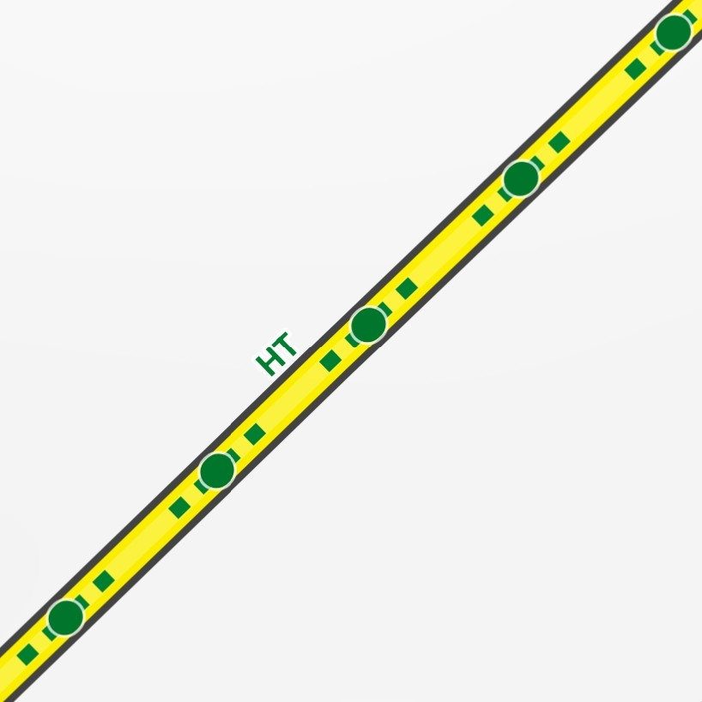 | 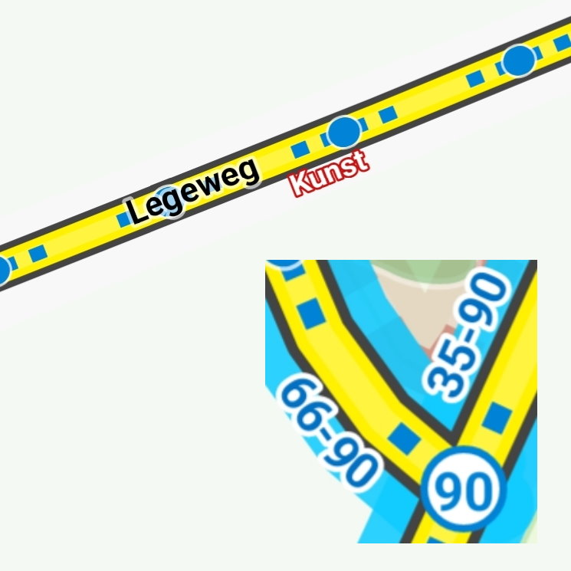 | 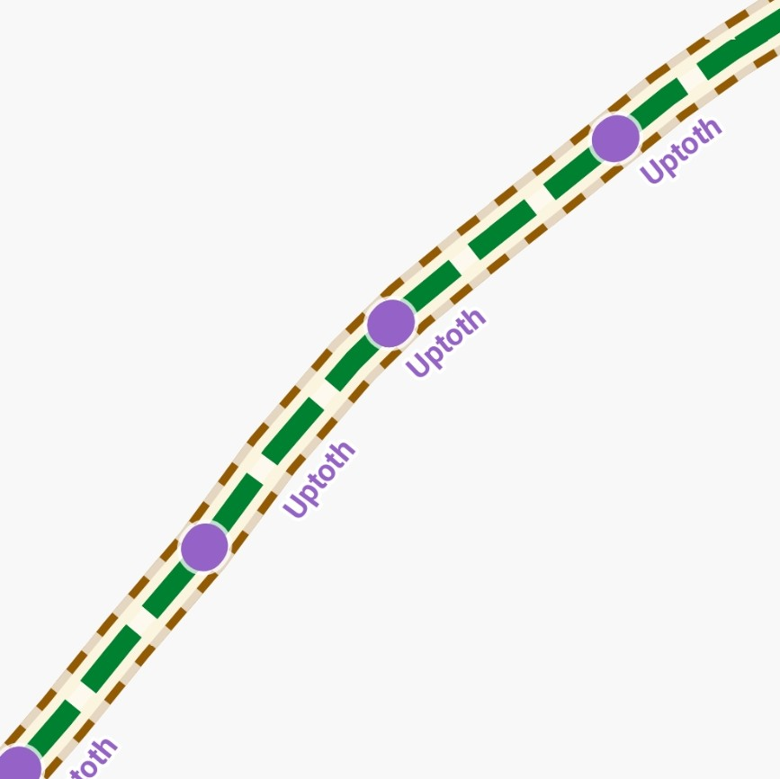
a) Emphasised hiking trail on path  b) Emphasised cycle route along road  c) Both emphasised cycle and mountain bike routes on road | 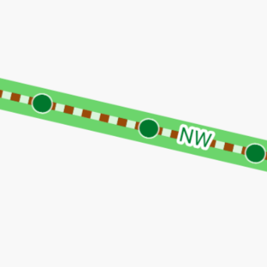 | 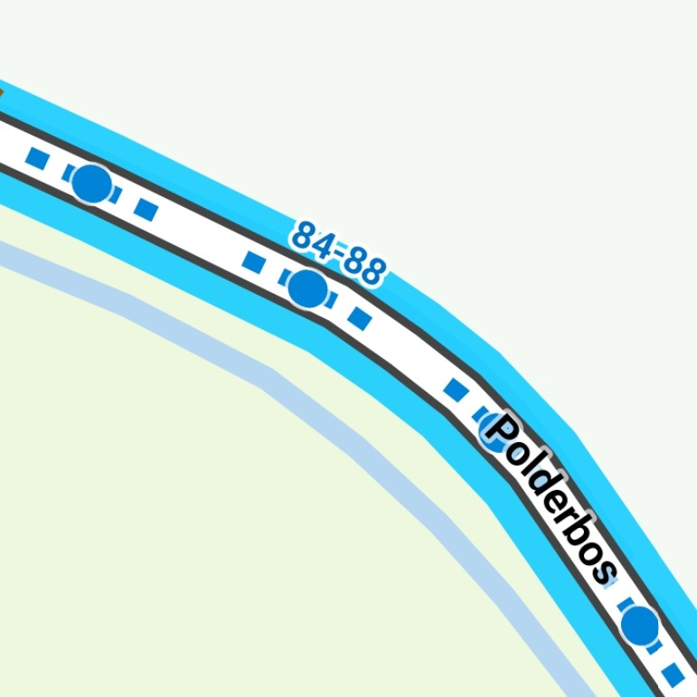 | 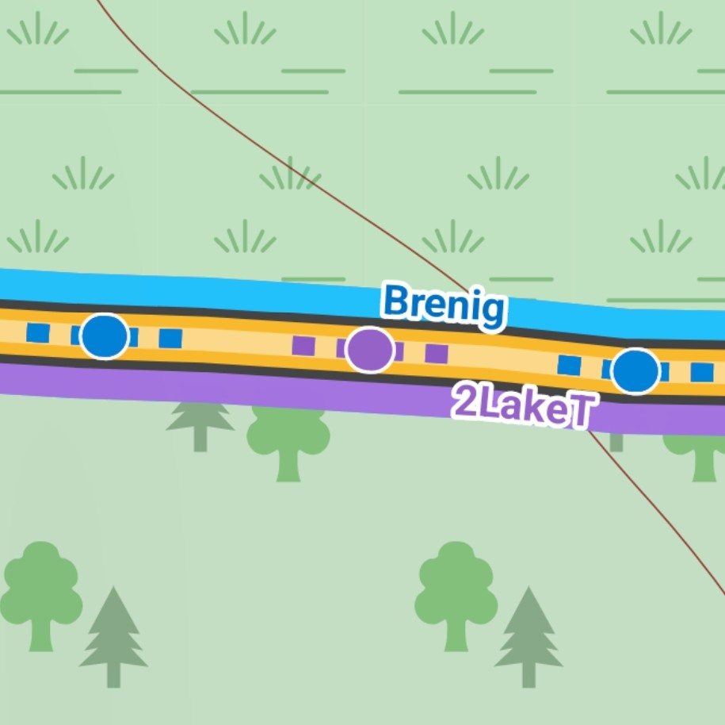
Key to route highlighting  1. Emphasised routes  Plus Cycle highway (OAM)  2. Colour-coded emphasis  i. International  ii. national  iii. regional  iv. local or node network (NL) | Hiking   | Cycle   | Mountain bike  
OSMC waymarked trails  a) Symbols and colour markers  b) OAM maps – text symbol and coloured markers  c) LoMaps – symbolic text marker (grey bar) and coloured markers for multiple trails | 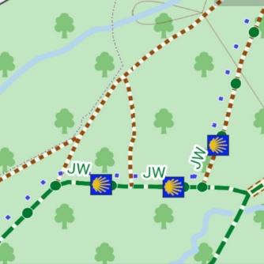 | 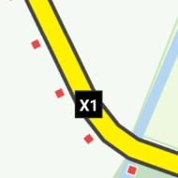 | 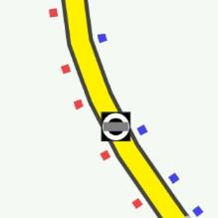
a) Roads – Velocity  b) Residential roads – Velocity  c) Track – Velocity | 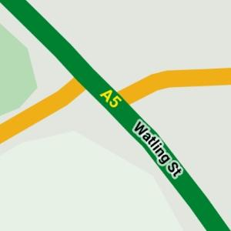 | 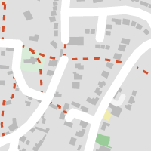 | 
a) Lock & footbridge  b) Lock & footbridge – Velocity  c) Canal, towpath, road bridge | 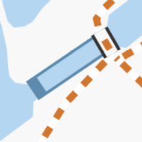 | 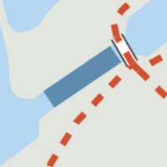 | 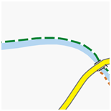
a) Access only (blue ticks)  b) Private access (red ticks)  c) Private path (red ticks) | 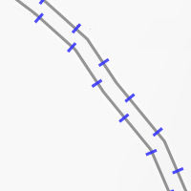 | 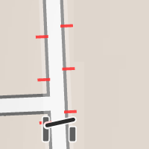 | 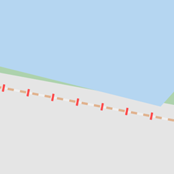
a) Access only – Velocity  b) Private - Velocity  c) Private path - Velocity | 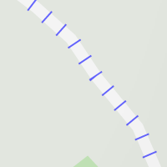 | 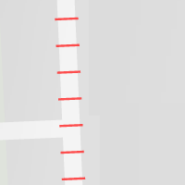 | 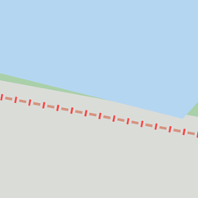
a) Car parking  b) Covered parking  c) Greenhouse | 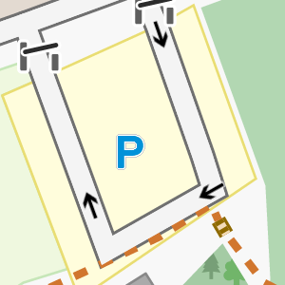 | 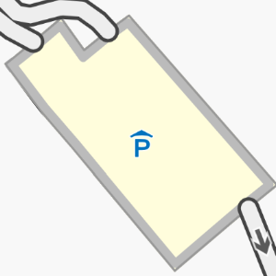 | 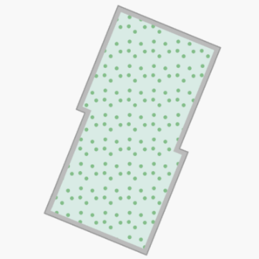
a) Private parking  b) Customer parking  c) Private garden or private green space | 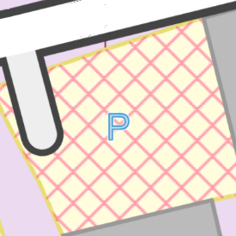 | 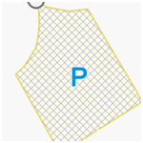 | 
a) Private parking -- Velocity  b) Customer parking – Velocity |  | 
a) Steps  b) Pipeline (above ground)  c) Wall | 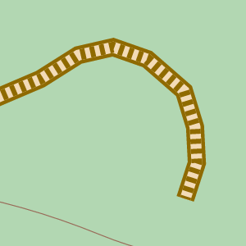 | 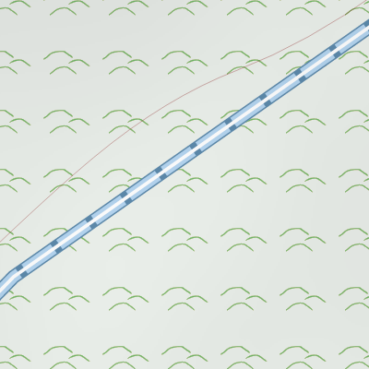 | 
a) Fence  b) Hedge  c) Line of trees |  |  | 
a) Ditch (barrier)  b) Cutting  c) Gully (natural) |  | 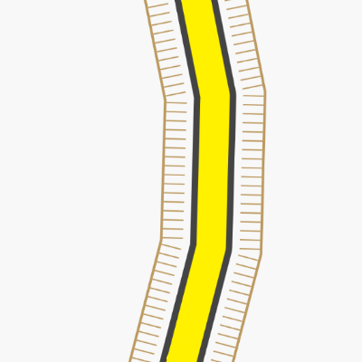 | 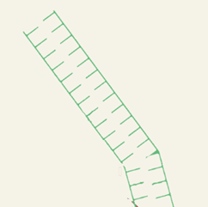
a) Embankment  b) Dyke, walls  c) Earth bank | 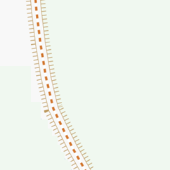 | 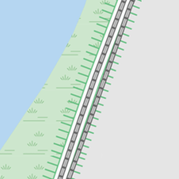 | 
a) Cliff  b) Cliff, rock outcrops etc. (UK OAM maps)  c) Groyne | 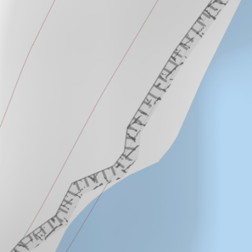 | 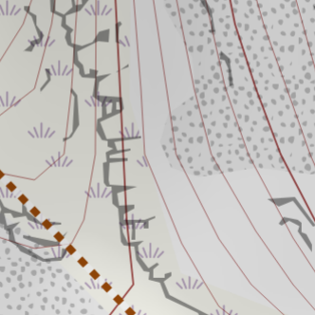 | 
a) Cliff, sand, rocks  b) Cliff area, sand, rocks, sea  c) Sand, above and below tide line, marsh | 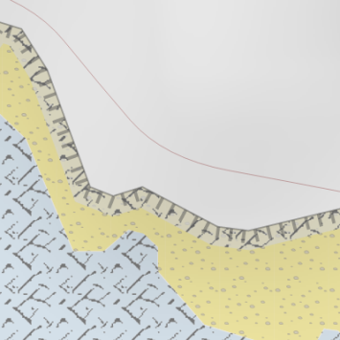 | 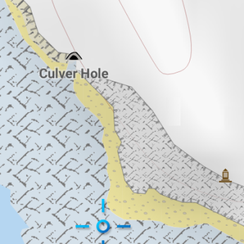 | 
a) Contour lines  b) Power lines, major and minor  c) Aerial cable car | 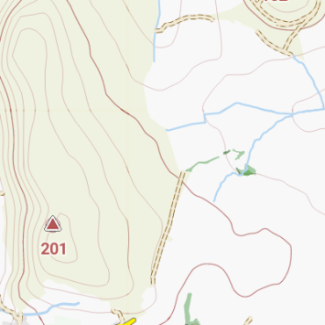 | 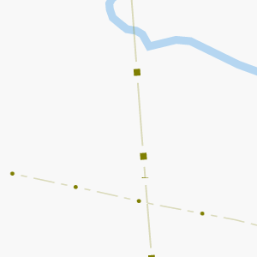 | 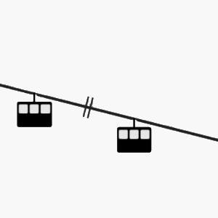
a) Sledding area (difficulty not known)*  b) Sled track (easy)*  c) Nordic skiing route (intermediate)*  *Border colours denote difficulty (see below) | 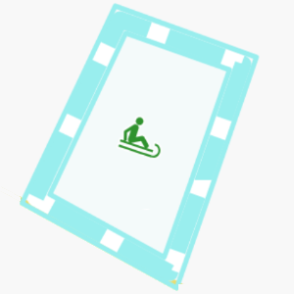 | 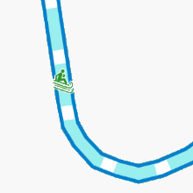 | 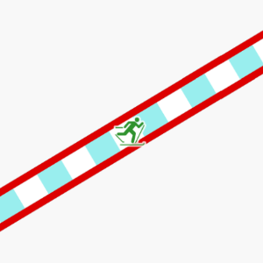
a) Downhill ski piste (easy)  b) Border colours show difficulty:  Novice: green  Easy: blue  Intermediate: red  Advanced: black  Expert: orange  Free ride: yellow  Not known: pale blue  c) Racetrack (inset: low zoom) | 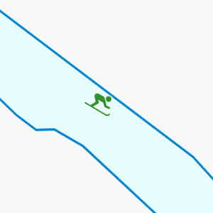 |  | 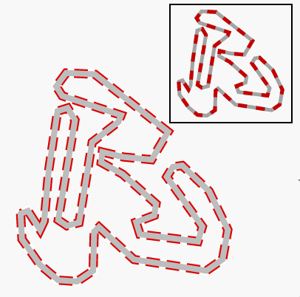
a) Athletics track  b) Toll road – main road  b) Toll road – minor road |  | 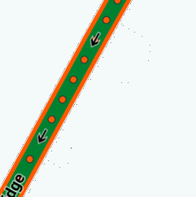 | 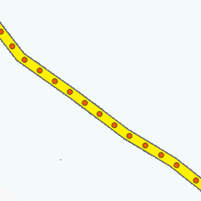
a) Road tunnels  b) Foot tunnel  c) Road tunnel -- Velocity |  |  | 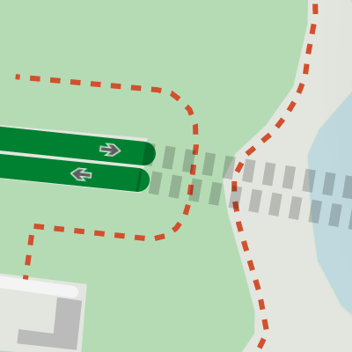
a) Railway  b) Narrow gauge, preserved, or funicular railway  c) Disused railway; abandoned railway |  | 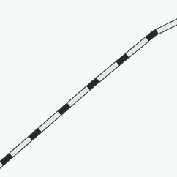 | 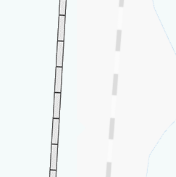
a) Miniature railway  b) Subway, Underground  c) Tram, light rail, bus guideway |  |  | 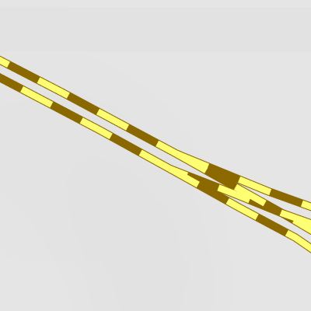
a) Railway tunnel (twin track)  b) Subway (rail) tunnel  c) Light rail tunnel | 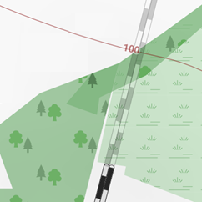 |  | 
a) Narrow gauge railway tunnel  b) Abandoned railway  c) Ferry route | 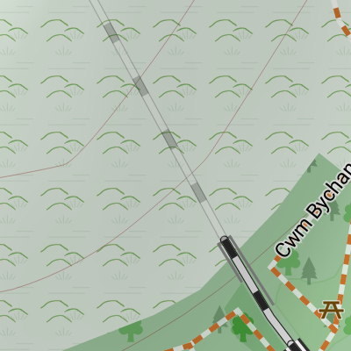 |  | 
a) Military building  b) Historic building  c) Historic area (to right) |  |  | 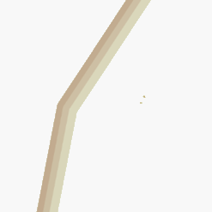
a) Military area  b) Nature reserve (symbol & boundary) or National Park (boundary only). Pink tint indicates likely access restriction, gold tint indicates probable accessibility  c) Tourist attraction (symbol & boundary) | 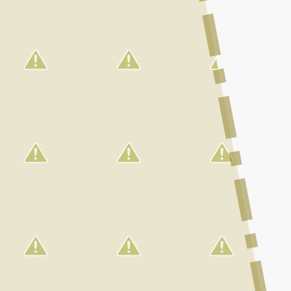 | 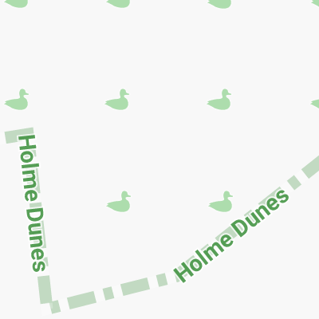 | 
a) International border  b) Disputed or de facto border  c) Regional boundary | 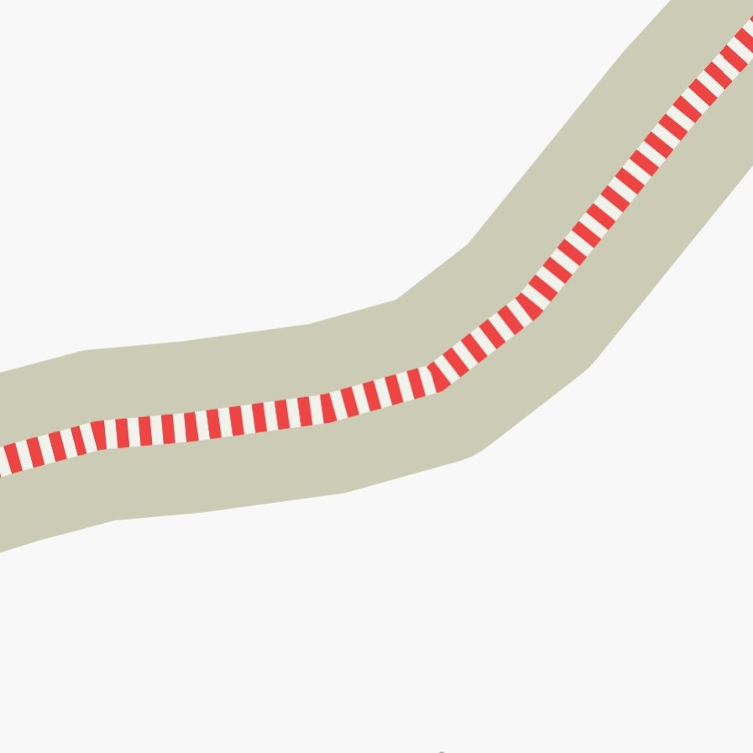 | 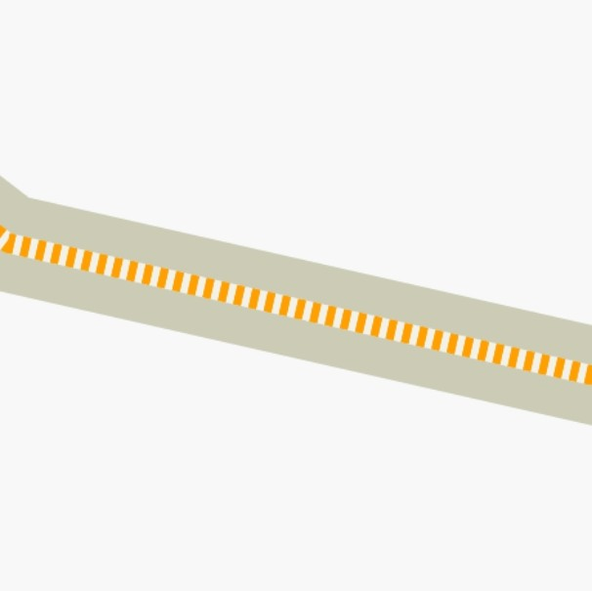 | 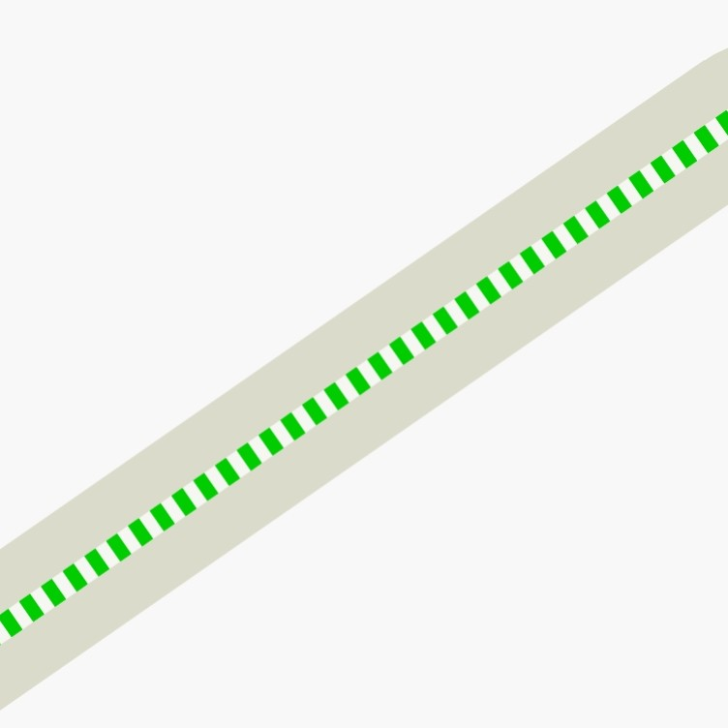
a) Boundary (Velocity)  b) Map border |  | 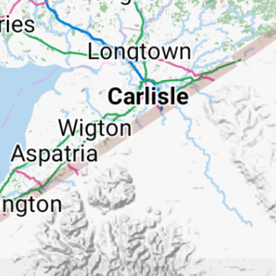

Areas
  aboriginal lands |   allotments |   beach |   beach resort
  construction site |   education |   fell |   glacier
  graveyard |   heath |   industrial |   landfill
  marsh/wetland |   military |   nature reserve |   orchard
  park etc | protected (accessible)* |   protected (restricted)* |   swimming
  quarry |   residential |   retail |   rock
  scree |   tourist attraction |   scrub |   vineyard
  water park |   wood - coniferous |   wood - deciduous |   wood - mixed or unknown

*Intensity of tint varies with zoom, being more intense at low zooms.

Accommodation, Transport and Water
  Airport gate |   Airport |   Mountain hut  (various) | 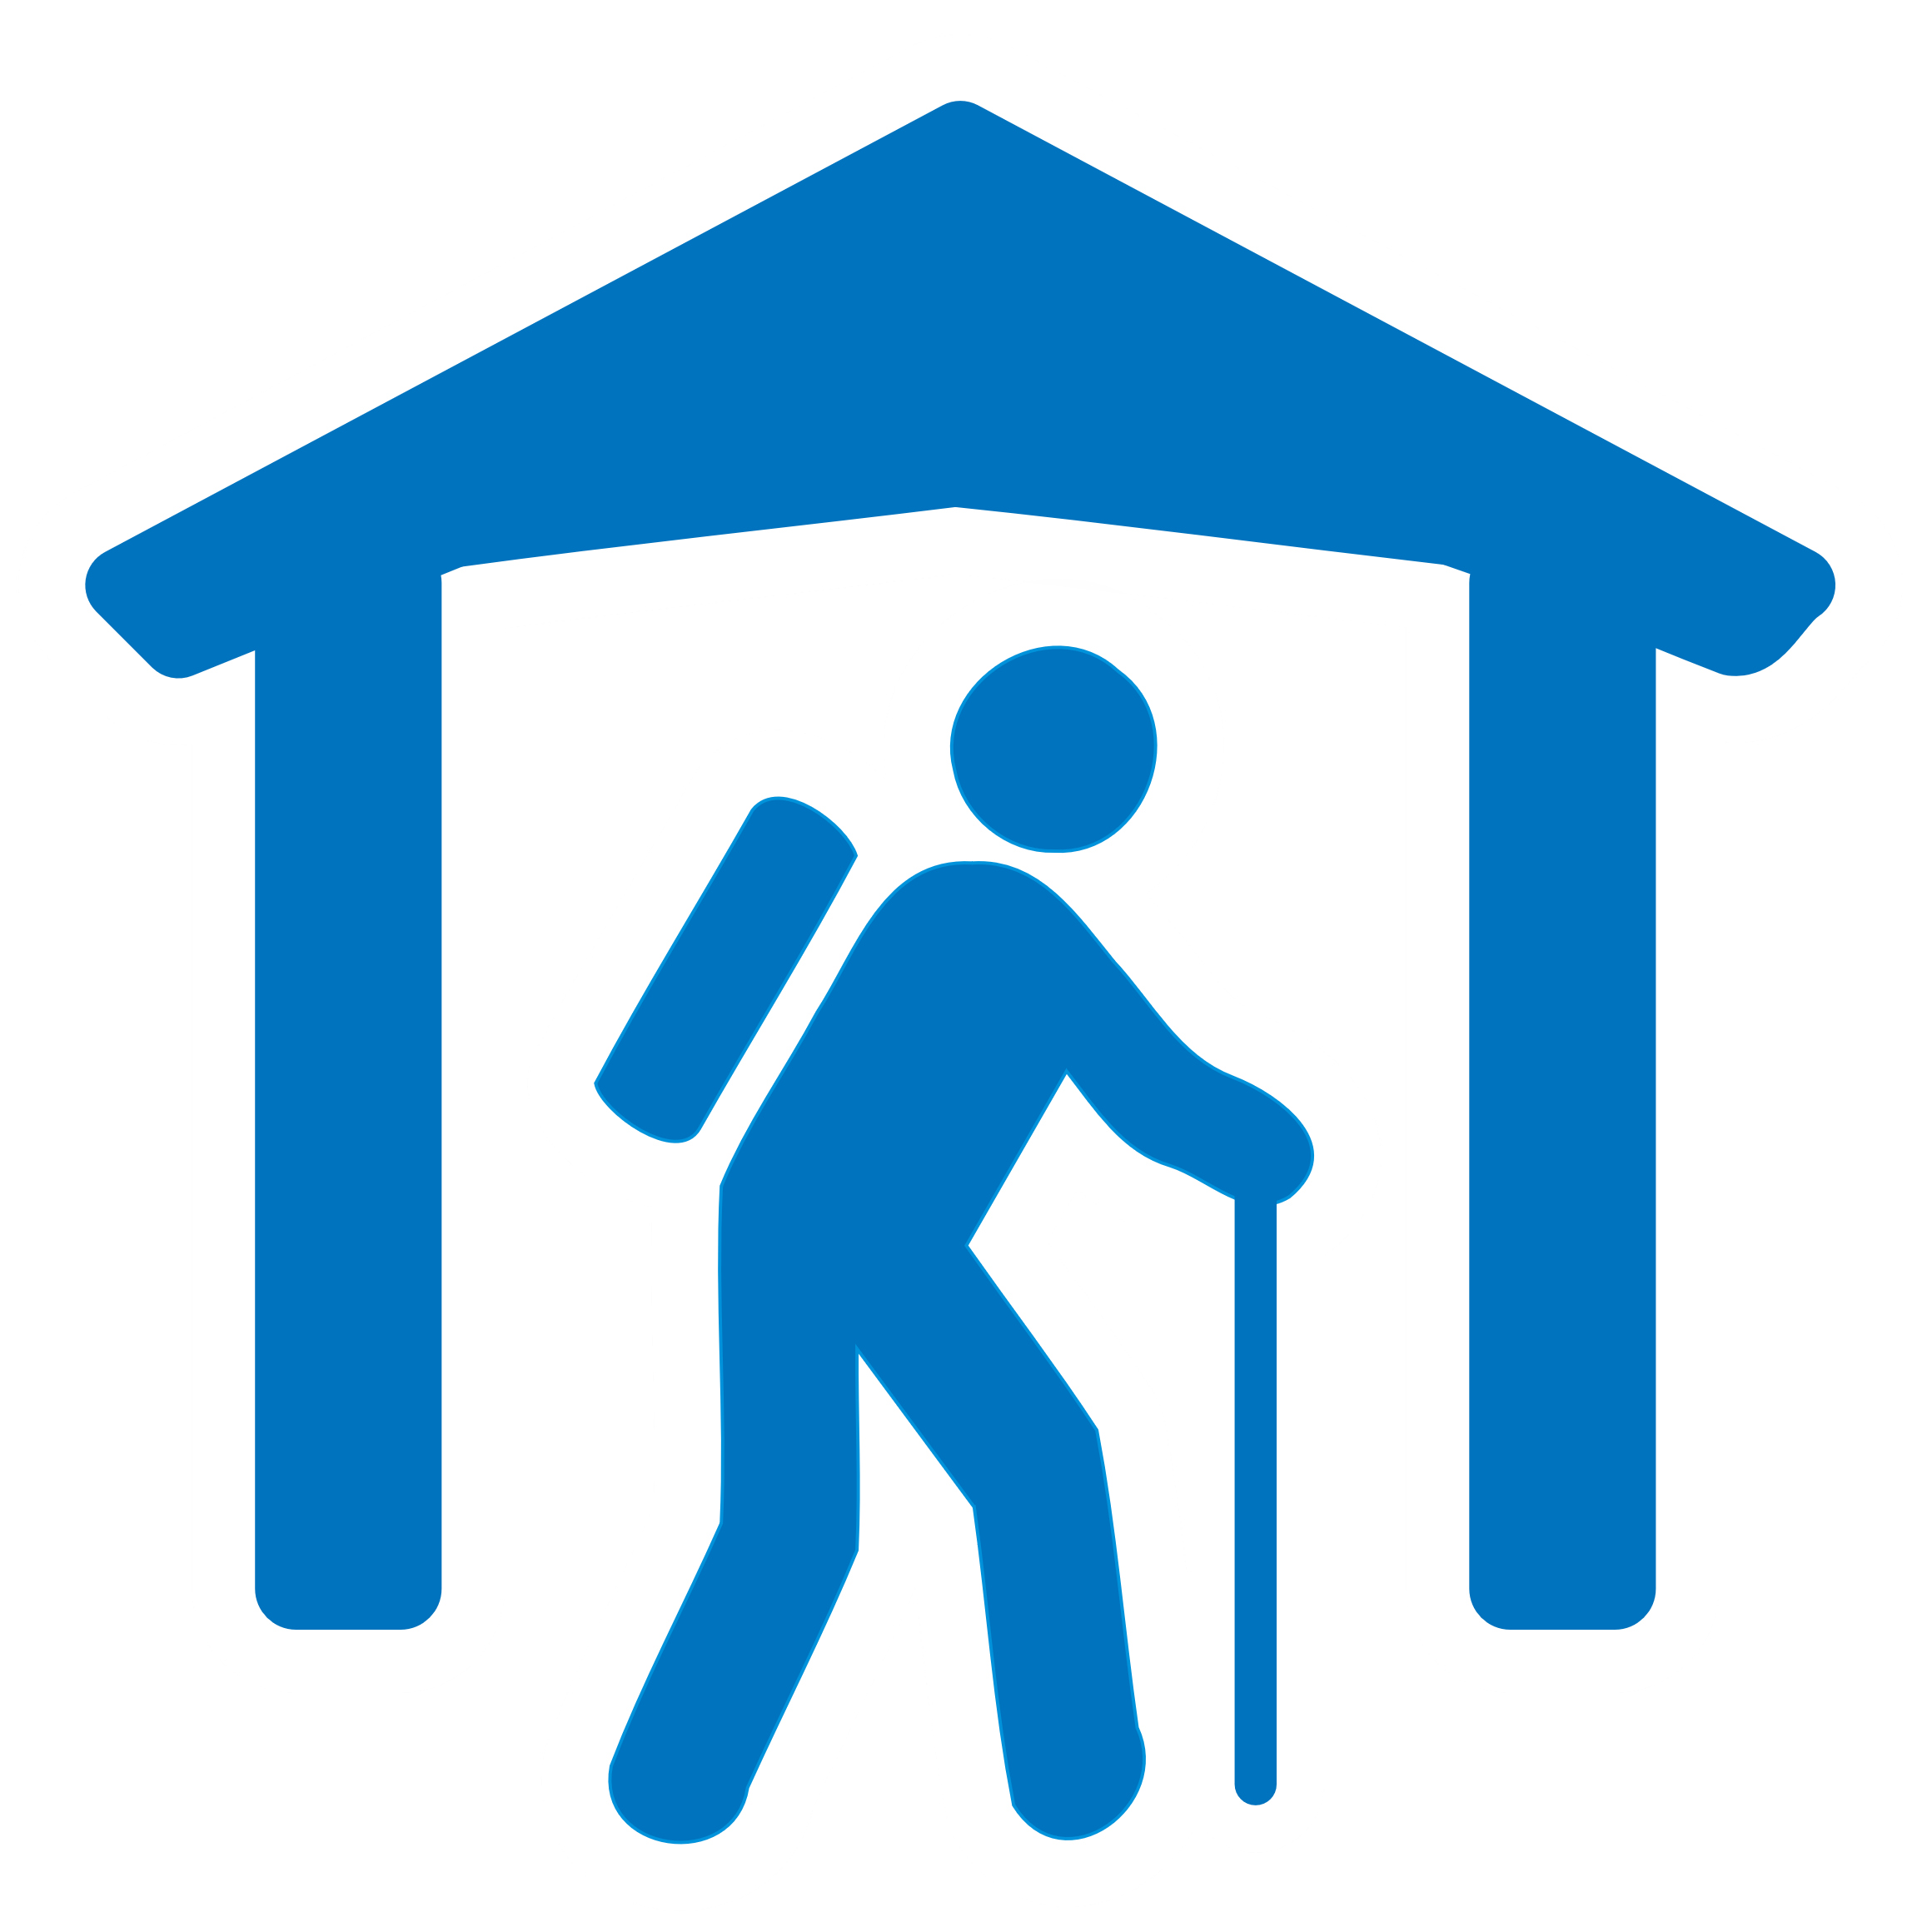  Alpine hut | 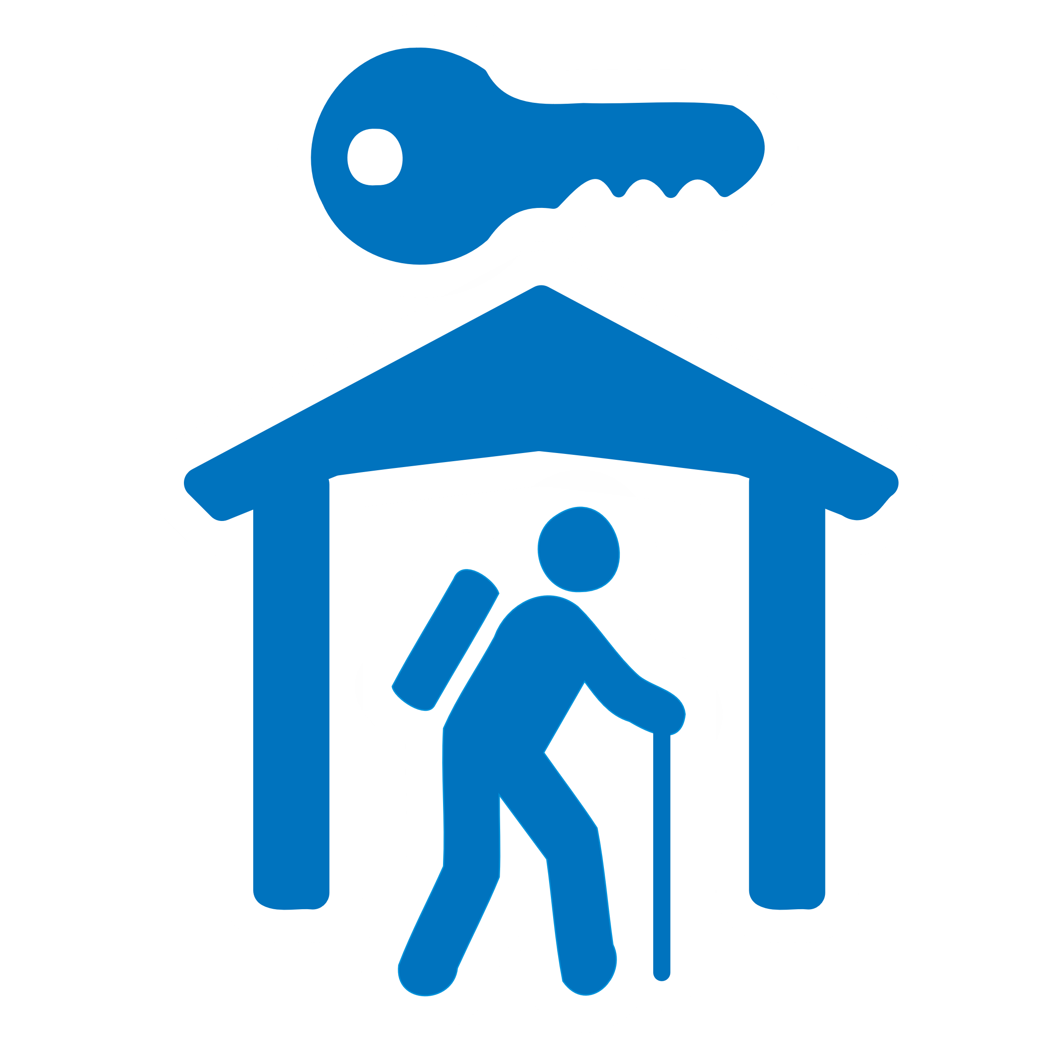  Alpine hut (private) | 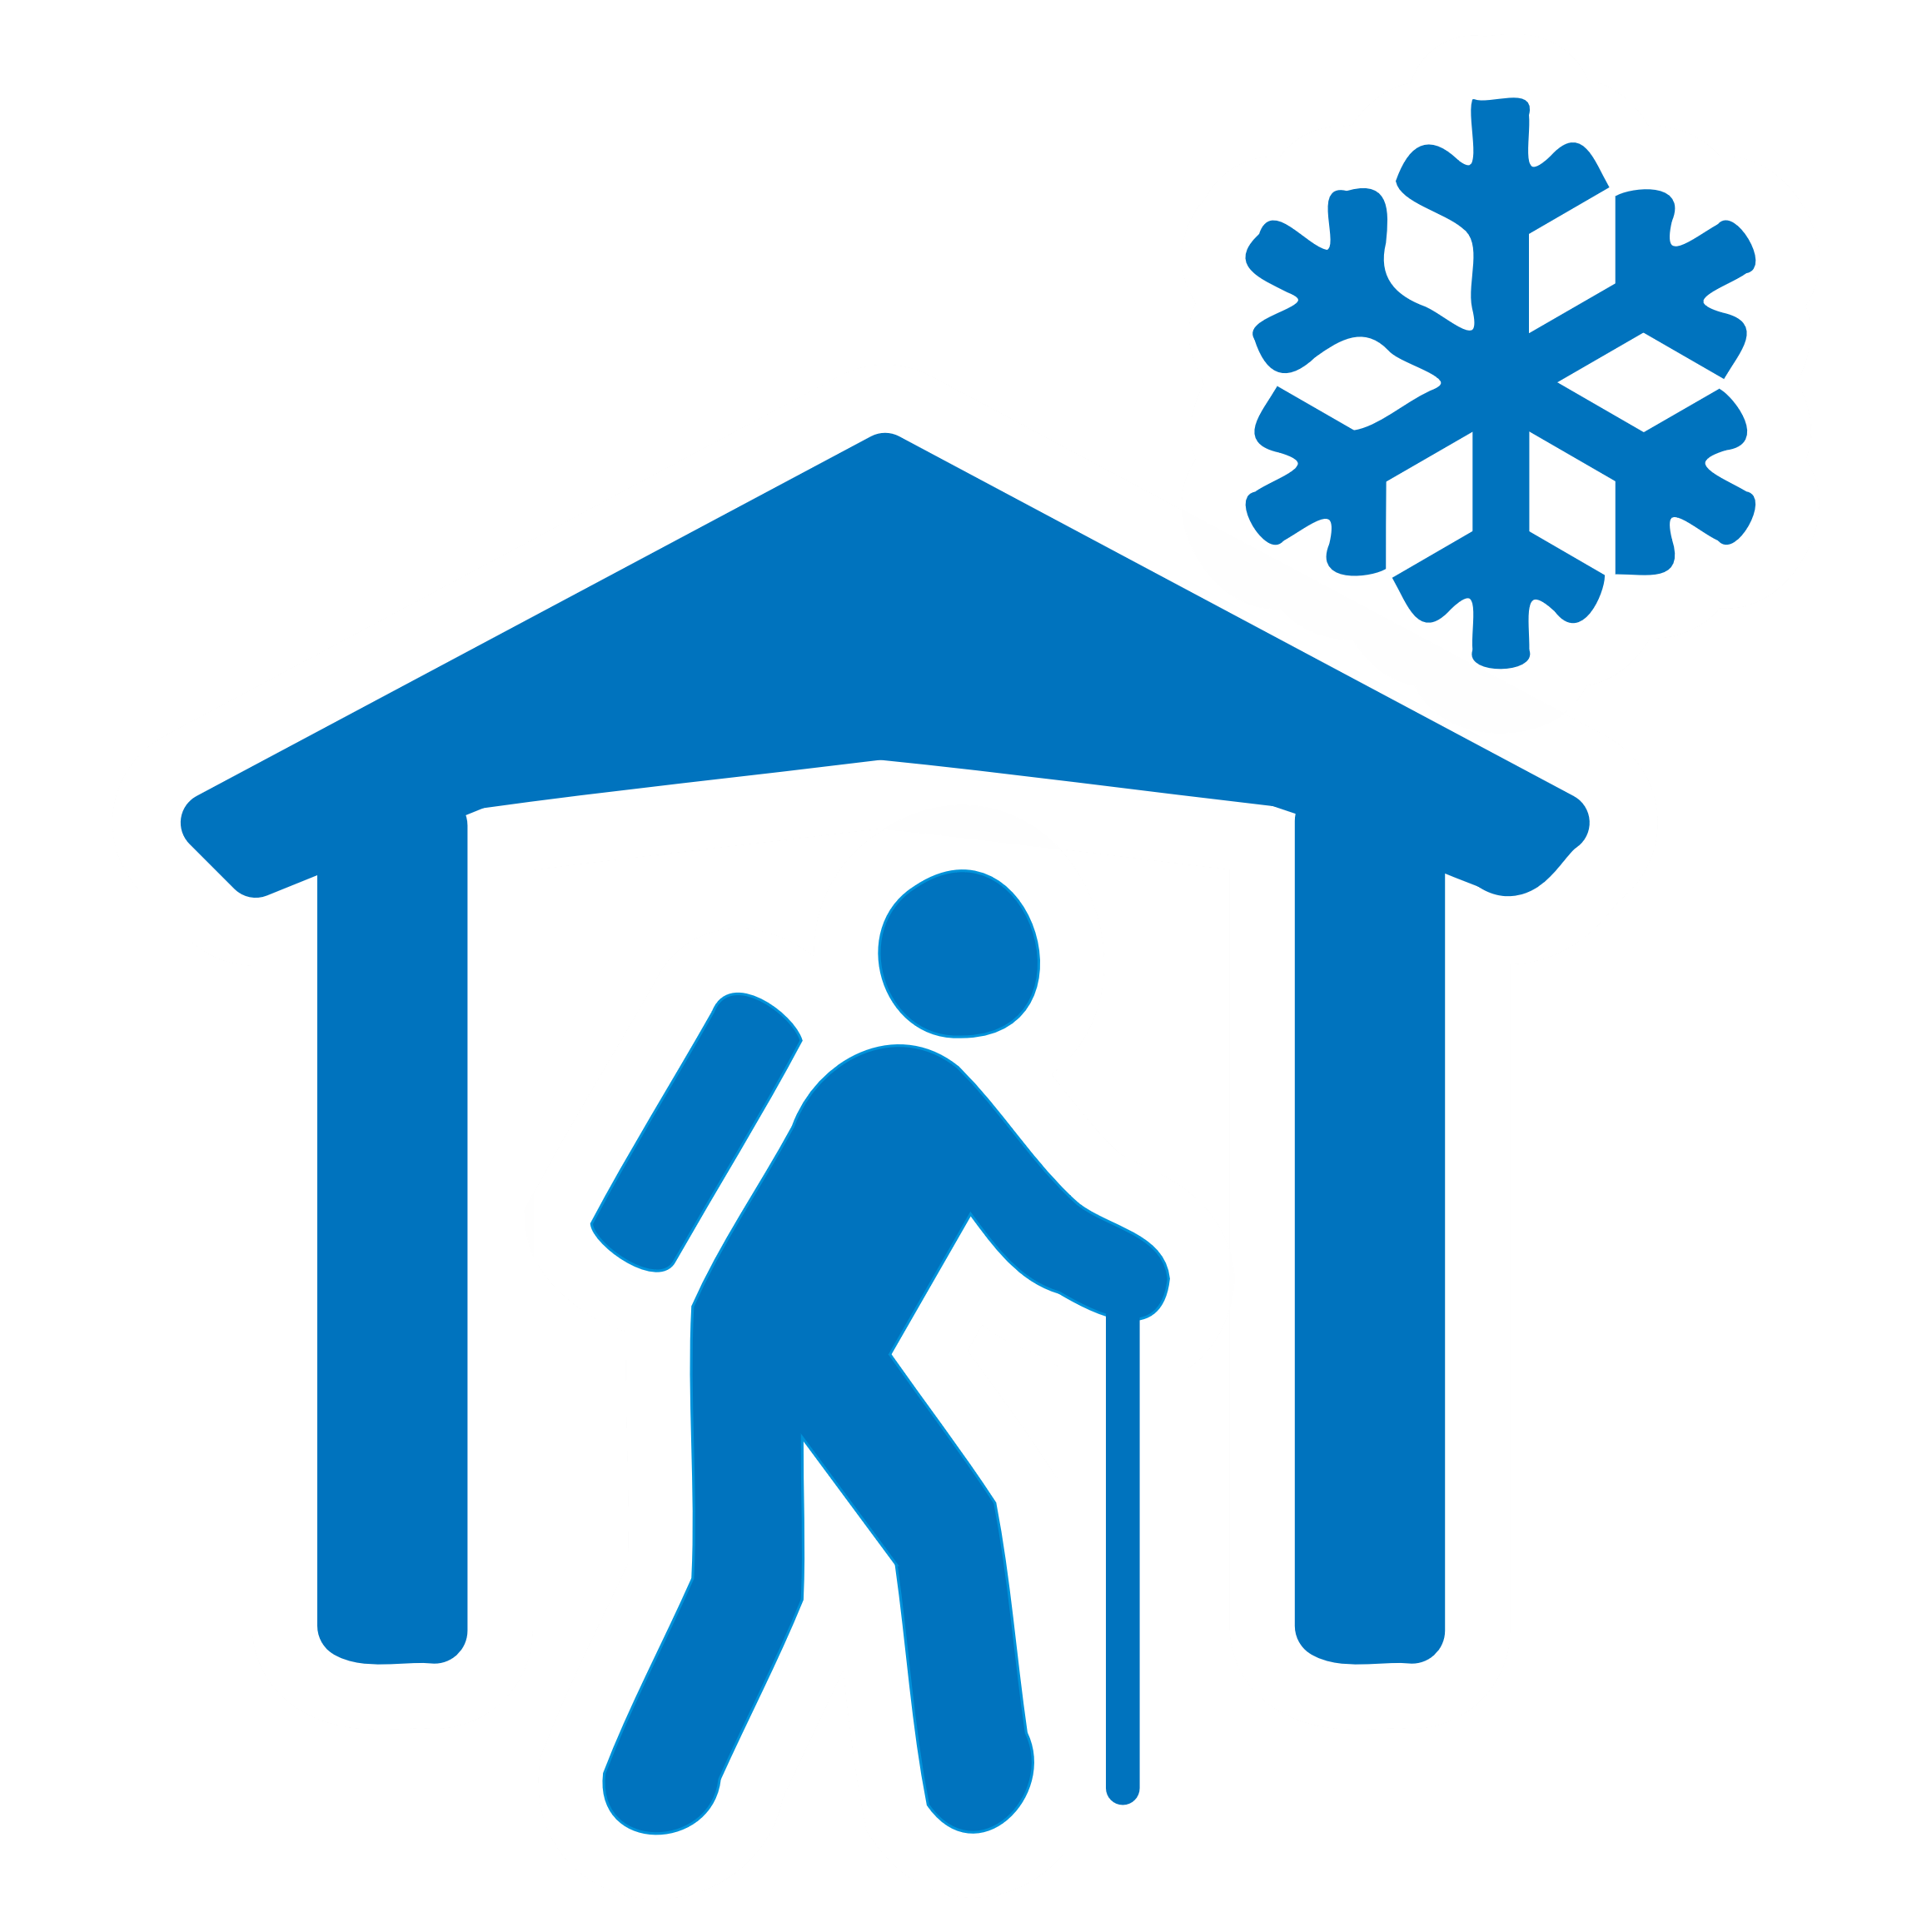  Alpine hut (winter) |   Wilderness hut |   Wilderness hut (private) |   Open front camping shed
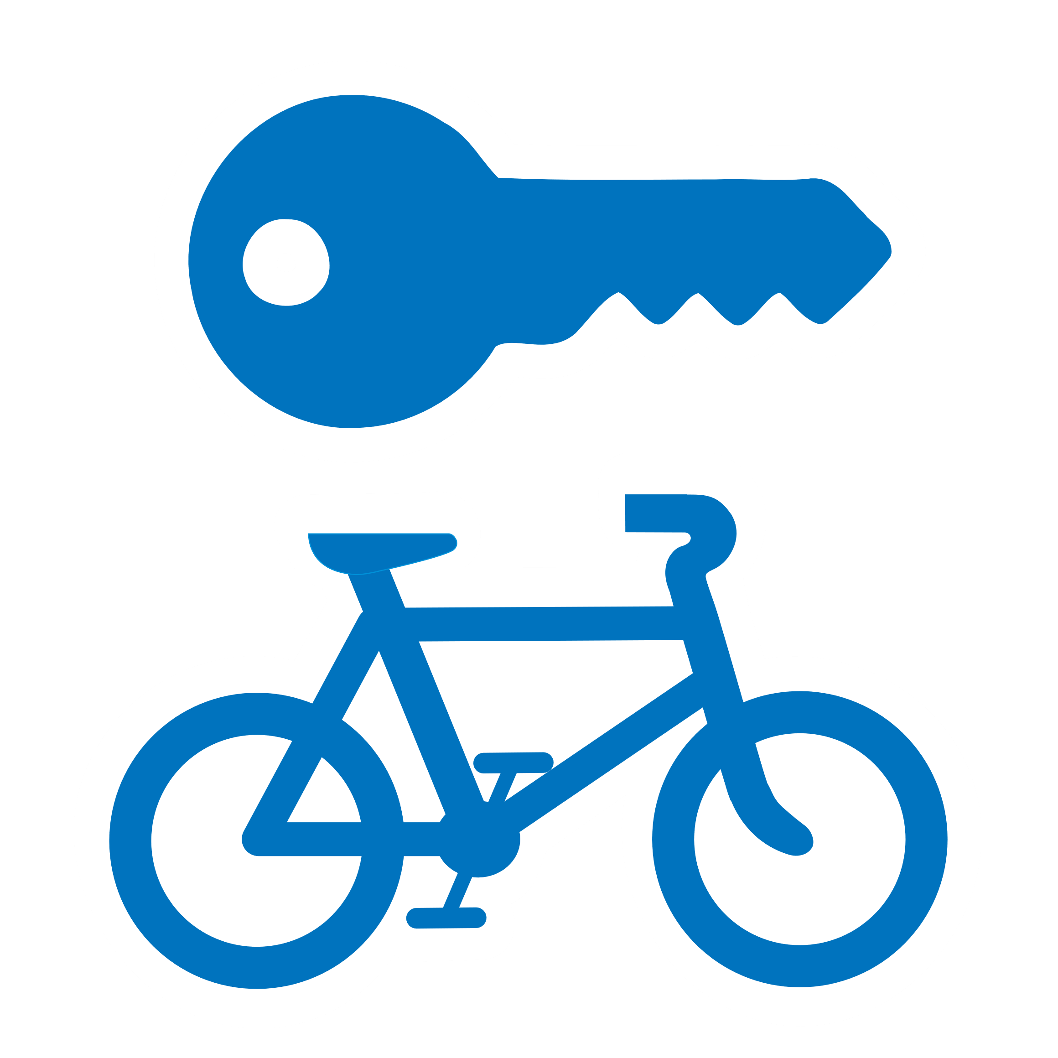  Bicycle hire |   Bridge (lifting) |   Bus stop  (low zoom) | 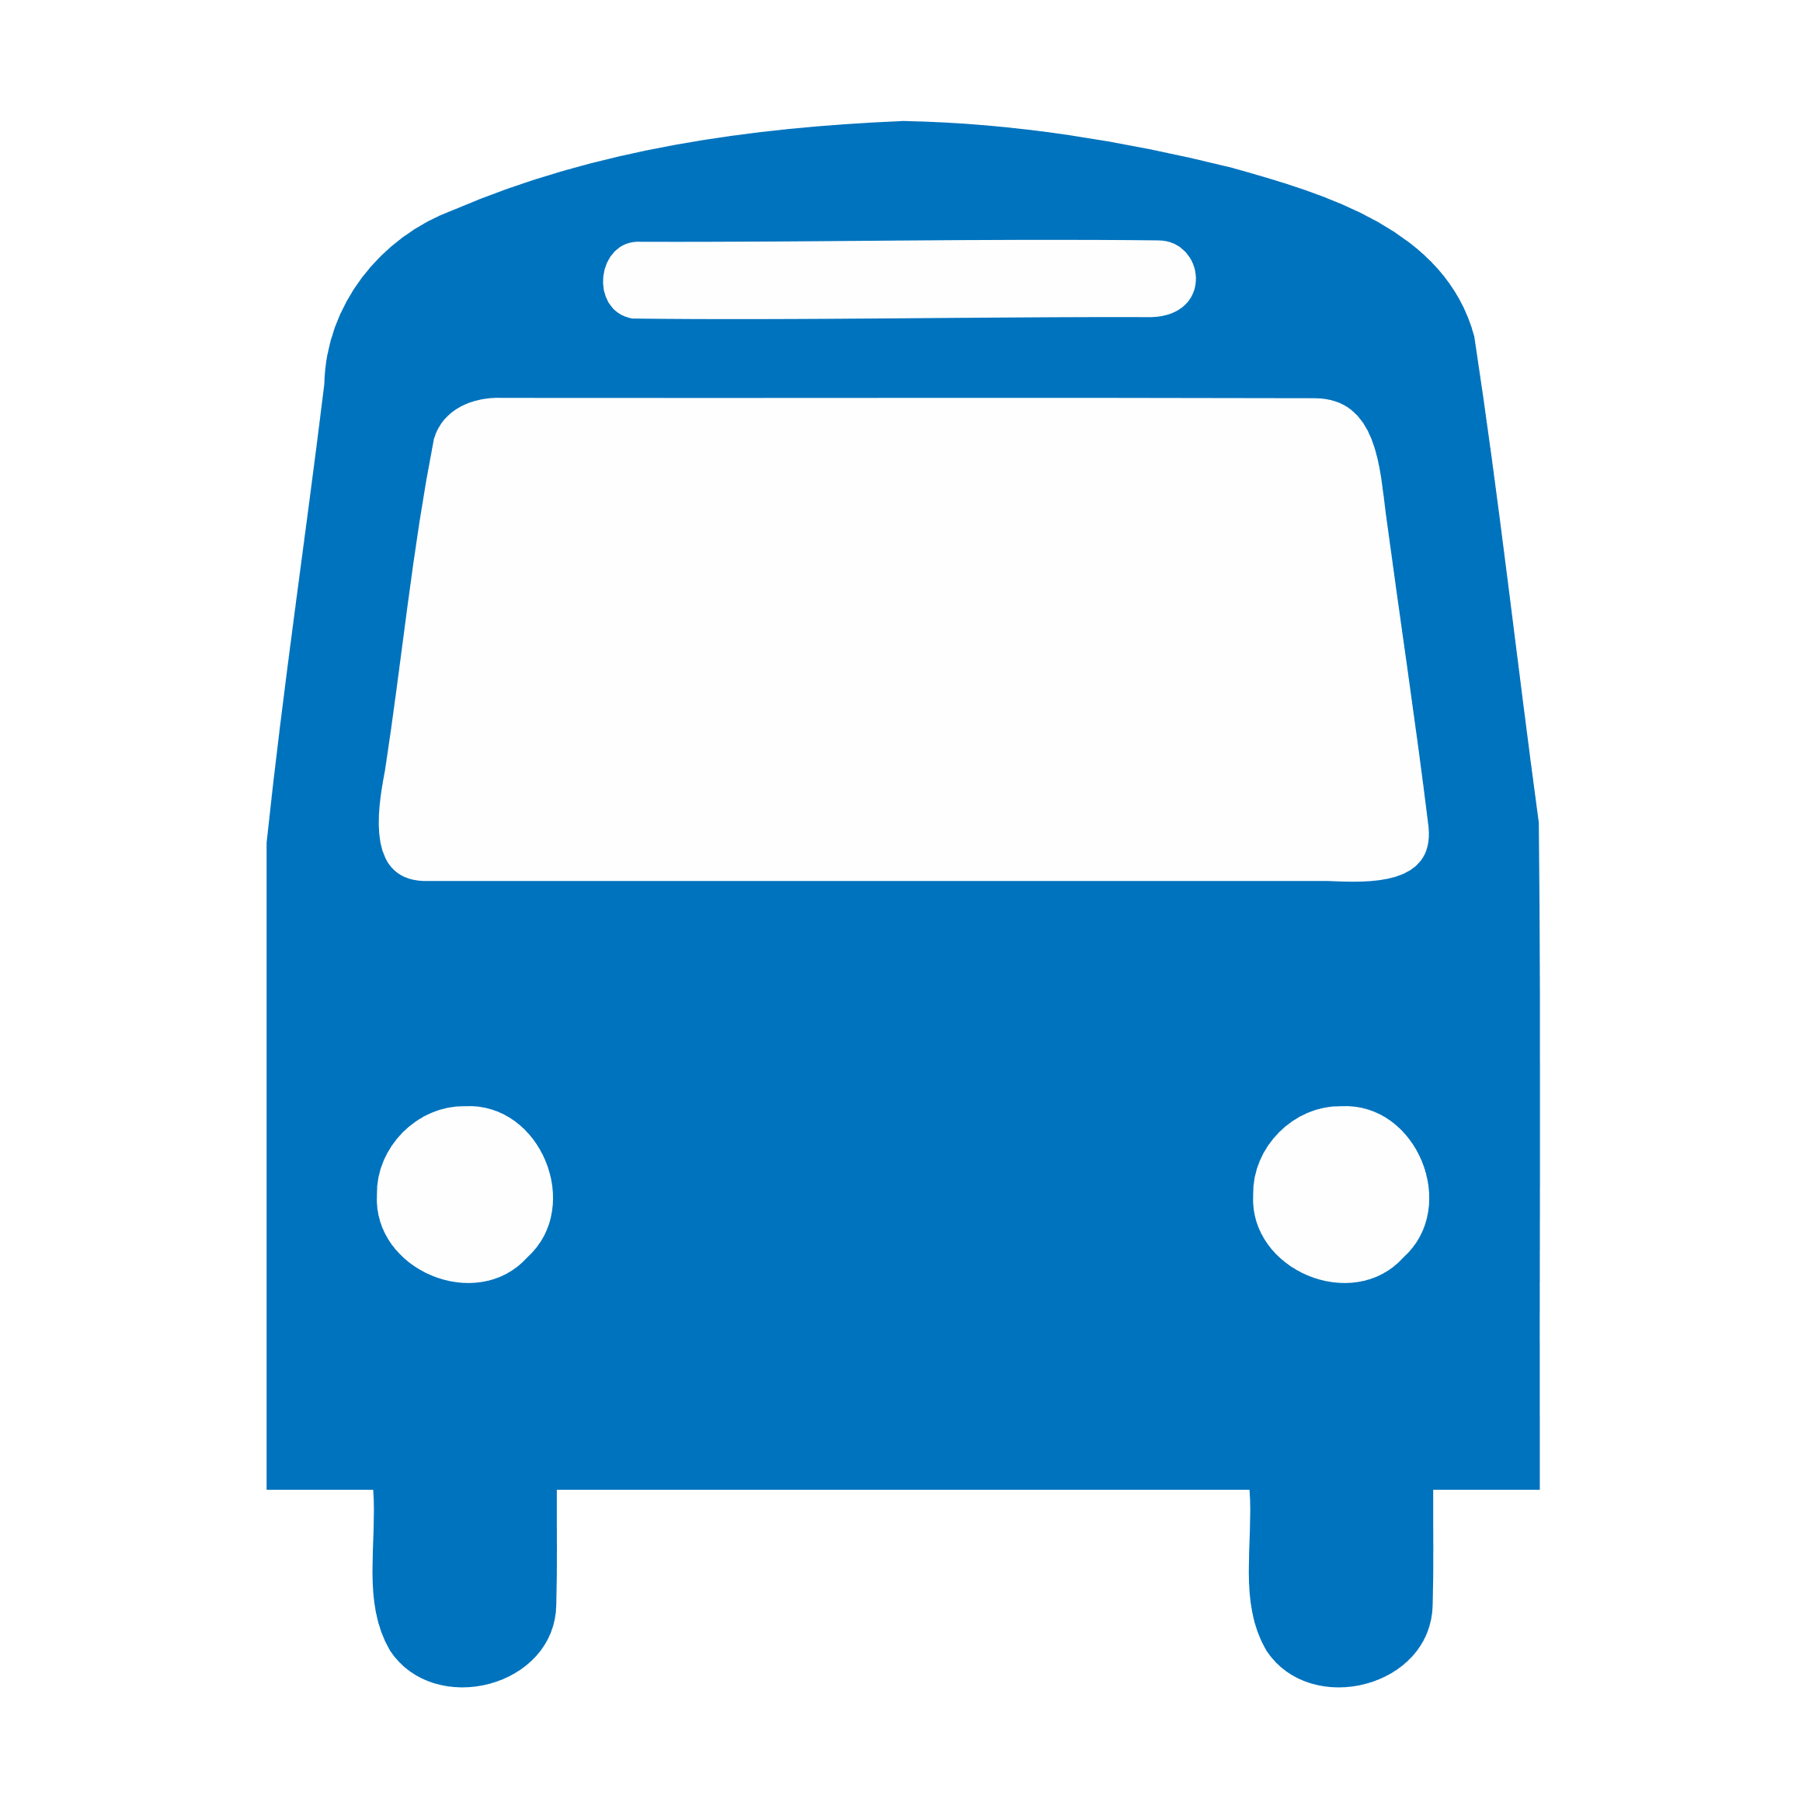  Bus stop | 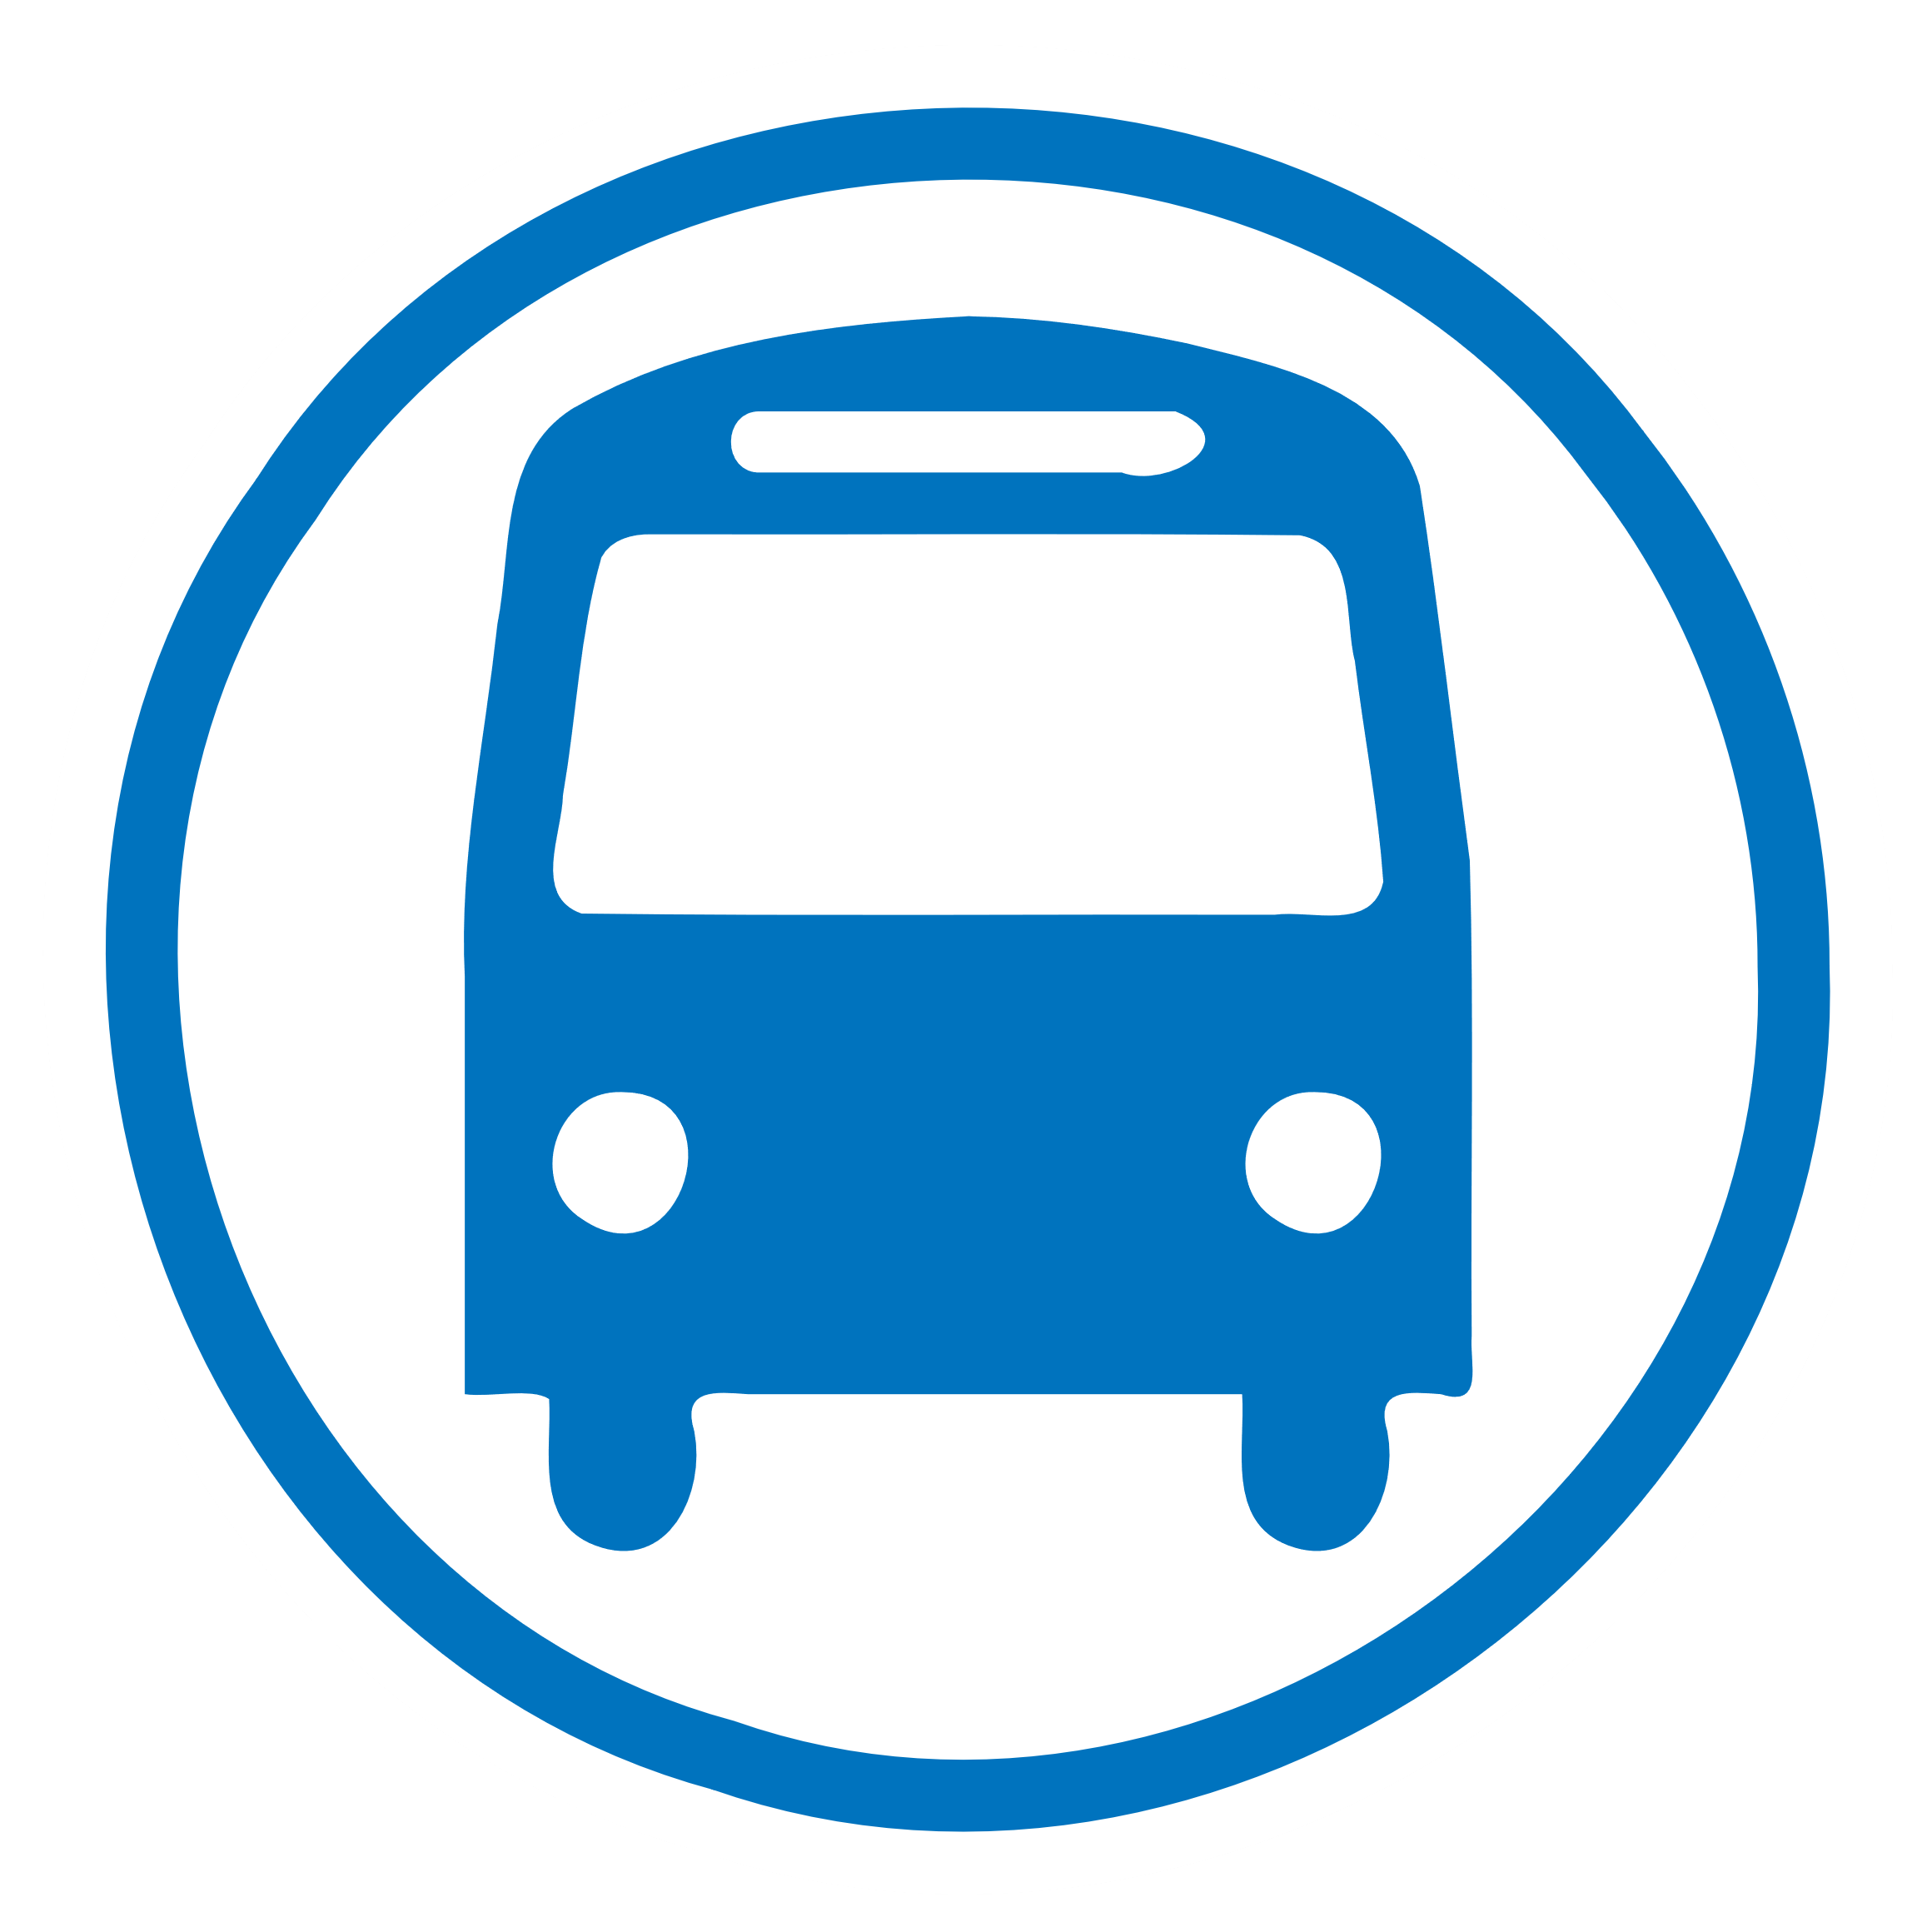  Bus station |   Camp site | 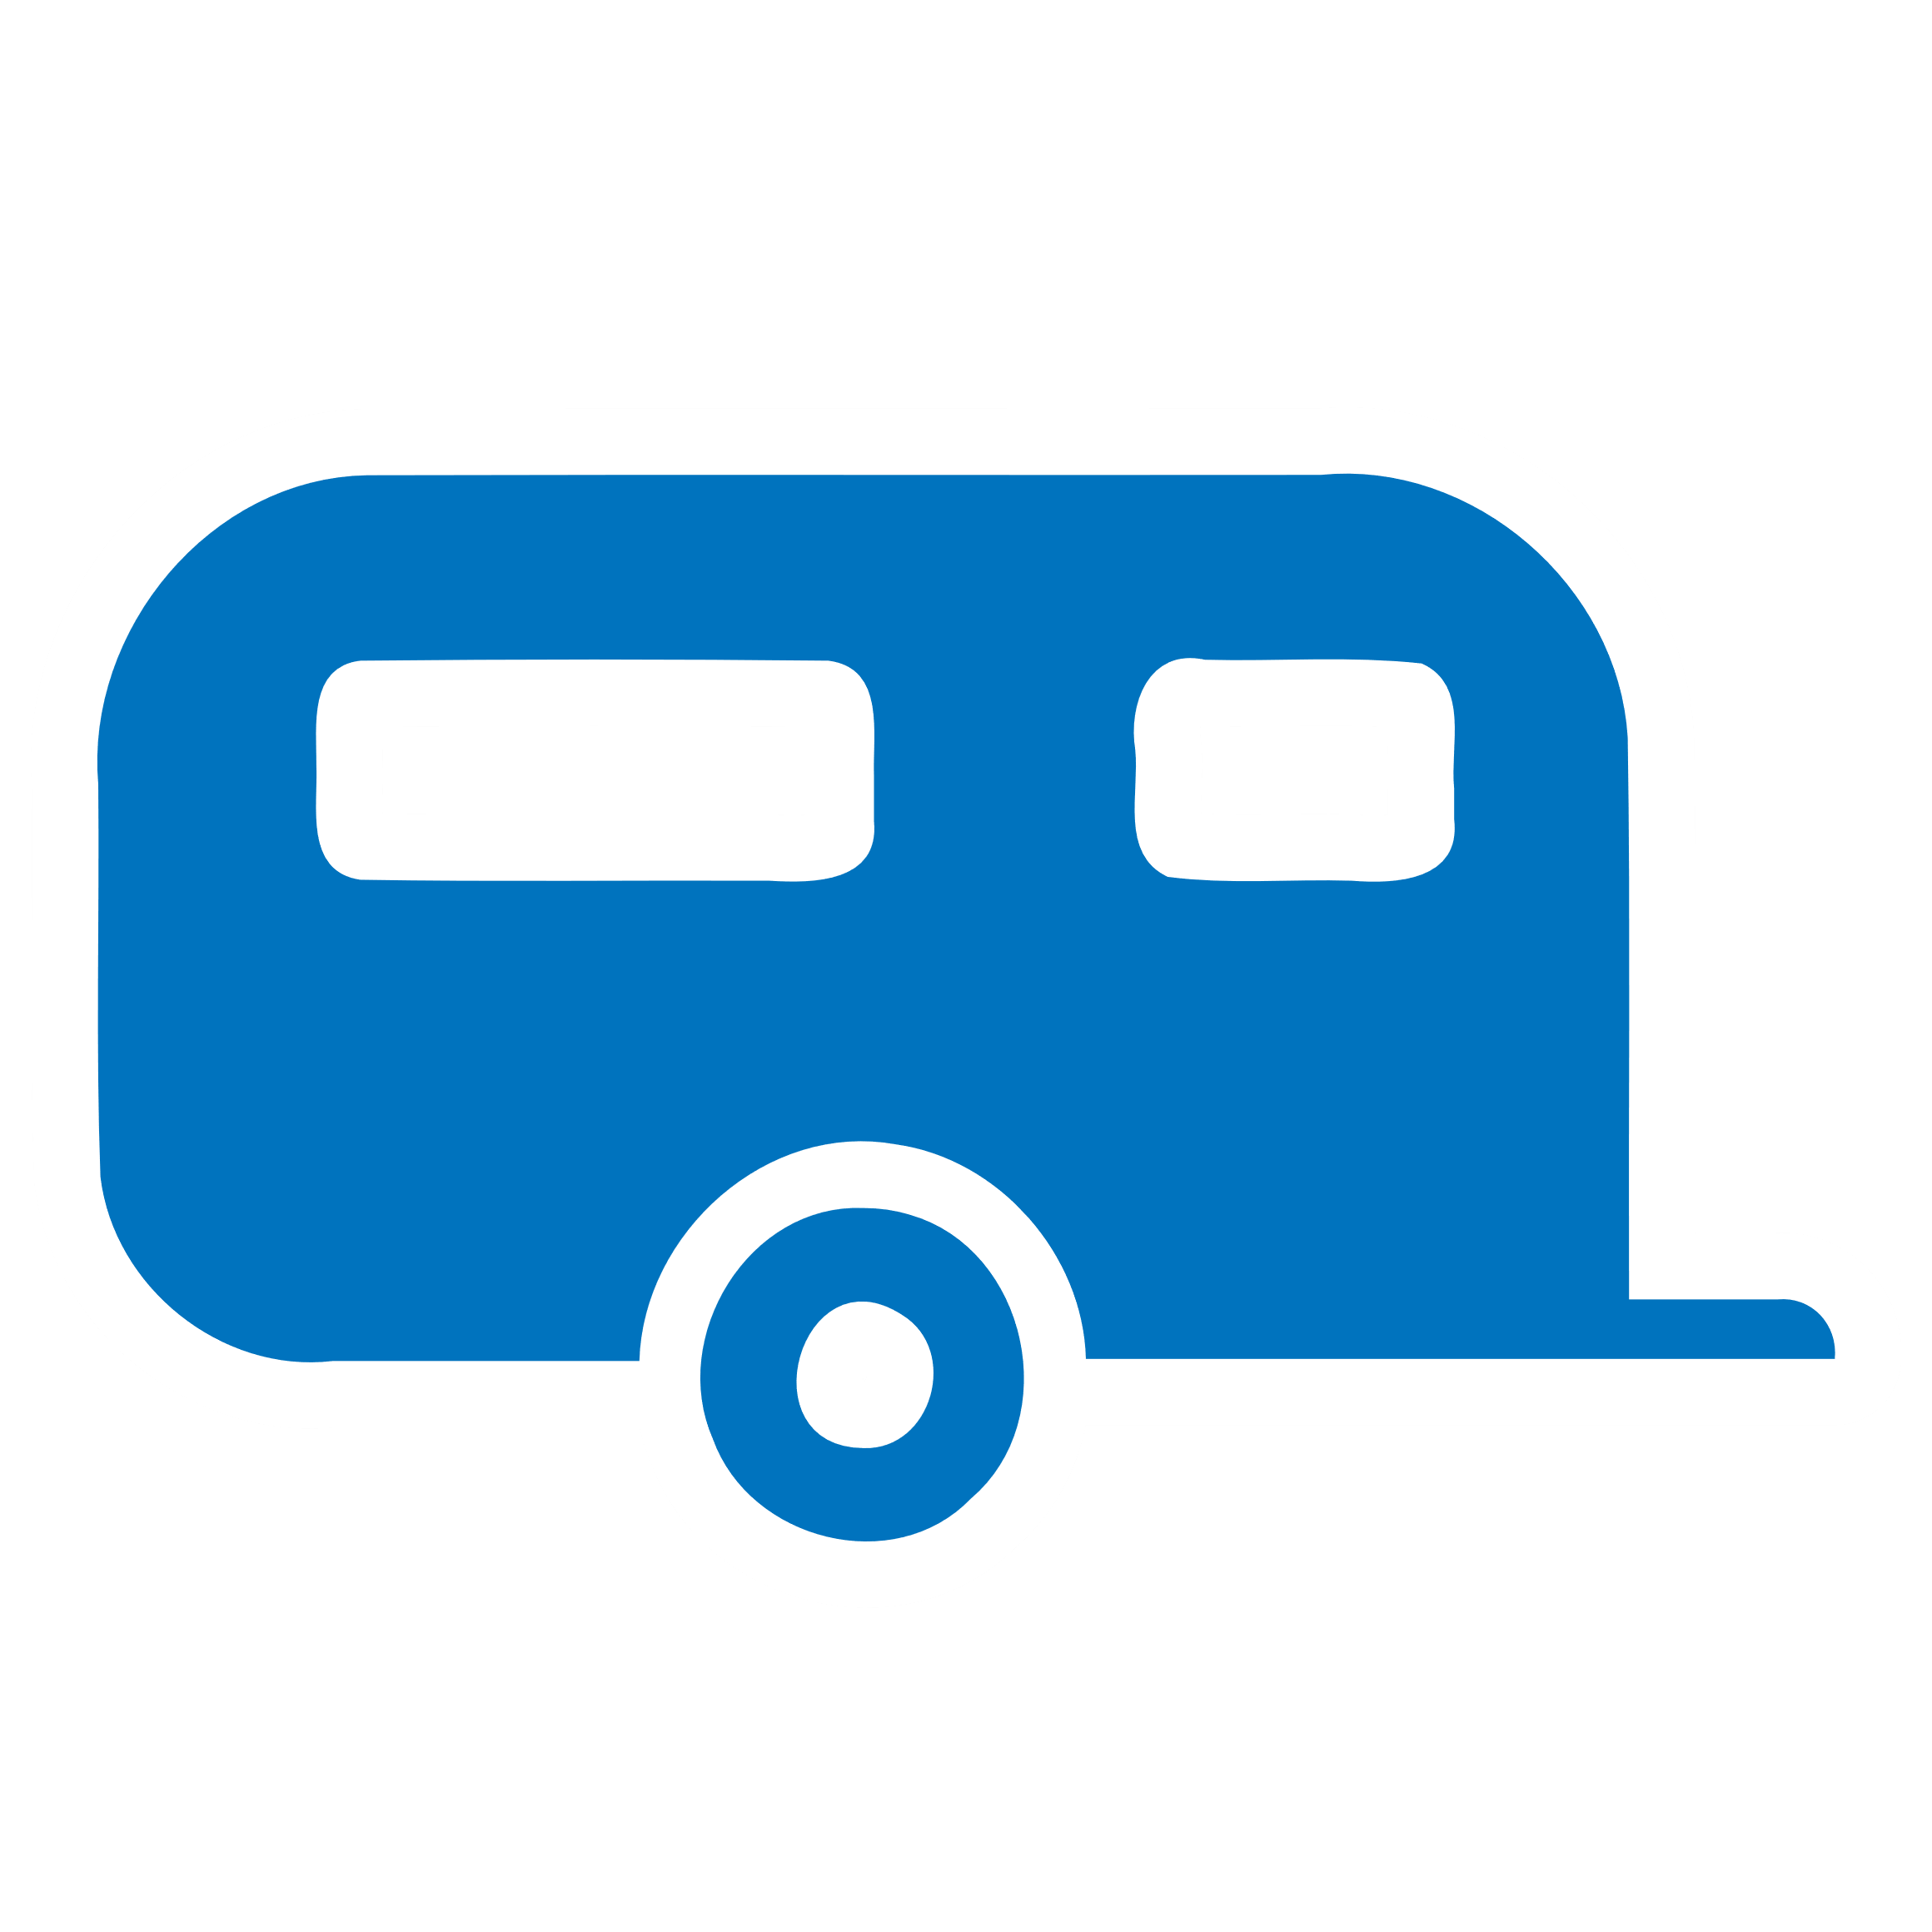  Caravan site |   Chalet |   Ferry terminal  (low zoom)
  Ferry terminal |   Ford |   Fountain |   Fuel |   Geyser |   Helipad | 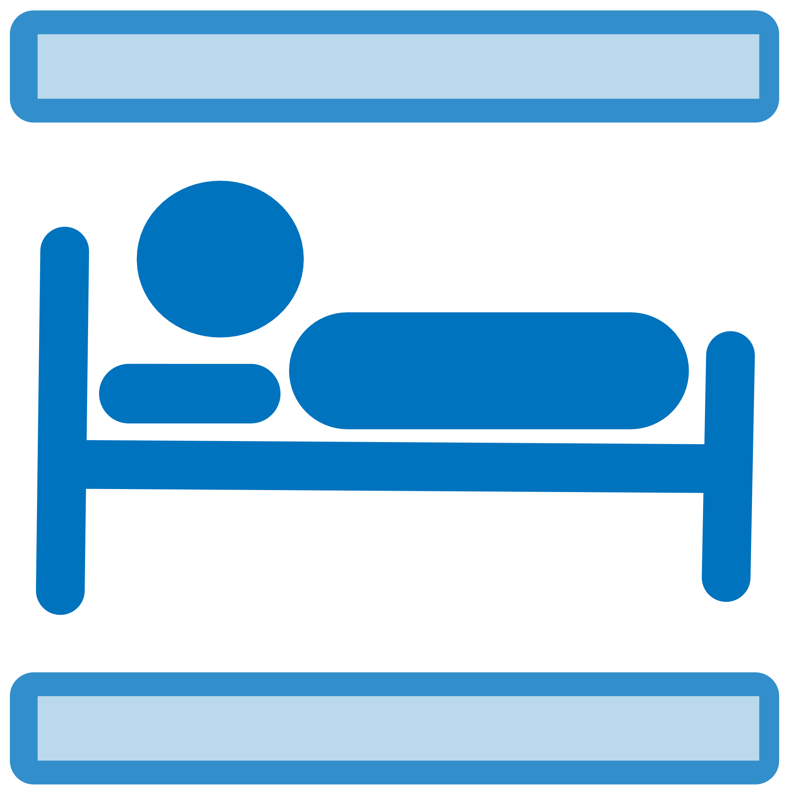  Holiday lets |   Hostel |   Hotel
  Junction number |   Lighthouse |   Parking |   Parking (covered) |   Parking |   Parking (covered, private) |   Rapids | 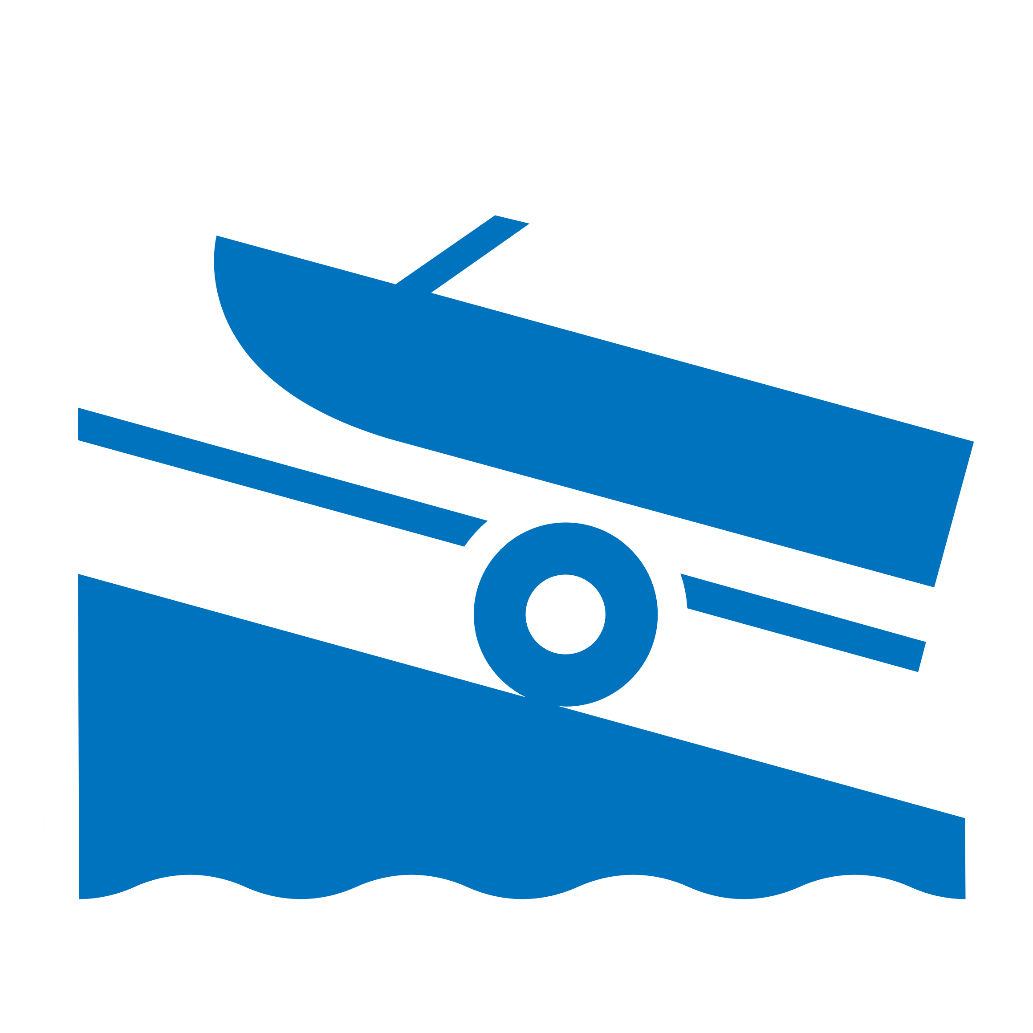  Slipway |   Spring
  Subway  (low zoom) | 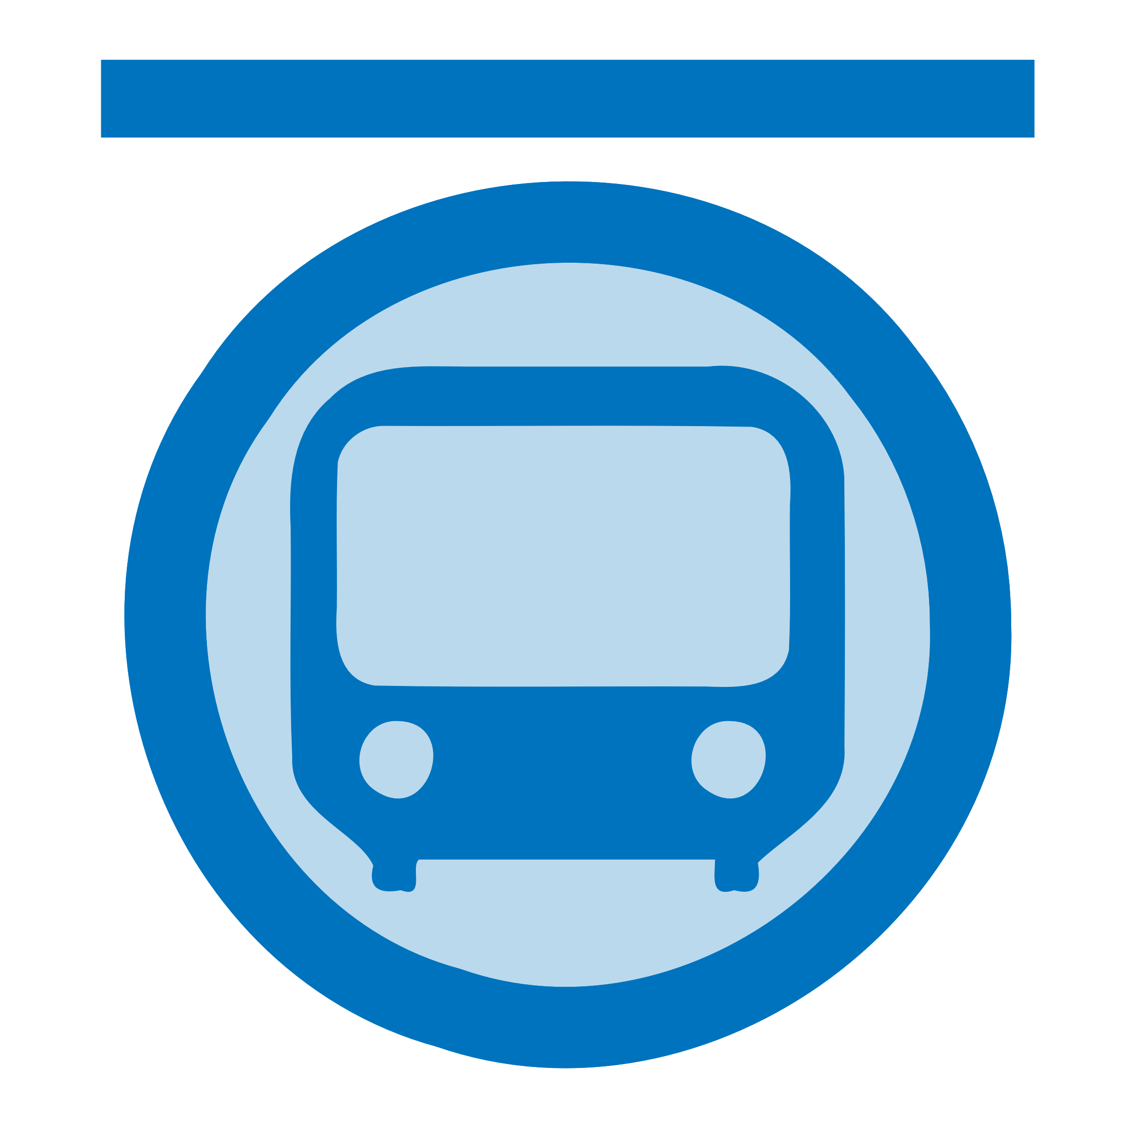  Subway | Station  (low zoom) |   Station |   Tram/light rail stop |   Tram stop |   Waterfall |   Weir |   Well
Food and Tourism
  Archaeo-logical |   Artwork |   Bar |   Bench |   Biergarten |   Boundary stone |   Cafe |   Castle |   Cinema
  Drinking water |   Fast food |   Fire station |   Guidepost |   Ice cream |   Information office |   Information terminal |   Info board |   Info map
  Information (other) |   Library | 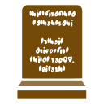  Memorial | 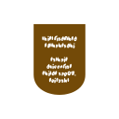  Memorial: plaque |   Memorial: statue | 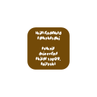  Memorial: Stolperstein |   Memorial stone |   War memorial |   Monument
  Museum |   Picnic site |   Police station |   Post box |   Post office |   Pub |   Restaurant |   Recycling |   Ruins
  Shelter  (low zoom) |   Shelter |   Shelter (picnic) |   Shelter (rock) |   Star attraction |   Stone (historic) |   Telephone |   Theatre |   Toilets
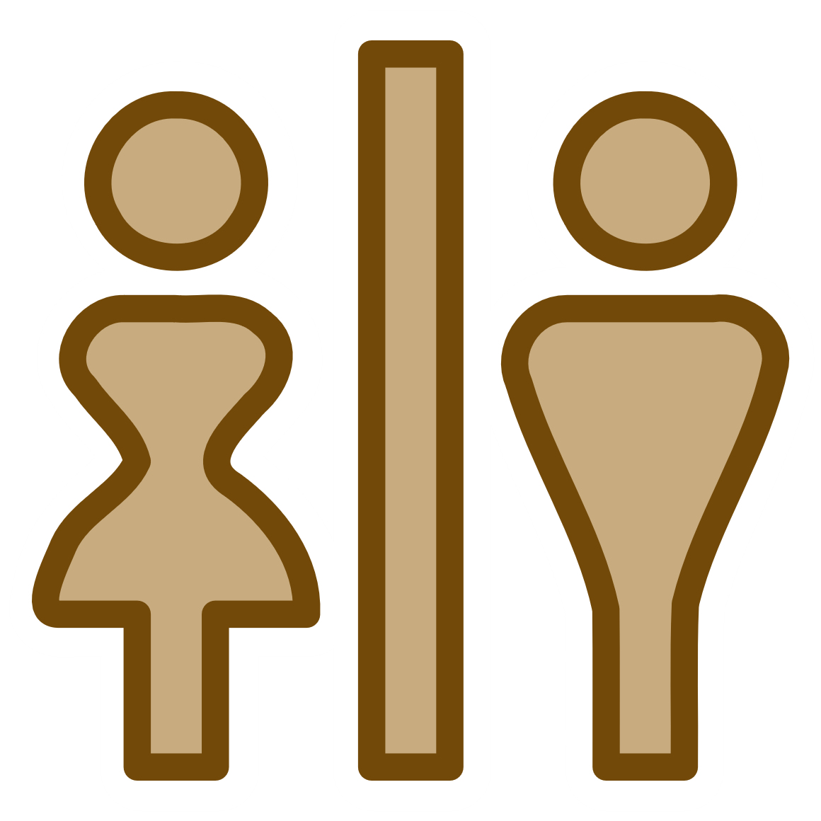 Toilets  (customer) |  Viewpoint |  Water wheel |  Wayside cross |  Wayside shrine |  Windmill |  Windpump |   Zoo

Barriers, Money & official, Aerial ways, Towers, Miscellaneous, Worship
  Blocks |   Bollard | Border or checkpoint (low zoom) |   Border control |   Police or military checkpoint |   Cattle grid |   Cycle barrier |   Gate |   Gate -- private
  Gate – no bikes |   Kissing gate |   Lift gate |   Log |   Stile |   Stone (natural) |   Turnstile
ATM | Bank |   Currency exchange | Embassy | Town hall
Aerialway station |   Cablecar |   Chair lift |   Drag lift |   Gondola |   Goods lift |   Comms mast |   Lookout tower |   Water tower
  Bunker (military) |   Bunker (disused) |   Cave |   Farm |   Mine |   Mine (disused) |   Petroleum well |   Sewage works | 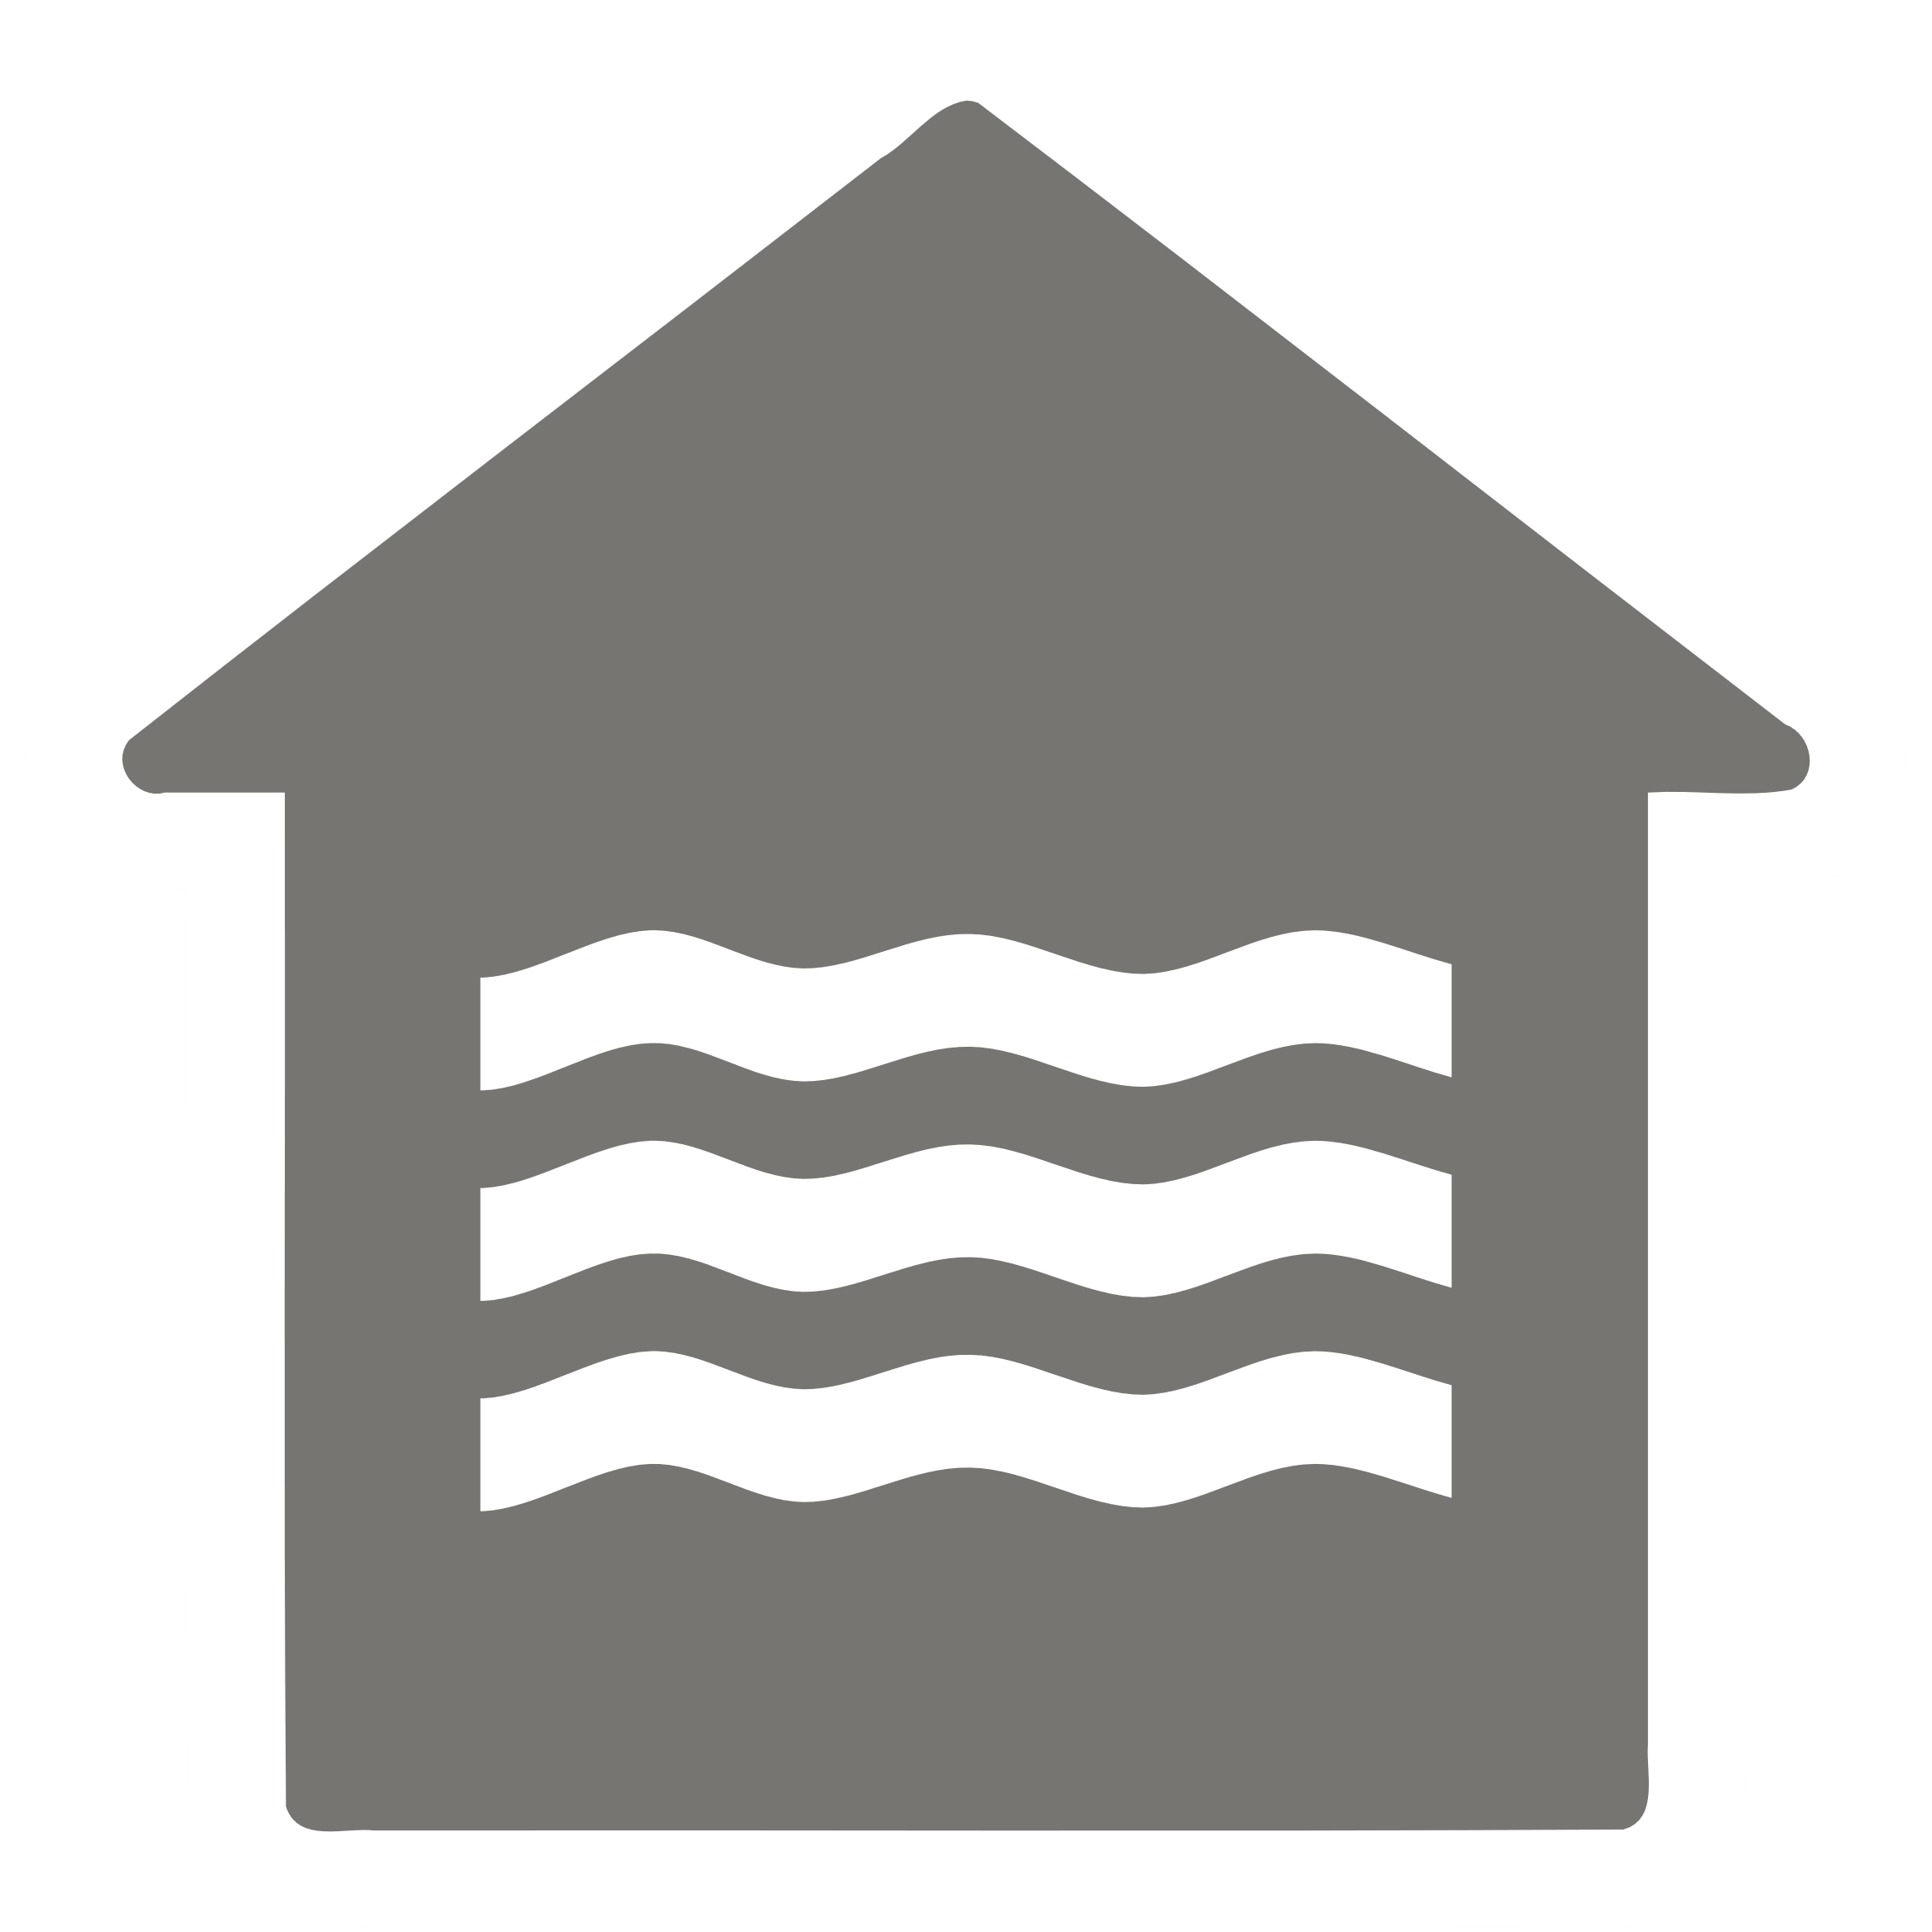  Waterworks
  Buddhist |   Christian |   Hindu |   Jewish |   Buddhist |   Shinto |   Unknown or other
Sport, Eco
  Beach resort |   Cliff diving |   Climbing | 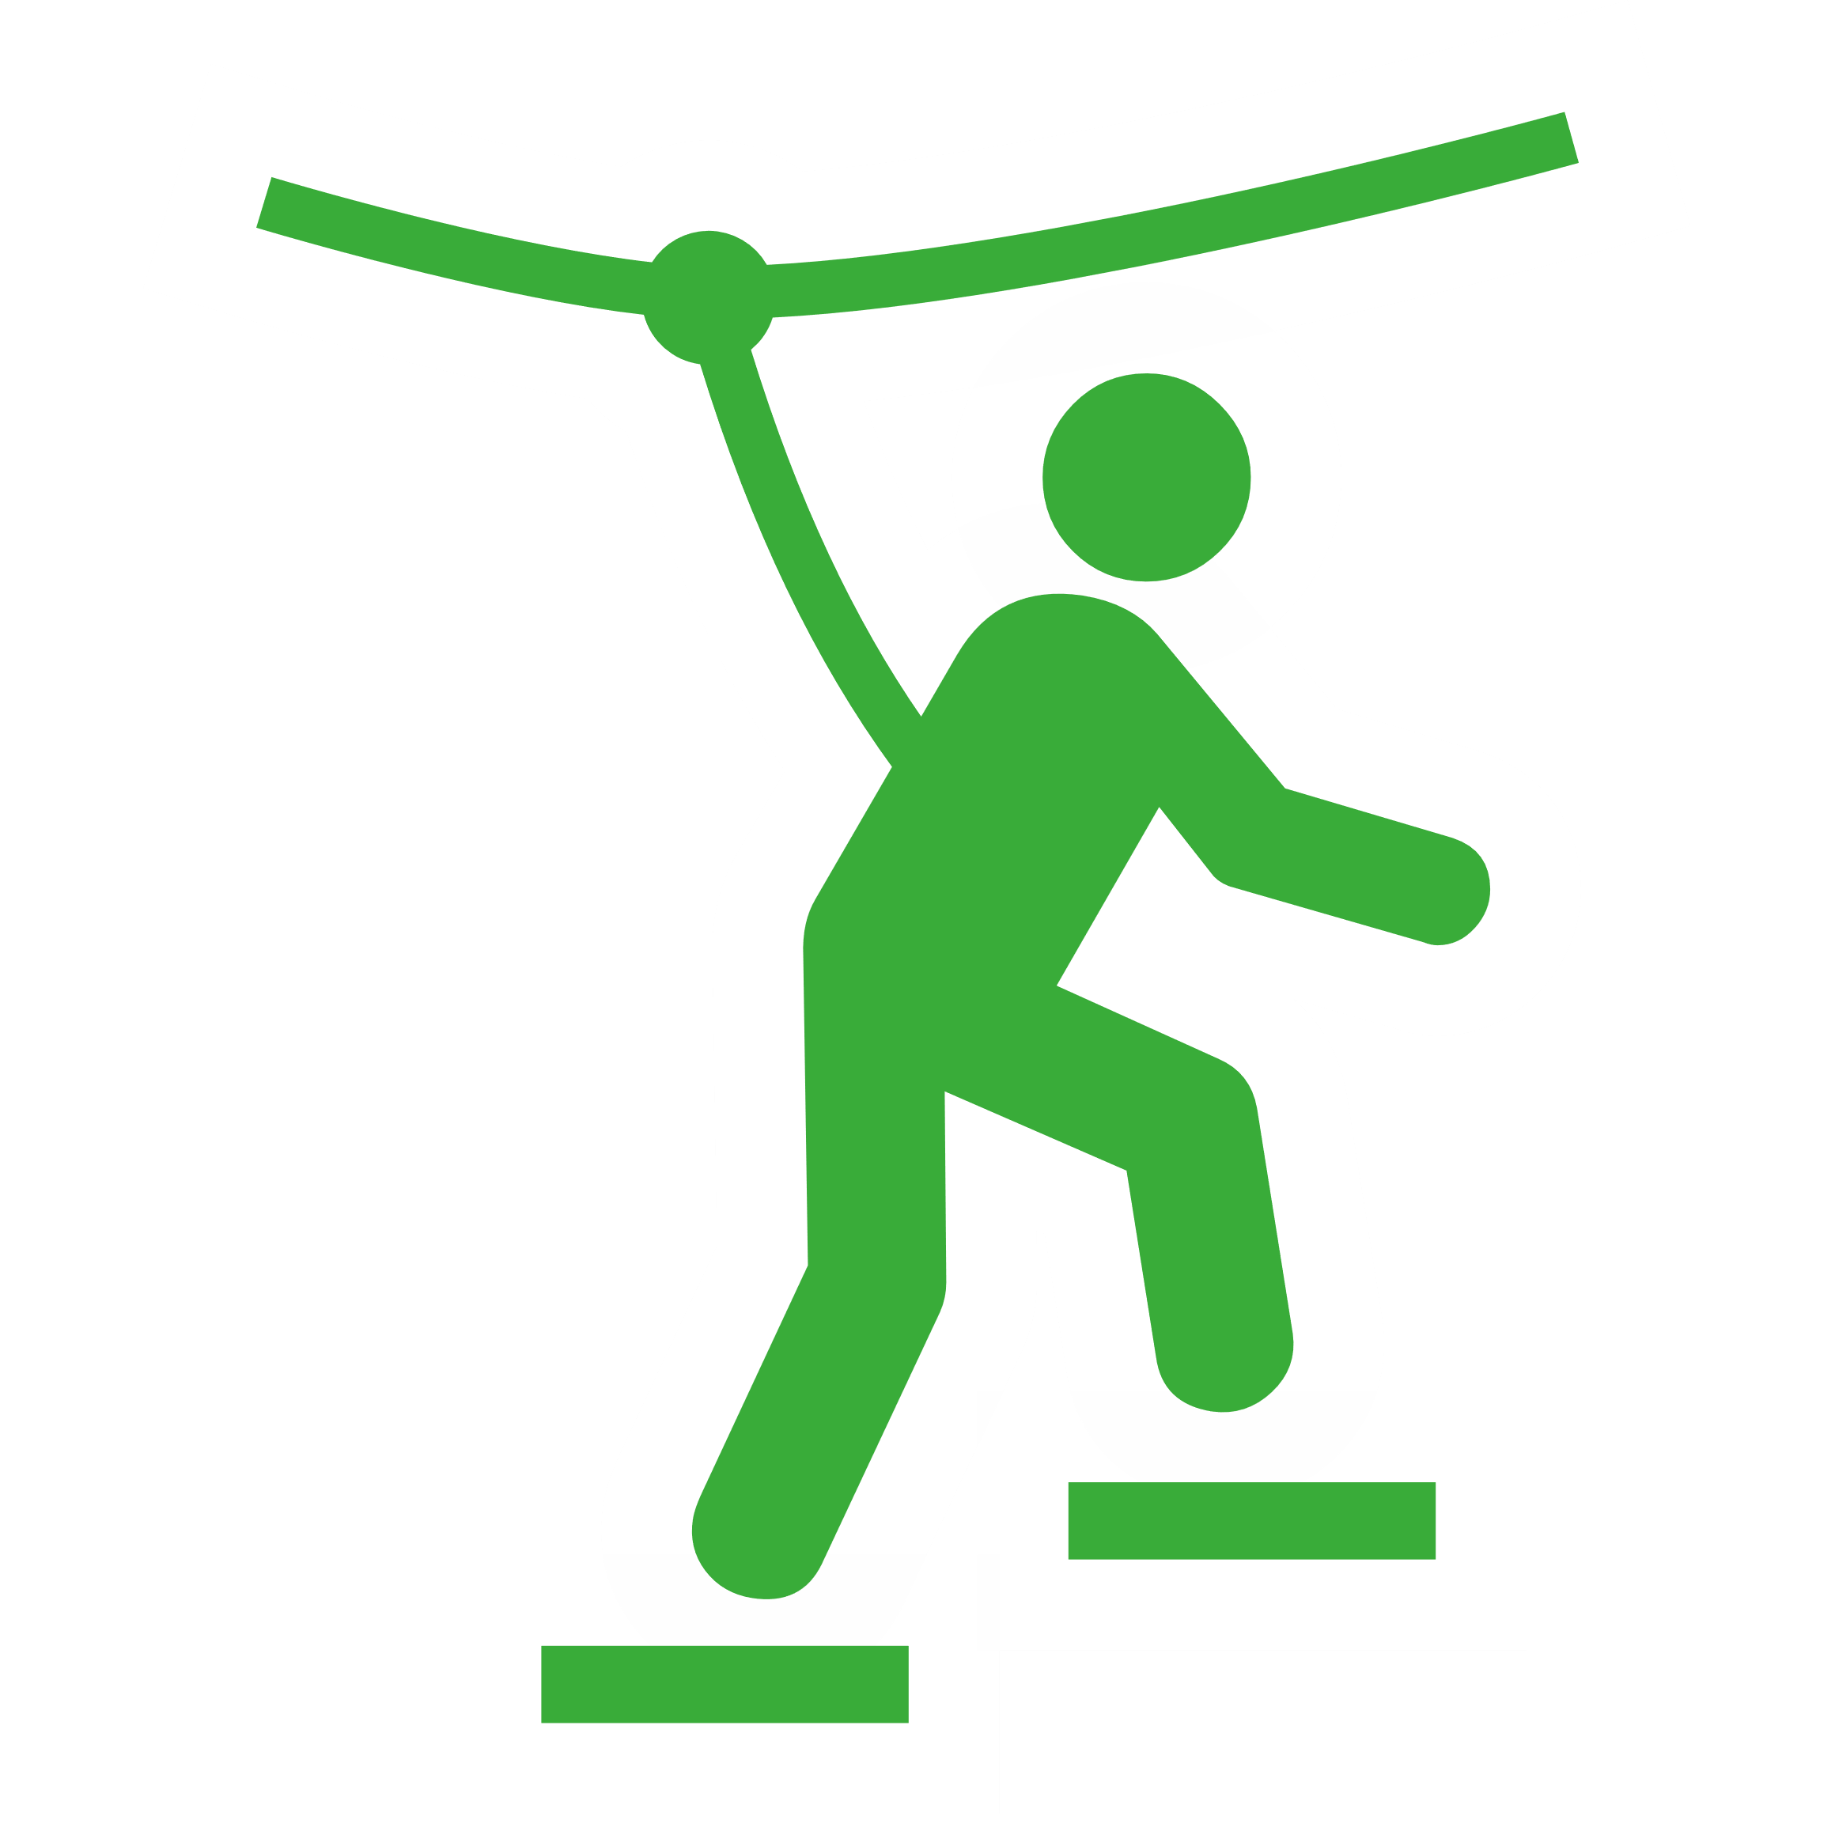  Climbing adventure |   Downhill skiing |   Football |   Free flying |   Golf |   Leisure centre
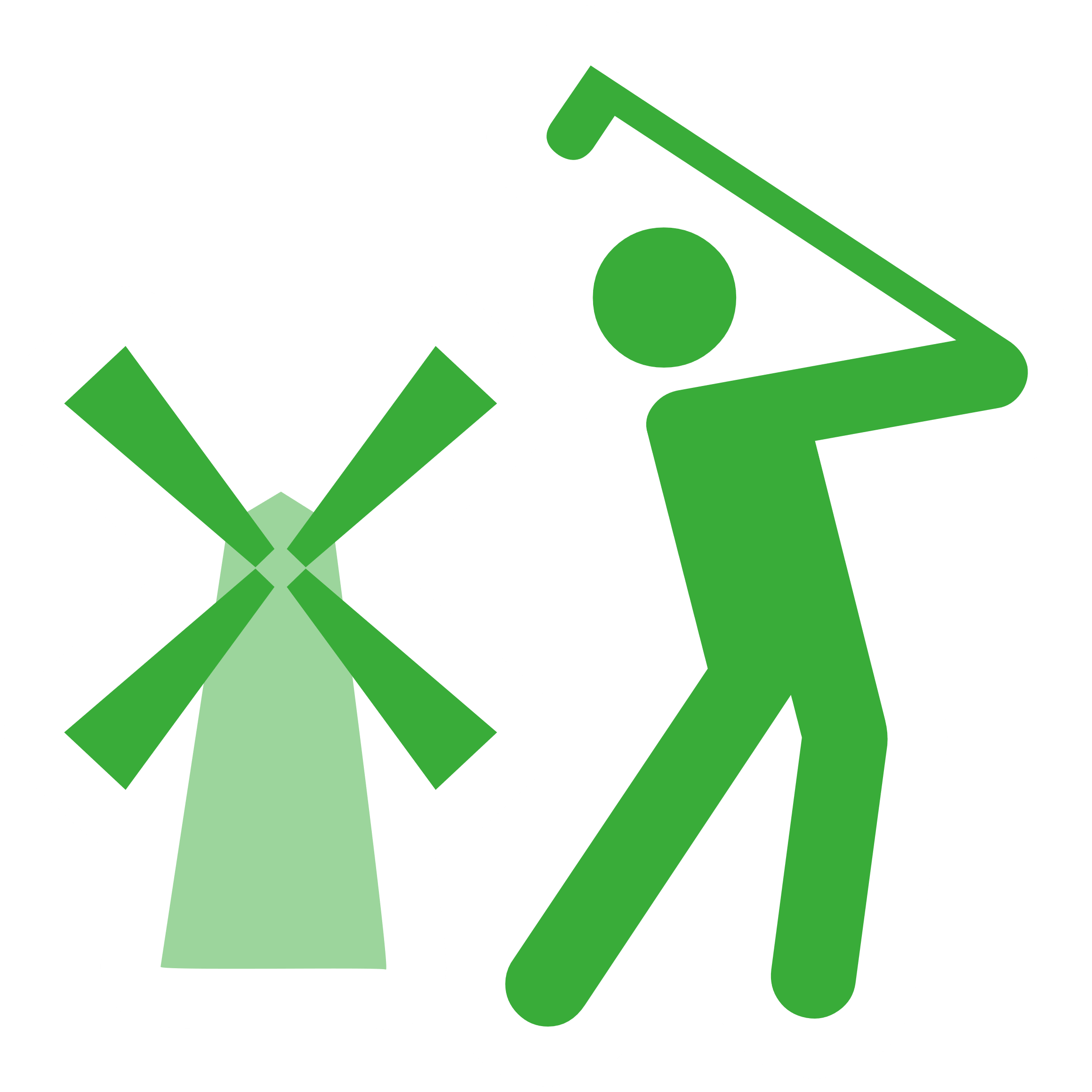  Miniature golf |   Nature reserve |   Nordic skiing |   Playground |   Playground (private) |   Recharging |   Roller skating |   Shooting |   Skateboard
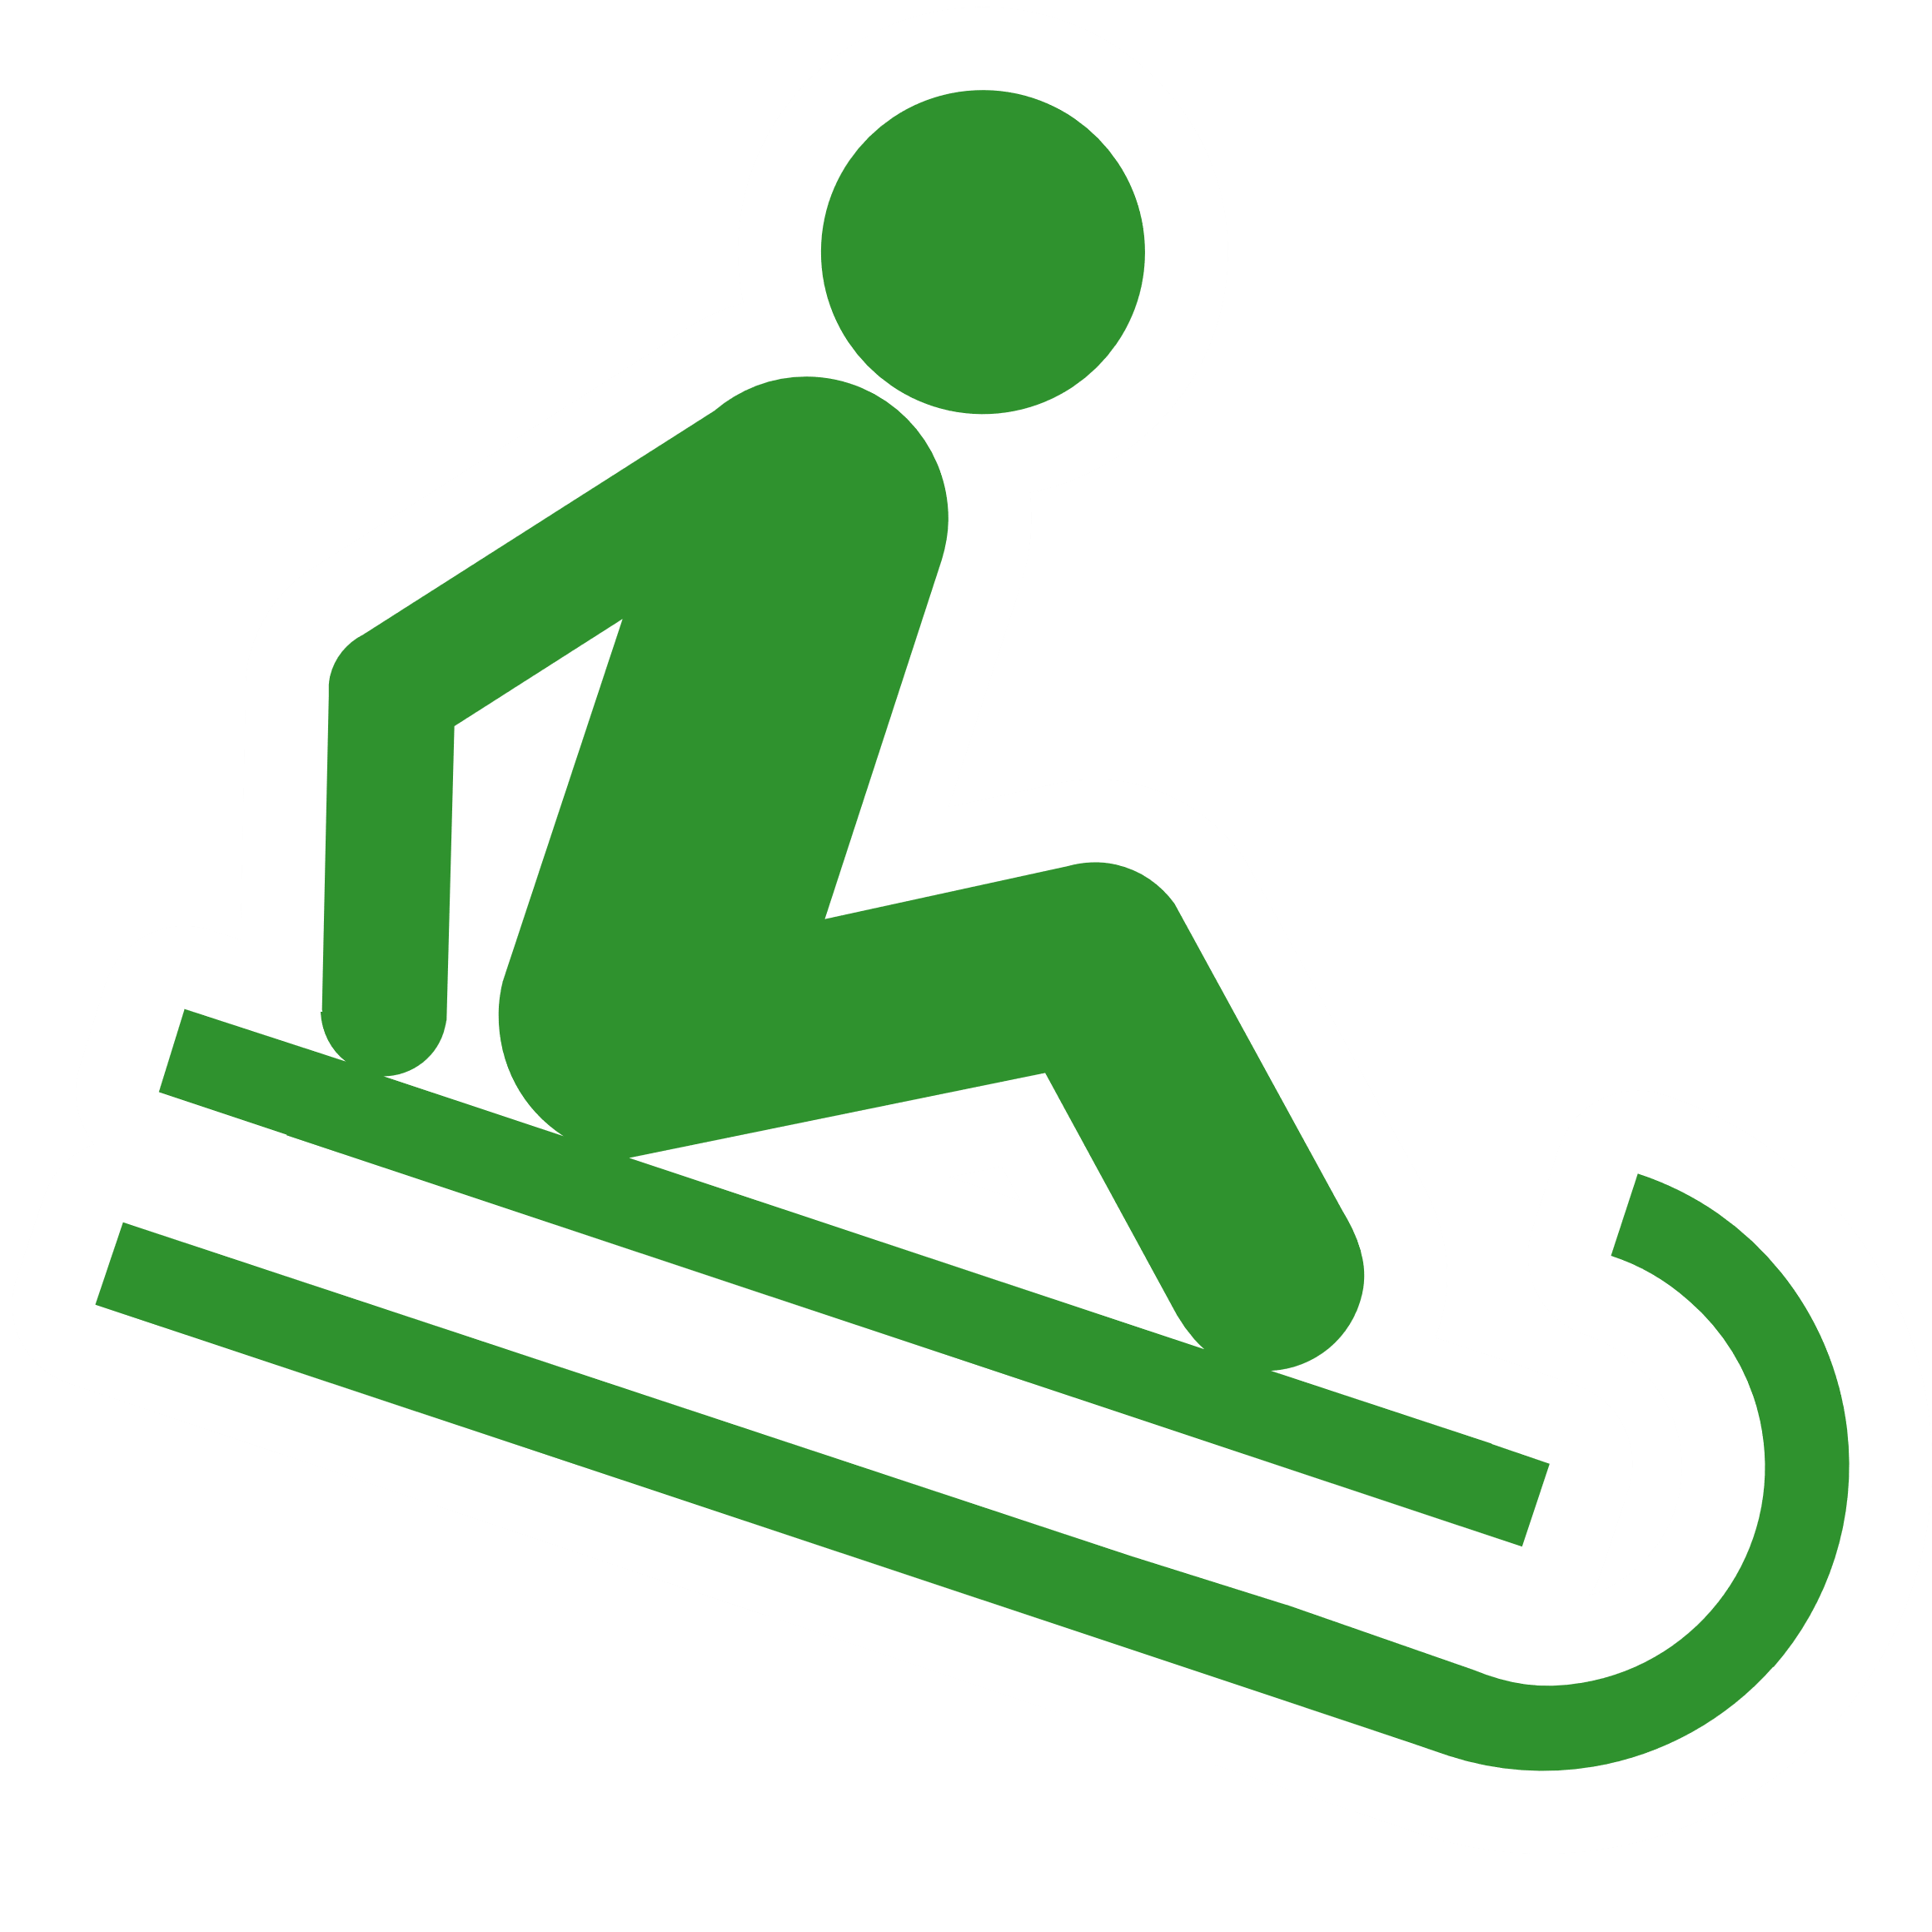  Sledding |   Stadium |   Swimming |   Tennis |   Track |   Tree |   Tree  (alternative) |   Water park

Shops
  Baker |   Bicycle shop |   Bookshop |   Butchers |   Car repairs |   Clothes shop |   Convenience store |   DIY store |   Drinks shop
  Farm shop |   Florist |   Hair-dresser |   Laundrette | Mall or Dept store |   Market |   Optician |   Organic,  Greengrocer |   Sports shop
  Super-market | Travel agency
Power
  Power station (coal) |   Power station (gas) |   Power station (nuclear) |   Power tower (major) |   Power tower (minor) |   Solar power | Water power |   Wind power
Emergency
  Defibrillator |   Doctor |   Emergency access |   Emergency phone |   Hospital |   Pharmacy
Education
  Nursery |   School |   College |   University
Mountains
  Peak |   Survey point (peak) |   Volcano |   Cairn |   Pass
Traffic
One way | One way ex. bikes |   Traffic lights | Level crossing | Foot crossing

